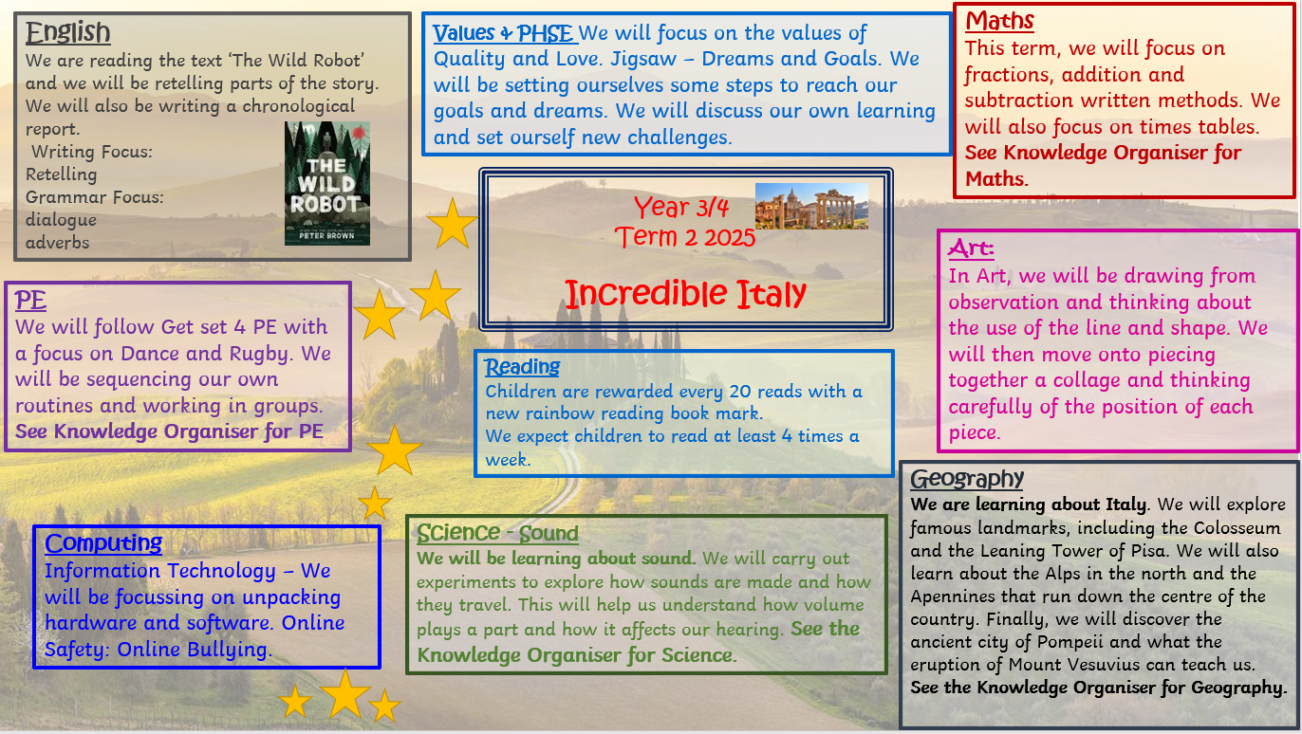

Year 4/5
Term 3 2026

Incredible Italy
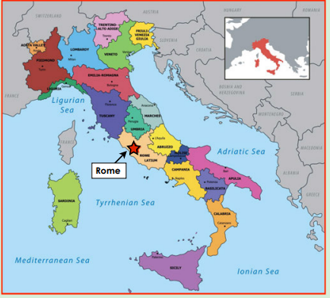
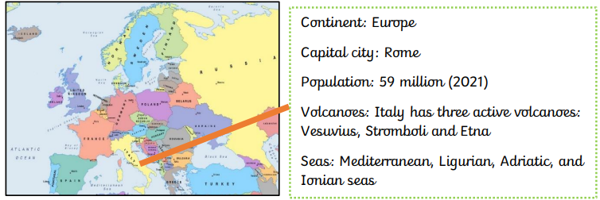

The capital city of Italy is Rome.

Physical Features

Human Features

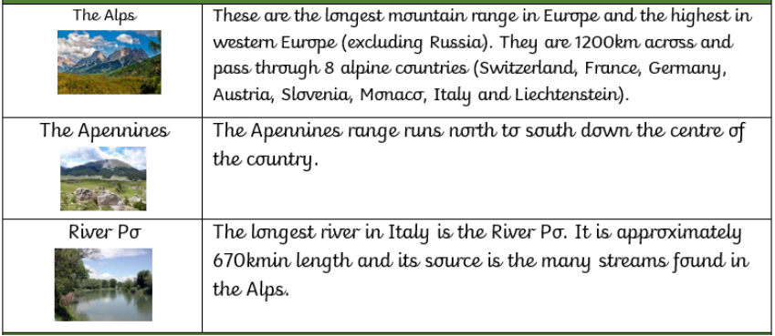
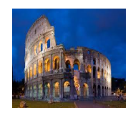
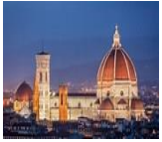
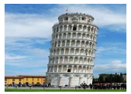
Cathedral of Santa Maria
Leaning Tower of Pisa
Colosseum
The Colosseum in Rome, built in 70 A.D., as one of many built throughout Italy during the time of the Romans. This huge amphitheatre could hold 50,000 spectators and was often the scene of chariot races, gladiator and animal battles along with executions.

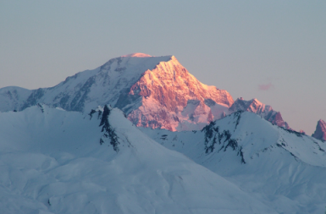
Mont Blanc is the highest mountain in the Alps.

Key Vocabulary
Pompeii

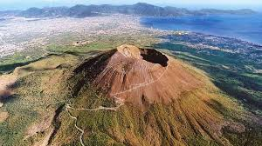
Mountains | A very high area of land with steep ides.
Volcano | A moutain from which hot melted rock, gas, steam and ash from inside the Earth sometimes burst.
Amphitheatre | Brick built oval stadium – Roman architecture.
Peninsula | A piece of land which is almost completely surrounded by water.
Borders | Political factors and physical (e.g rivers, ountains and seas) affect where borders between countries are set.
Roundhouse | A circular dwellling.
Landmark | A key feature or building that is easily seen and important to the area.
Human feature | Something man-made such as a landmark, road, factory or airport.
Physical feature | Something natural as mountains, deserts, jungles or rivers.
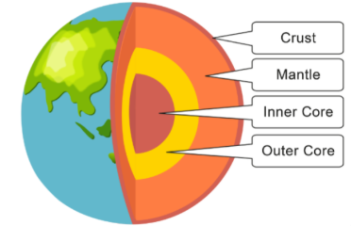

The city of Pompeii was a major resort city during the times of Ancient Rome. However, in 79 AD, disaster struck the city when it was buried under 20 feet of ash and debris from the eruption of the nearby volcano, Mount Vesuvius. The city of Pompeii was a popular vacation destination for the Romans. It is estimated that between 10,000 and 20,000 people lived in the city. Many wealthy Romans had summer homes in Pompeii and would live there during the hot summer months.

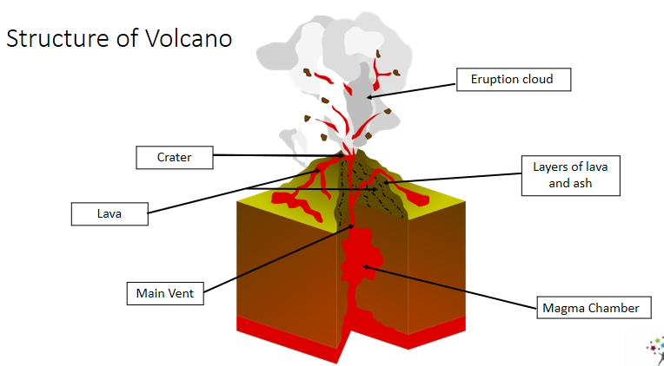

Sound
How sounds are made and travel
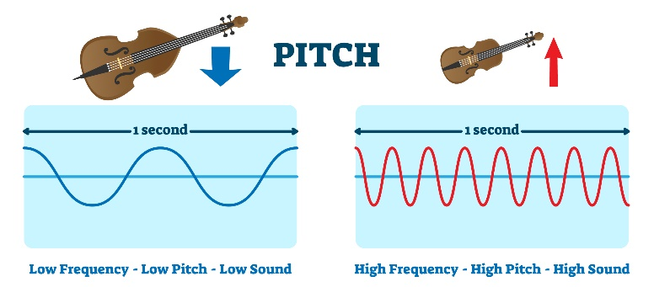
Pitch

When objects vibrate, a sound is made. The vibration makes the air around the object vibrate and the air vibrations enter your ear. These are called sound waves. If an object is making a sound, a part of it is vibrating, even if you cannot see the vibrations. Sound waves travel through a medium (such as air, water, glass, stone, and brick).

The pitch of a sound is how high or low it is. A squeak of mouse has a high pitch A roar of a lion has a low pitch.
A high pitch sound is made because it has a high frequency. The sound source vibrates many times a second.

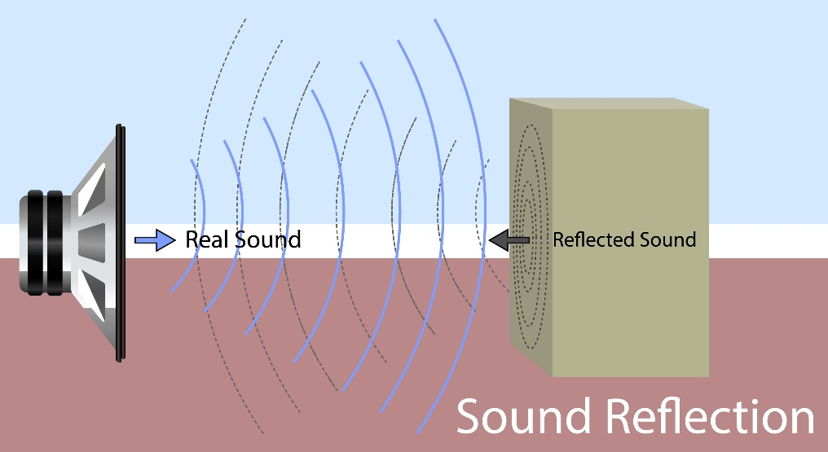
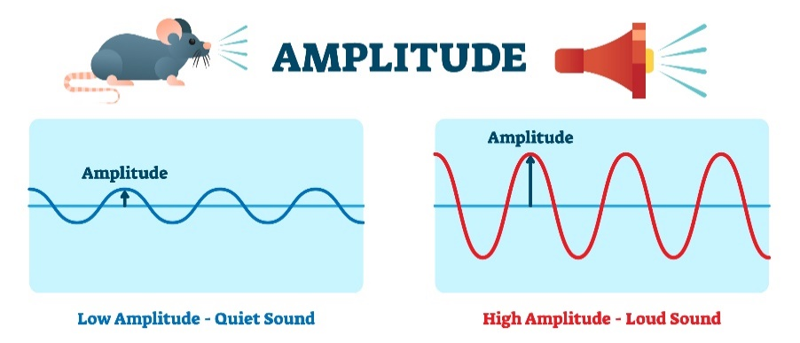

Volume

The volume of a sound is how loud or quiet it is. Quieter sounds have a smaller amplitude and less energy (smaller vibrations) and louder sounds have a bigger amplitude and more energy. The closer we are to a sound source the louder it will be. A train arriving at a station sounds loud. The further away from a sound the fainter it will be. A train in the distance sounds quieter.

How do we hear?

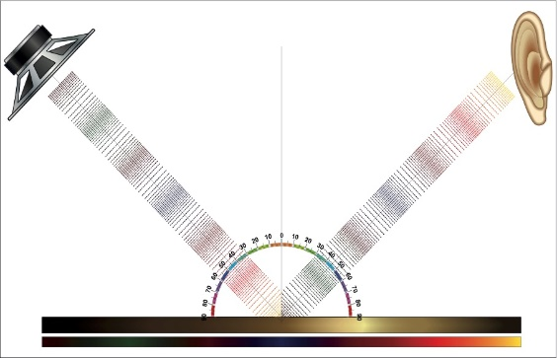
The sound waves travel to the ear and make the eardrums vibrate. Messages are sent to the brain which recognises the vibrations as sounds.

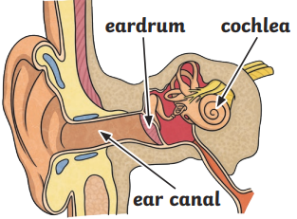
The Ear

Key Vocabulary
Sounds in Solids

Vibration | Particles moving very quickly.
Medium | A substance such as air, water or a solid.
Source | The start of something.
Energy | The power to make something work, move or grow.
Materials | Anything used in making something o building.
Reflect | Bounce back from a surface.
Volume | How loud or quiet a sound is.
Decibels | The unit to measure loudness
Pitch | How high or low a sound is.
Instruments | Objects used to play music.
Partivles | Tiny pieces that make up something larger.
Sound source | The object that started the sound.
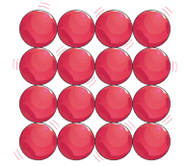 | The vibrations that create sound move from particle to particle. The particles in a solid are closely held together. This means that it is easier for sound to travel through a solid object than through other states of matter.

Sounds in Liquids

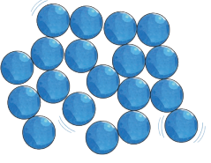 | In a liquid, the particles are quite close together and can move freely over each other. This means that the vibrations from a sound can’t travel as easily as in a solid. Sound can still travel through liquids but not as well as in a solid.

Sounds in Gases

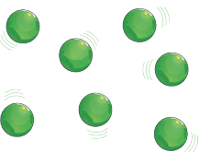 | Gas particles are spread far apart. It is more difficult for vibrations to travel through a gas than through a liquid or a solid. Sound can still travel through gases. Most of what we hear travels through the air.

