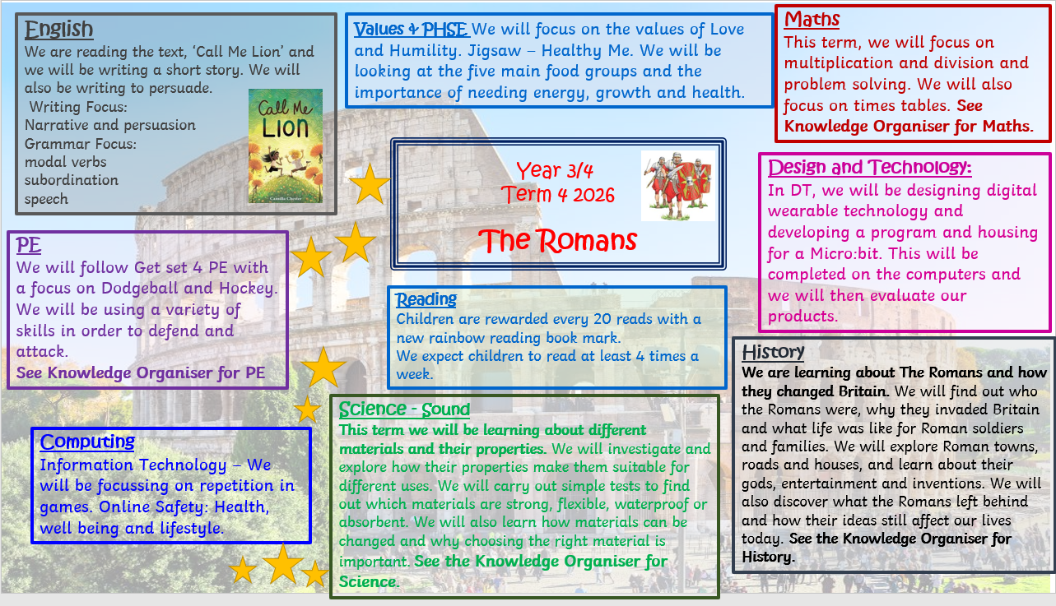

Year 4/5

The Romans

Timeline
The first Romans lived in Italy nearly 3000 years ago. They founded the city of Rome in 753 BC and, over the centuries, conquered many lands to create a huge empire.

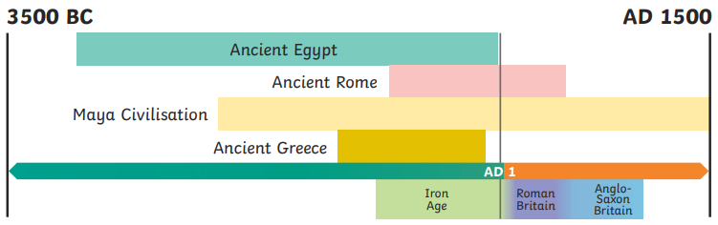
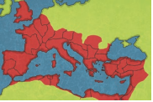

Roman Villas

Emperor Claudius
Wealthy Romans and some Celts built large homes in the countryside called villas. The land attached to these homes was used for farming as agriculture was an important business for the Romans. Countryside villa complexes, included a main house, bath house, workshops and gardens.

In AD 43, Emperor Claudius launched a third attack on Britain. He sent a powerful and well-organised army of around 40,000 men (that landed in southern England) to conquer the Celtic tribes. This time, much of Britain (or Britannia as the Romans called it) did become another province of Rome.

The Colosseum
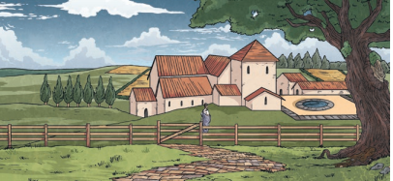

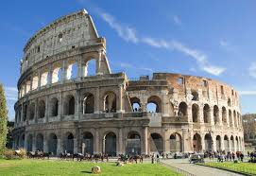
The Colosseum is in Rome. This is the most famous, surviving Roman amphitheatre.
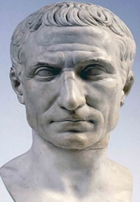
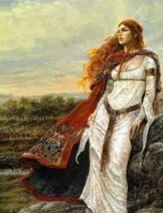
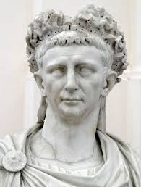
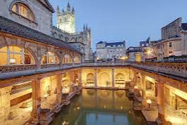

Emperor Claudius
Julius Caesar
Boudicca

Key Vocabulary
Hadrian’s Wall in AD 122

tribe | A group of people who share the same culture and values.
Roman Empire | The name used for the land that was controlled by the Romans, including large parts of Europe plus parts of North Africa and West Asia.
empire | A group of countries controlled by one ruler or government.
emperor | The ruler of an empire.
conquest | Taking control of a place by fore, often with an army.
citizen | A person with all the rights and protections of a nation or land. In the Roman Empire, only citizens were able to vote.
Celts | People living in Britain tribes, including the Iceni, Brigantes and Catuvellauni.

In AD 122, Emperor Hadrian gave an order to build a wall in the north of the country. Roman legions had tried to conquer Caledonia (Scotland), but the Picts would not give up their lands and they also raided land that the Romans controlled. Hadrian’s Wall took around six years to build and it was 73 miles long. Around 15,000 troops lived at Hadrian’s Wall so they could defend this northern border of the Roman Empire.

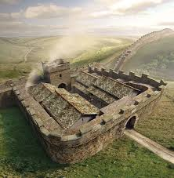

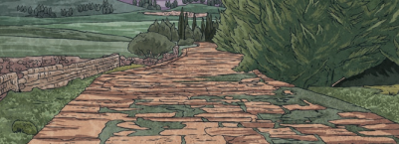

Roman Roads and Towns
The Roman army are famous for building long, straight roads. Special engineers planned these roads and they criss-crossed the whole Roman Empire. They boosted trade, communication with the emperor and helped the legions to keep control of all the different provinces.
The Romans built new towns all over Britain. Each one had a marketplace, town hall, shops, temples and homes; large towns had an amphitheatre. Bath houses were elaborately designed and were popular places to relax and meet friends.

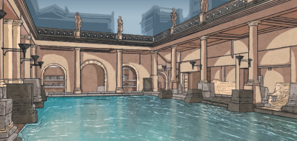

Properties of Materials
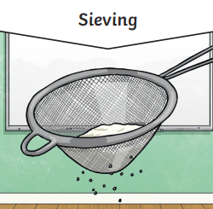
Soluble Materials
Properites of Materials

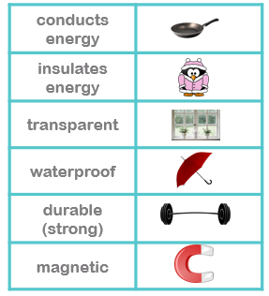
Some solids dissolve in water (Soluble).

Some solids do not dissolve in water. (Insoluble).


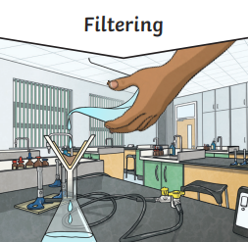

Separating Materials

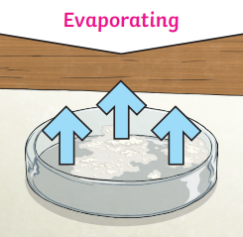
Everyday Materials
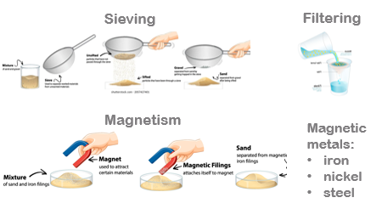

Metal saucepans conduct heat to warm food.
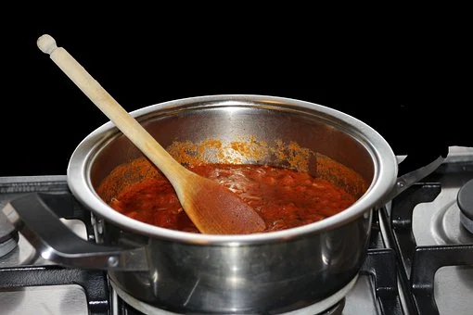
Wooden spoons and plastic handles insulate heat so hands do not get burned.

Key Vocabulary

conductive | A material that allows heat and/or electricity to pass through it.
magnetics | Material that is attracted to a magnet
Conduction | Heat moving from one objct to another through contact.
force | When an object is acted upon by a pull or push mtion in a specific direction
dissolve | To mix with a liquid and become part of a liquid.
solute | A substance that can be dissolved in liquid.
substance | Any material such as sugar.
filtering | The seperation of a mixture using a tool with small holes to separate particles.
evaporation | The process of where a liquid changes into a gas.
thermal | Using or producing heat.

Irreversible Changes

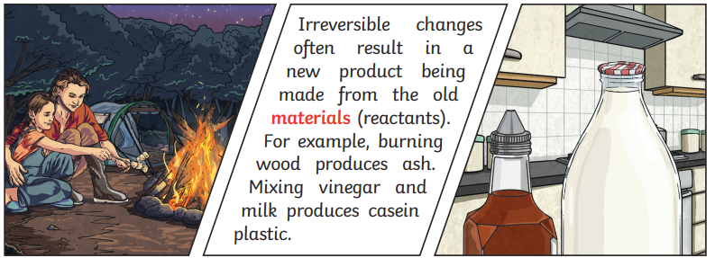

Dissolving

