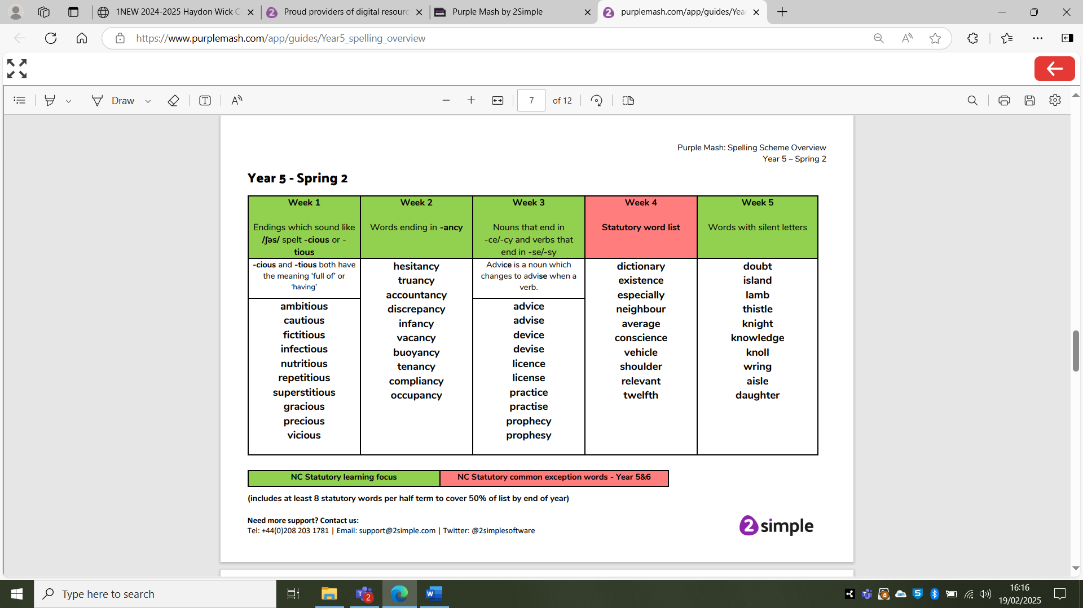

w/c 3rd February

w/c 27th January

w/c 20th January

w/c 13th January

Week 6 – Recap week of all the words above!

w/c 3rd February

w/c 27th January

w/c 20th January

w/c 13th January

w/c 6th January

w/c 6th January

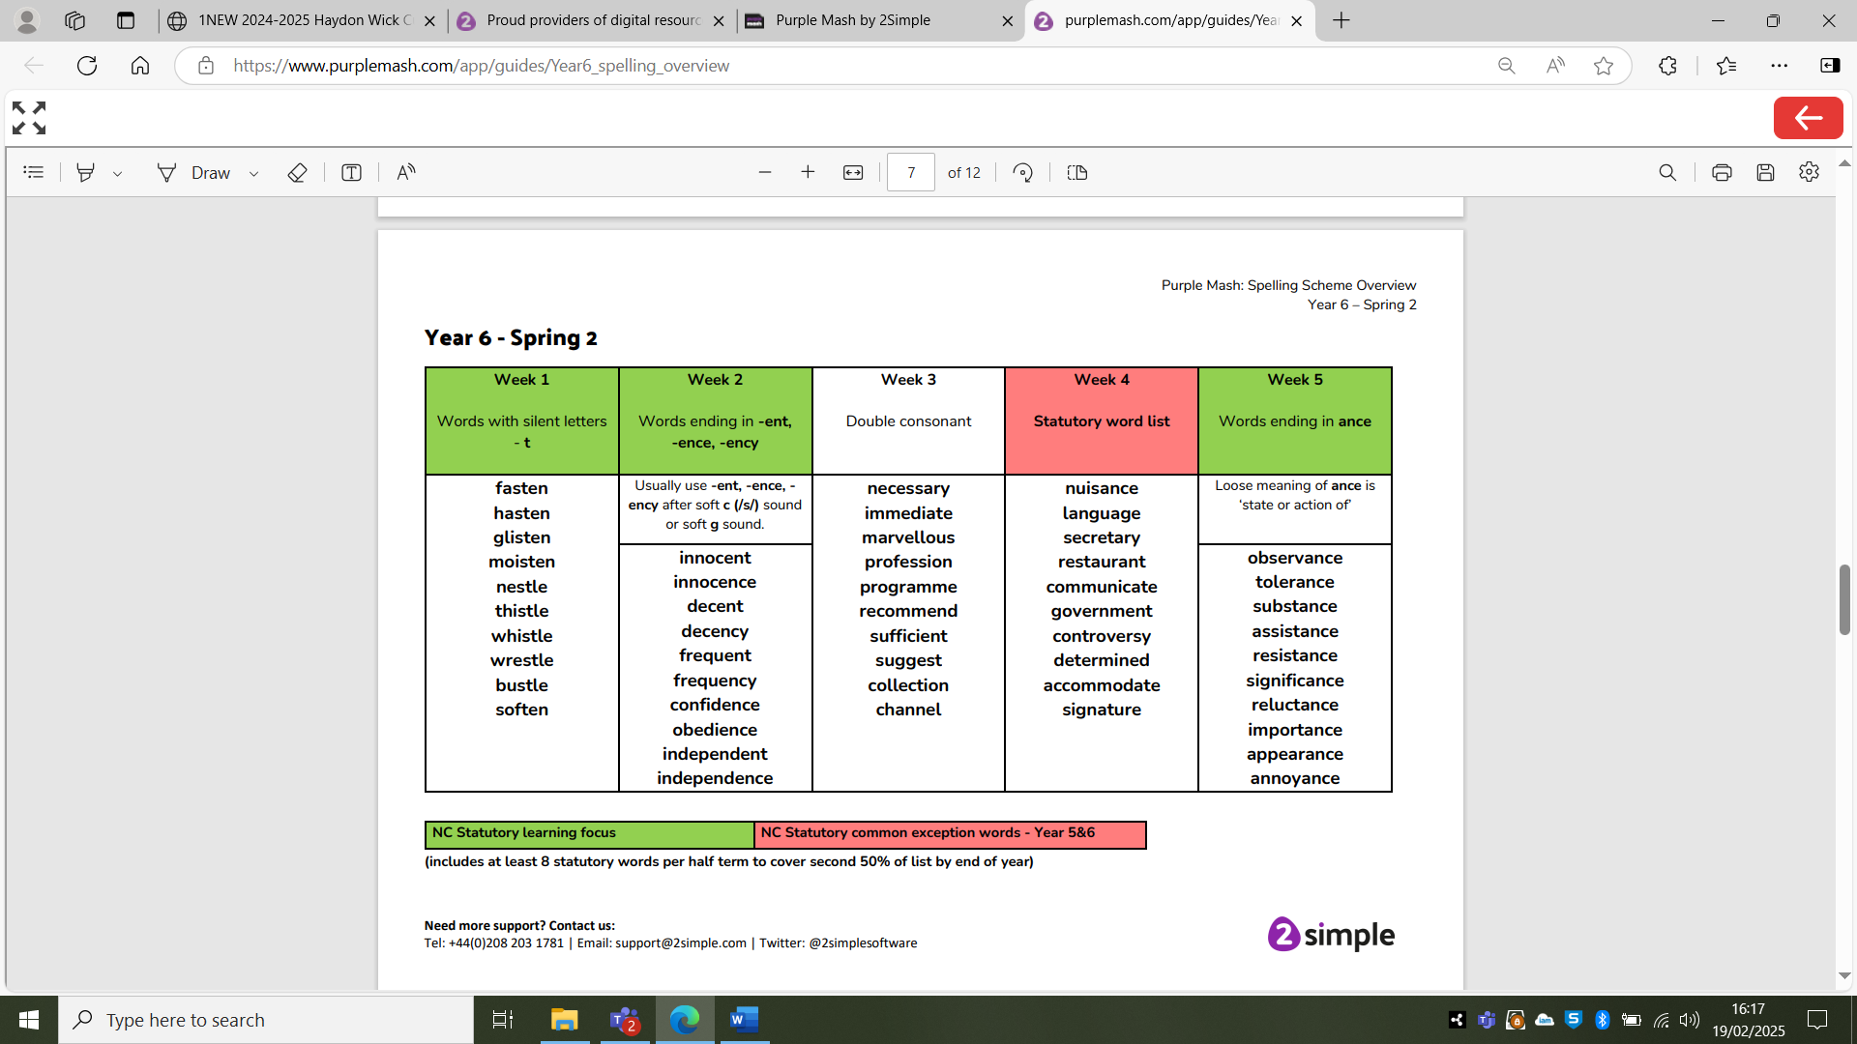

Week 6 – Recap week of all the words above!