In Maths, Year 5 are working on fractions. Can you make a step by step poster, explaining how to exchange improper fractions and mixed numbers?
Year 6 will be revising for our upcoming SATs. Take some time to revisit anything which you find tricky,

Jaguars and Tigers Class
Pick and Mix Homework
Term 5
Remember you don’t need to do all 7!

In PSHE, our focus is ‘relationships’. Can you create a PowerPoint to help people with how to use technology safely?

In Science, we are studying Space. Try and make your own miniature solar system model!

For Geography, we are learning about trade. Can you create a poster describing trade links in and out of the UK?

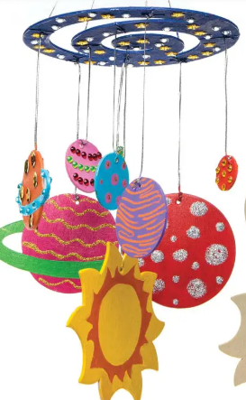

For Art, we are making different outfits in fashion design. Can you design an outfit linking to Space?
Essential Homework
Y6 maths and SPAG homework set every Friday.
Read for 10 minutes
Learn and practise your spellings on Purple Mash.
Pracitse your times tables and use maths rockstars!
In English we are writing about a book set during the time of WW2. Can you write a letter as an evacuee? Consider the feelings they would have felt. Perhaps you could tea stain the paper before writing, to make it look old!

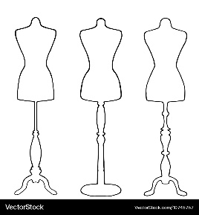

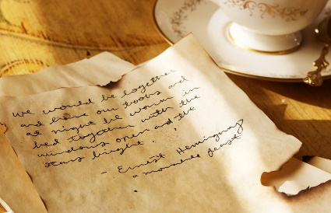
All work to be returned by the last week of term.

