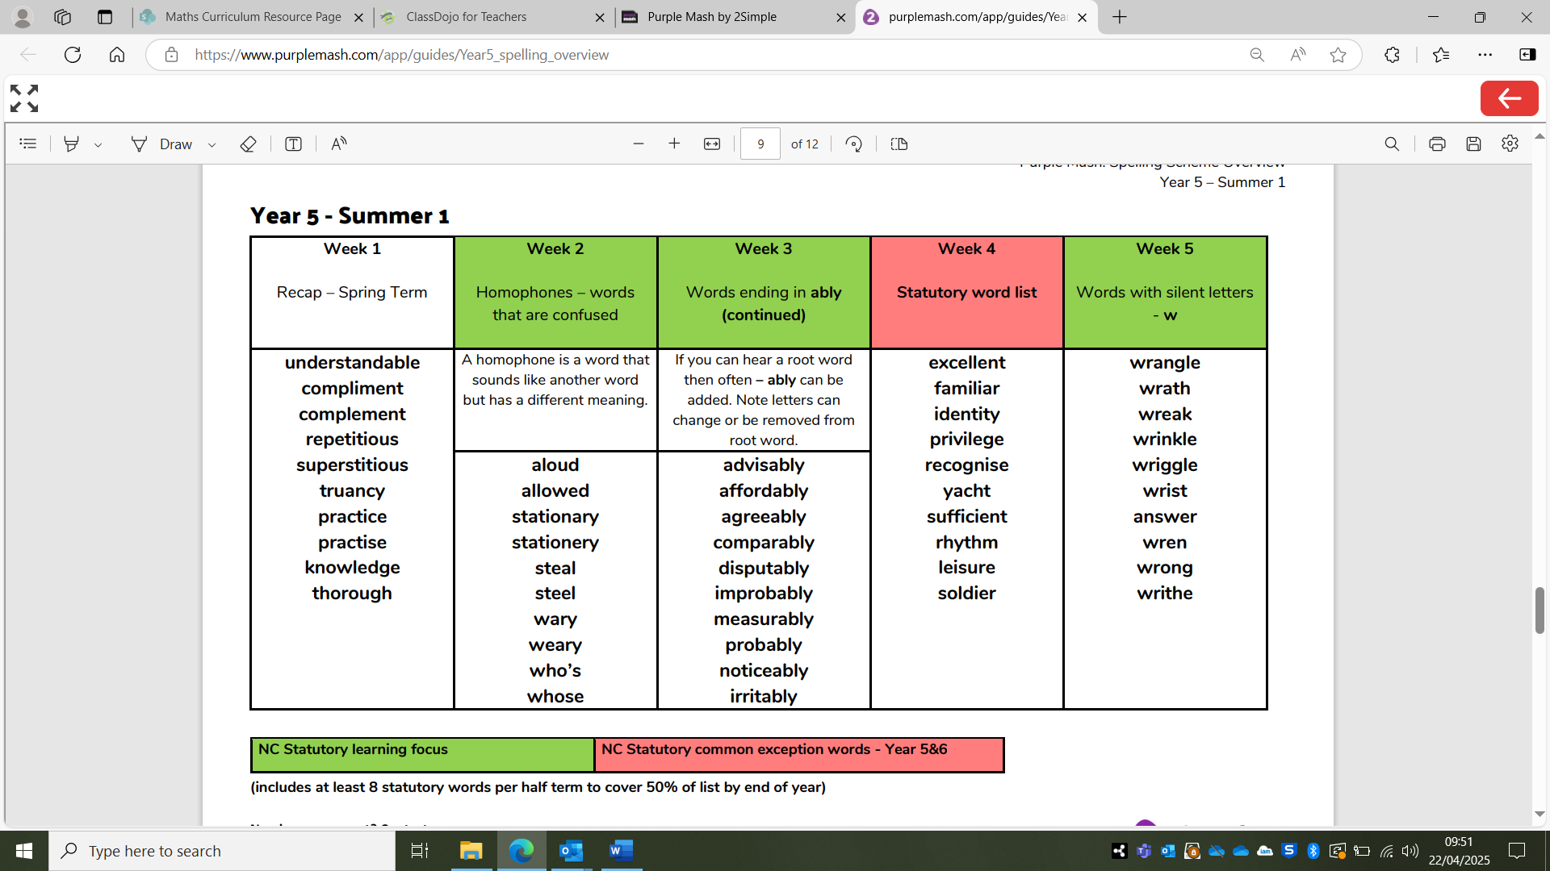

Week 6 – Recap week of all the words above!

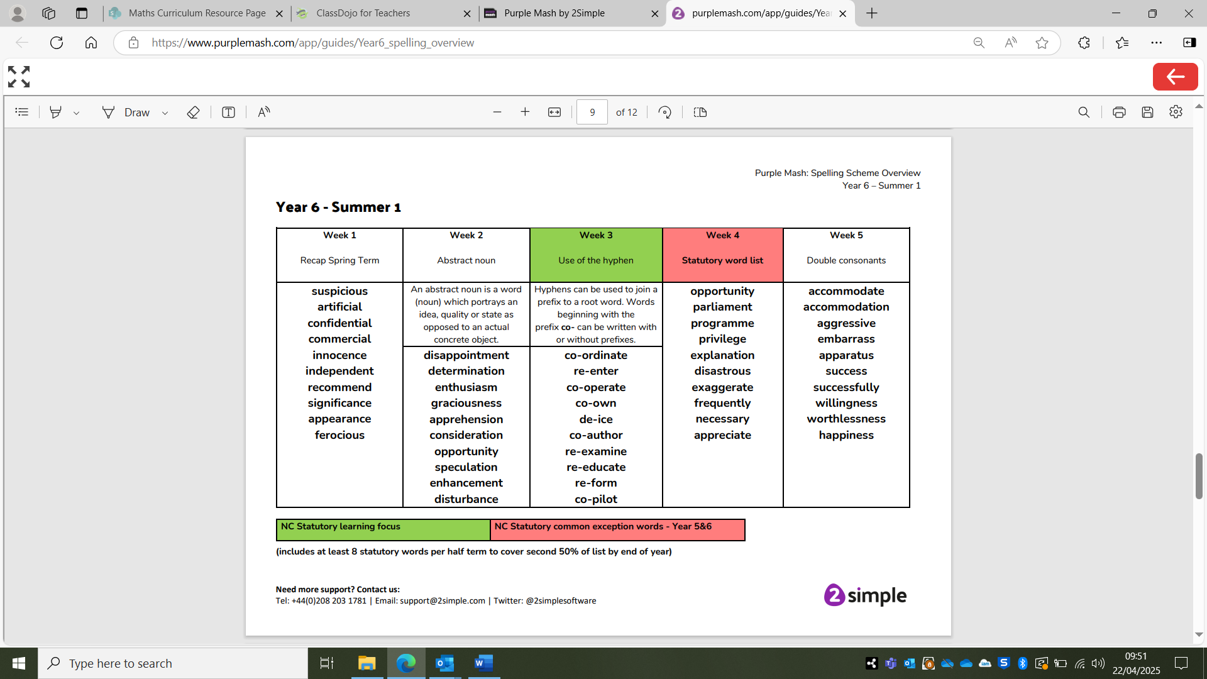

Week 6 – Recap week of all the words above!