English  Write a detailed setting description and get AI to illustrate it for you. (The more detail you add the better the picture will be.) www.craiyon.com  Create a biography of your favourite famous person. | Maths  Learn to tell the time.  Have a game of Monopoly (or other board game) but you must be the banker.  Bake a cake/biscuits. Follow instructions and measure carefully. | Science  Be a Leaf detective: Collect lots of different leaves and find out which tree they came from.  Think carefully about how to present your findings.
Geography/History  Do some research about ‘How to save the rainforests.’  Try creating a poster that we could put up around school, telling us what we could do to save the rainforests. | Reading  Write a book review for your favourite book. Try and persuade others to read it. | 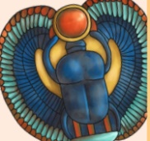  Art  Research some art work by Henri Rousseau. Find a picture about rainforests and recreate it. You could sketch, paint, collage. It is your choice.
Computing  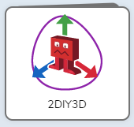  Create a 3-level game for your paired reader to play.  (Ensure that it is not scary.)  Use 2code and try the following lessons:  1.Air traffic control 2. Princess and the frog 3. Magician. |  | Physical activity  Practice for your ‘Healthy me’ fitness challenge.
Be creative and careful in the way you present your work. To be handed in on 20/5/24 and presented to the class.
Photos and videos can be uploaded to Dojo. Parents welcome in after school on 21/5/24 to see what we have produced.
Pick ‘n’ Mix Homework (term 5)

