For Maths, Yr 5, explore area, volume and angles using BBC Bitesize.

Yr 6, revisit any areas you have found tricky so far this year. You can also keep up your arithmetic skills using this website: [SATS - Key Stage 2 Arithmetic - Compact Version](https://mathsbot.com/primary/ks2Mini)

For Computing, use Purple Mash to complete the ‘to do’ on Victorians. You will need to research about Victorian schools and add your own information. Our school trip to Sevington should help you with this!

Jaguars and Tigers Class

Pick and Mix Homework

Term 6

Remember you don’t need to do all 7!

For History, create an outdoor game that children could have played in the Victorian times or research and create a poster of Kings and Queens of the past.

For Science, can you create a model of our solar system?

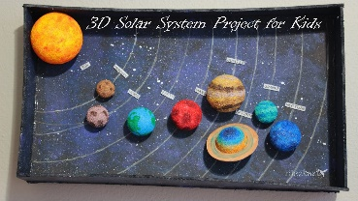

For Art/DT, create your own shadow puppets. You could create a story to go with them.

Essential Homework

Y6 arithmetic maths homework set every Friday.

Read for 10 minutes

Learn and practise your spellings on Purple Mash.

Pracitse your times tables and use maths rockstars!

For English, write your own set of instructions for a meal you have prepared. It could be something simple like a sandwich or a three-course meal.

**All work to be returned by the last week of term.**