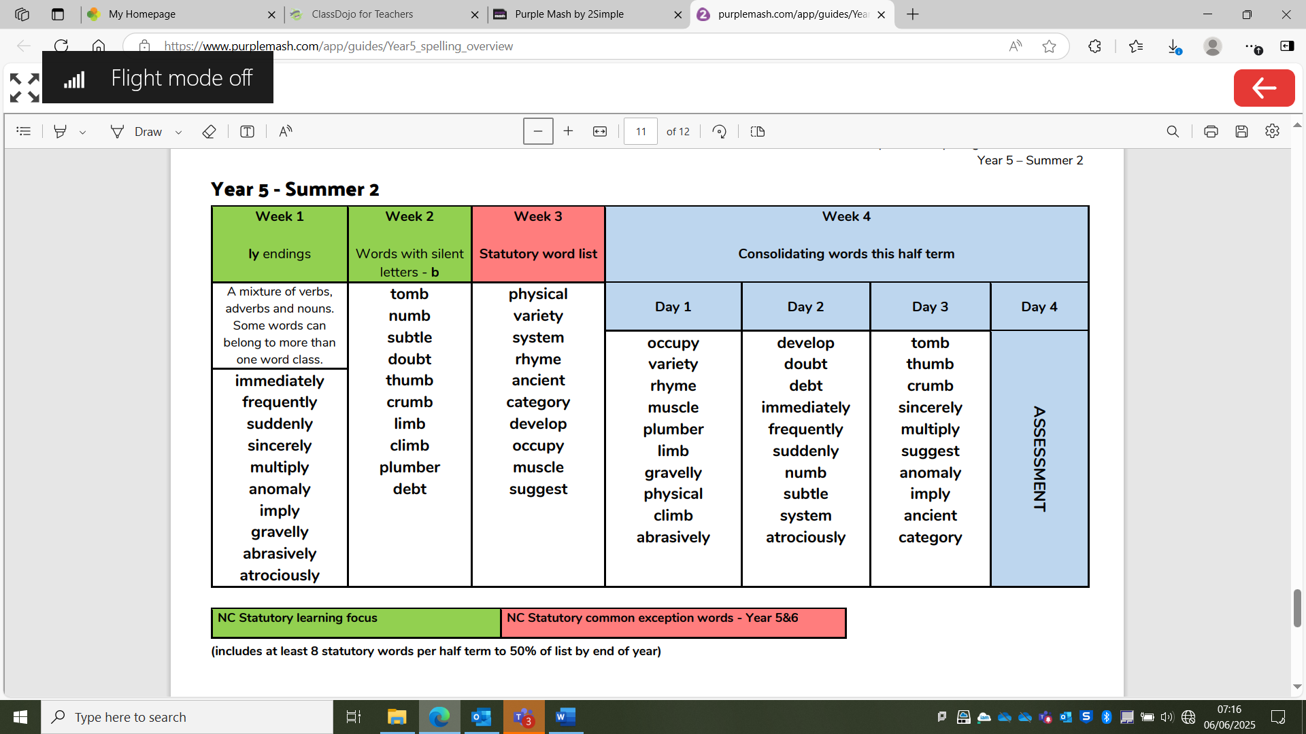

Week 5 and 6 – Recap week of all the words from this term!

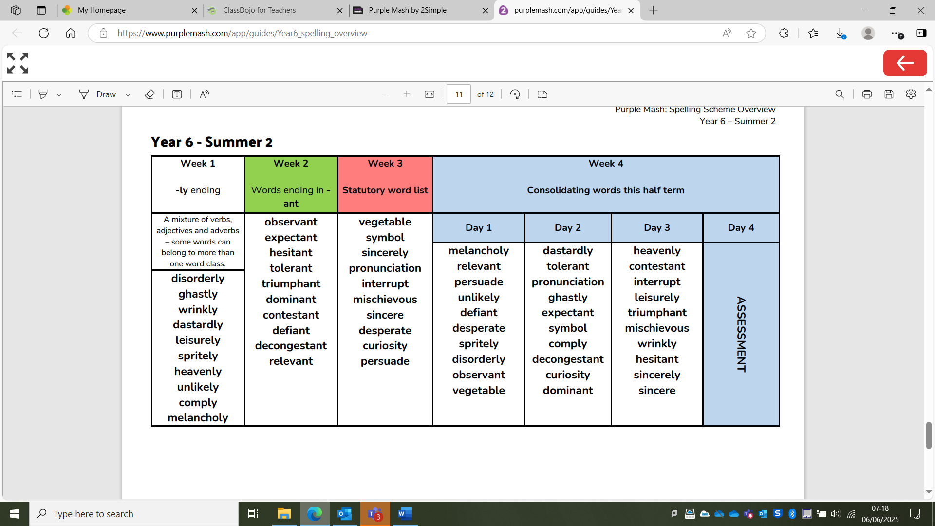

Week 5 and 6 – Recap week of all the words from this term!