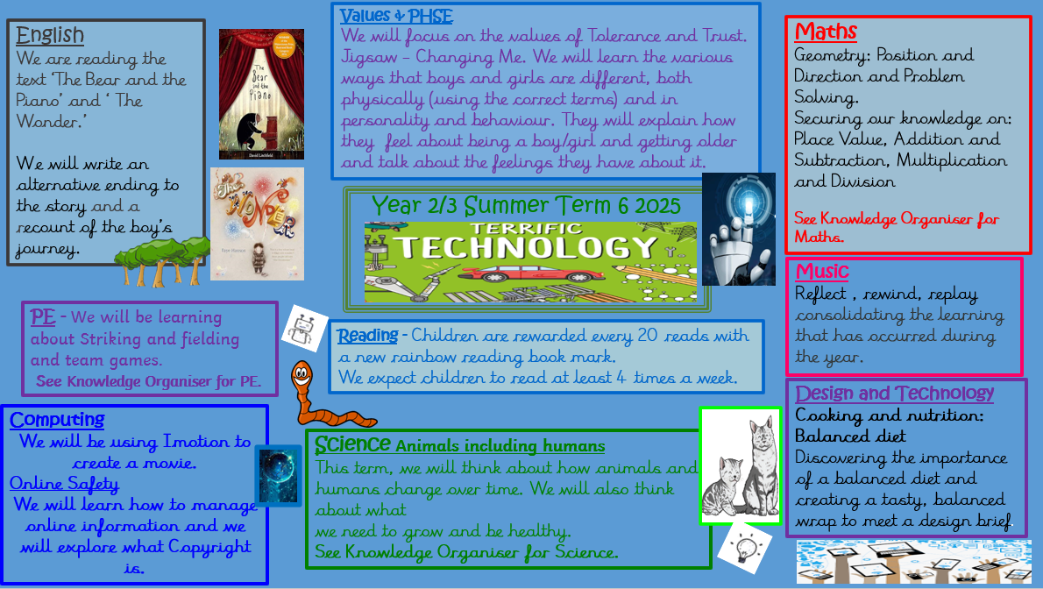

Knowledge Organiser – Terrific Technology

|  |  |
| --- | --- |
| **Key Vocabulary** | |
| **inventor** | An inventor makes or discovers a new way of doing something. They might make something new. |
| **scientist** | Scientists study the world around us, the people and animals in it as well as studying space. They do this by looking and by doing experiments. |
| **world wide web** | An information system on the Internet, which allows documents to be connected to other documents by hypertext links. |
| **Internet** | A global computer network providing a variety of information and communication facilities consisting of interconnected networks. |
| **web** | The World Wide Web or the Internet. |

|  |
| --- |
| **Key People** |

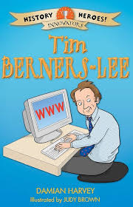

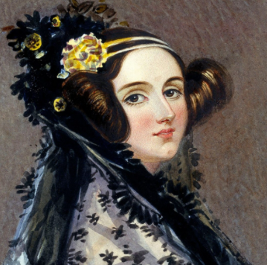

Ada Lovelace was born in London, 1815 and she was an only child. In 1843, Ada wrote the first step-by-step set of instructions for this machine: The Analytical Engine. This is said to be the first ever computer program. Unfortunately, Ada died at the age of 36.

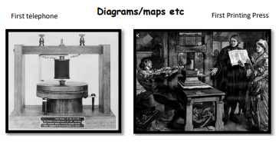

Tim Berners Lee (1955 – present). An English engineer and computer scientist, best known as the inventor of the World Wide Web. On 6th August 1991, Sir Tim launched the first ever website. It explained what the world wide web was and gave people ideas on how to set up their own websites.



