Tiger and Jaguar Pick and Mix Home Learning

This term you may choose your own homework!!

- Simply choose one or more tasks from the table on the other side of this sheet.
- You can CHOOSE how to present your homework. You could act it out, make it and photograph it, draw and label it, write it!! These are just a few ideas….
- Hand in the homework on 13th October

You will need to keep doing important things like reading, spelling, maths and times-table practice. Look at the checklist below and make sure that you do the tasks every week.

checklist
- Spellings
Daily practise in school and a quick check at home.
- Read
At home least 4 times a week for at least 15 minutes.
- Times-tables
Practice your times-tables using X-table Rockstars.
- Year 6 Maths and grammar
Year 6 - You will need to complete your weekly maths and grammar homework.

We will share all of our fabulous homework in class as a presentations and via Dojo.

We look forward to seeing all the wonderful work you produce.
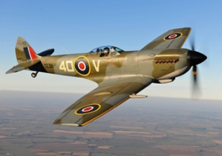  Research the aircraft used in WW2 then make a labelled poster/diagram/model of the aircraft | 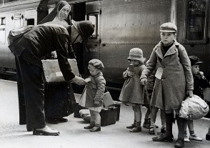  Write a story about an evacuee | 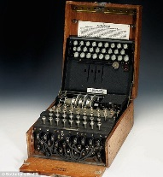  Research the ‘Enigma’ machine and Bletchley Park. Present your information as a PowerPoint, a booklet or a poster
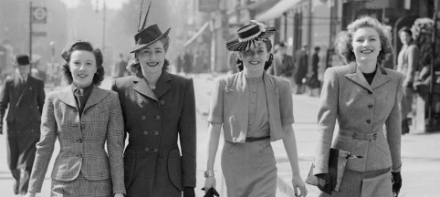  Research the rationing and the clothes people wore during WW2 Design and label an outfit for a family | 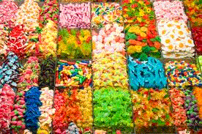  Pick and mix homework  Term 1 | 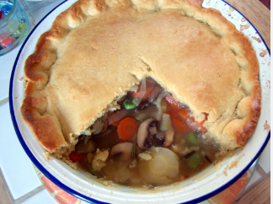  Research and make a recipe popular during the war years.
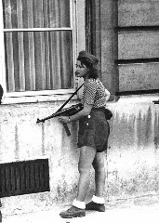  Do you have a family member who was born during the war? Interview somebody with first-hand experience and film it or write it up to show the class! | 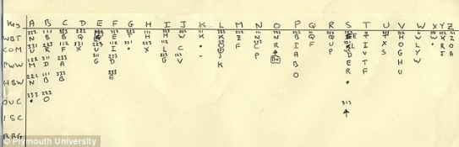  Create your own secret code and use it to write some messages. | 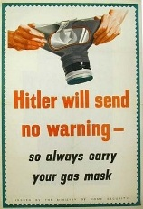  Create a poster persuading children to remember to carry their gas masks at all times.

