Write a biography of a famous person from WW2 who you find interesting. Choose how to present the information. It could be a poster, booklet, PowerPoint.  Winston Churchill, Anne Frank, Vera Lynn….  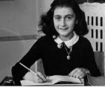  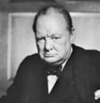 | Learn a song or dance from 1940’s. Perform it to the class!  (Look at BBC dance party 1940’s for inspiration)  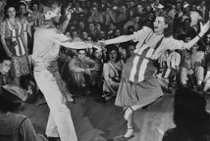 | 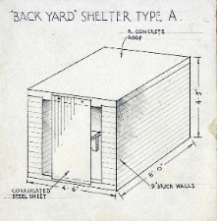  Research and make a model of an air-raid shelter
Write a newspaper article for the front page of the Times for the day the war ended.  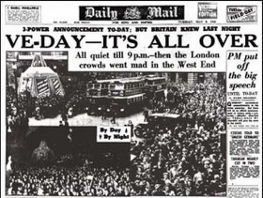 | Pick and mix homework  Term 2  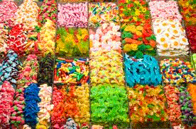 | During World War 2 food was strictly rationed. Design a menu for one day using original recipes from WW2 or make your own recipe book!  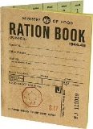
Write an information leaflet or travel brochure for a country in North America. Include information like famous landmarks, what the climate is like, largest mountains and rivers, capital city, population…  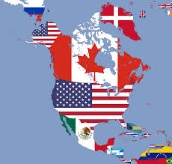 | Who were the ‘Land girls’ and why were they important to the war effort?  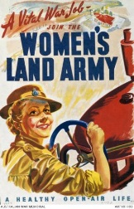  Research and present your findings as a poster, powerpoint, report. | 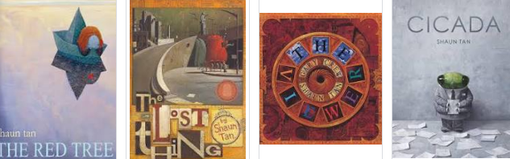  We’ve been looking at the art work of Shaun Tan – can you research his other works? You could produce a set of drawings in his style to create your own wordless picture book.

