Curriculum Intent, Impact & Implementation – Writing
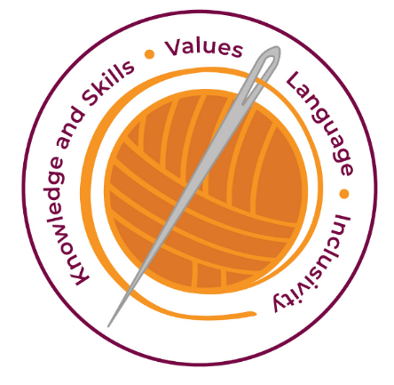

Our curriculum has four golden threads which are woven through all we do.
3R’s – Respect, Resilience and Responsilbity
Within these threads we have our 22 core values – understanding, unity and co-operation, freedom, appreciation and simplicity, hope, resilience, responsibility, thoughtfulness, tolerance, trust, friendship, perseverance, patience, peace, quality, love, humility, honesty, caring, happiness and courage.

Knowledge and Skills Intent & Implementation  Our intention is to develop lifelong learners who have the skills knowledge, and curiosity needed to take full advantage of every opportunity in life. | - Helps them with real life bigger picture to give them skills and understanding to take them on their journey to next year and beyond with their writing.  - Experiences that are embedded within our curriculum.  - Our hooks in Phase 1 develop curiosity and a love of books  - Each writing session is in Phases to allow skills used in their own pieces of writing.  - Revisiting genres allows children’s knowledge to build up throughout their primary life.  - The skills are mapped out for each year group from 1-6. T

Impact – All children are ready for the next part of their life whether that be the next year at primary or ready for their move to secondary and beyond. They understand the importance of learning and value all opportunities.
Values Intent & Implementation –  Our intention is that all children recognise and maintain a shared set of values, which will allow them to make a positive difference to themselves and others in a rapidly changing world. | - Partner talk helps develop our values (unity, co-operation, friendship)  - Children have a positive approach and show resilience to keep trying.  - The grammar skills that are taught and slowly built up allow children courage to have a go at the writing. They need to show perseverance to complete the challenges as the thought process becomes deeper with their sentence structures.  - The texts expose the children to all of the school values.

Impact - All children have a core set of values which underpin every decision they make. They understand the importance of values and how these make us feel personally and how showing values allows children and young people to live positively in modern Britian.
Language Intent & Implementation –  Our intention is that all children will acquire the language to allow them to express their thoughts, ideas and learning in a clear and coherent manner. | - We model partner talk to ensure that children acquire the skills to articulate their thinking with quality answers.  - Children use quality stem sentences and generalised sentences to help ensure coherence in their reasoning.  - Children are immersed in the book and the language is displayed on the working wall.  - Opportunities to use thesaurus to share ideas and vocabulary with the class.

Impact – All children have a language rich curriculum where they are encouraged to communicate effectively in full sentences. They are taught the skills to communicate efficiently within a vast range of situations and understand the need of listening attentively and responding appropriately to be a successful communicator
Inclusivity Intent & Implementation –  Our intention is that no child is left behind. Every child, regardless of background, social, emotional, or educational need will achieve well and fulfil their potential. | - Lesson structure reduces cognitive load and focusses on the new learning.  - Small manageable steps means no child is left behind.  - Help yourself resources are used within the learning.  - Verbal feedback is given throughout the lesson and catch – up lessons are given to ensure children achieved the learning objective.  - The main texts and supplementary texts ensure diversity is represented.

Impact – All children feel valued and consider themselves as equal while also developing a good understanding of the difference between equity and equality. Diversity is celebrated. Children are supported to show resilience and are proud of their achievements whatever their starting points.

The Foundation Stage
We believe that communication and language with opportunities to explore reading and
writing underpins children’s future learning. The practice in Foundation Stage follows the DFES curriculum guidance and will work towards the Early Learning Goals and month bands aiming to meet the statement of the goals by the end of reception year.
In reception the daily routine will include planned adult led activities and child
initiated time to encourage independent learning, these include:
•a wealth of opportunities to develop and experience speaking and listening;
•experiences that develop gross and fine motor skills through play and handwriting
activities;
•sharing and enjoying a range of rhymes, songs, stories and books;
•immersion in a print rich environment with opportunities for oral language and
written communication, e.g. differentiated phonic activities;
•focus activities that teach children early communication language and literacy skills.

Key Document Details
Author: B.Phillips | Approver: Whole School
Owner: E Rushen-Gough | Version: 2.0
Last Update Date: September 2024 | Next Review: Sept 2025

