Y1 PSHE Jigsaw Knowledge Organiser Celebrating Difference

**Puzzle Outcomes**

* I can identify similarities between people in my class.
* I can tell you some ways in which I am the same
* as my friends.
* I can tell you some ways I am different from my friends.
* I can tell you what bullying is.
* I understand how being bullied might feel.
* I know some people who I could talk to if I was feeling unhappy or being bullied.
* I can be kind to children who are bullied.
* I know how to make new friends.
* I know how it feels to make a new friend.
* I can tell you some ways I am different from my friends.
* I understand these differences make us all special and unique.

Our Values of the term: Patience and Peace

Celebrating Difference at Haydon Wick Primary School

As good citizens of Haydon Wick Primary School, we understand that everybody is unique and we should respect and celebrate everyone’s differences.

Anti-bullying week: One Kind Word

Key Vocabulary

|  |  |
| --- | --- |
| Similarity | The state or quality of being similar. |
| Differences | What makes two or more persons or things not the same. |
| Bullying | unwanted, aggressive behaviour that involves a real or perceived power imbalance. |
| Deliberate | Done or said on purpose. |
| Unfair | Treating people in a way that is too harsh or that is unequal with the way others are treated |
| Included | To be a part of something. |
| Friend | A person that someone likes or knows. |
| Unique | Being the only one of its kind. |
| Celebration | The act of honouring or celebrating. |

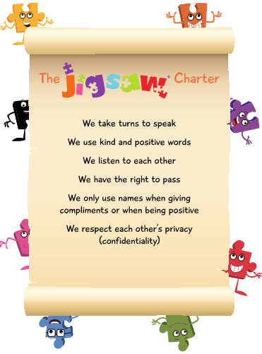

Weekly Celebrations

Week 1: Accept that everyone is different

Week 2: Include others when working and playing.

Week 3: Know how to help when someone is being bullied.

Week 4: Try to solve problems.

Week 5: Use kind words.

Week 6: Know how to give and receive compliments.