Y3 PSHE Jigsaw Knowledge Organiser Changing Me

**Puzzle Outcomes**

* To understand that in animals and humans lots of changes happen between conception and growing up, and that usually it is the female who has the baby.
* To express how I feel when I see babies or baby animals.
* To understand how babies grow and develop in the mother’s uterus and understand what a baby needs to live and grow.
* To express how I might feel if I had a new baby in my family.
* To understand that boys’ and girls’ bodies need to change so that when they grow up their bodies can make babies.
* To identify how boys’ and girls’ bodies change on the outside during this growing up process.
* To recognise how I feel about these changes happening to me and know how to cope with those feelings.
* To identify how boys’ and girls’ bodies change on the inside during the growing up process and why these changes are necessary so that their bodies can make babies when they grow up.
* To recognise how I feel about these changes happening to me and how to cope with these feelings.
* To start to recognise stereotypical ideas I might have about parenting and family roles.
* To express how I feel when my ideas are challenged and be willing to change my ideas sometimes.
* To identify what I am looking forward to when I move to my next class.
* To start to think about changes I will make next year and know how to go about this.

Our Values of the term: Happiness and Courage

Changing Me at Haydon Wick Primary School

As good citizens of Haydon Wick Primary School, we know that it is important to learn about our bodies and how they change as we grow up. We recognise that we should value our amazing bodies and feel good about ourselves.

Key Vocabulary

|  |  |
| --- | --- |
| Birth | The act of bringing a new baby or baby animal into the world. |
| Womb | The part inside a woman’s body where a baby grows before it is born. |
| Uterus | The part inside a woman’s body where a baby grows before it is born. |
| Ovaries | The organ in a female animal that produces eggs and certain hormones. |
| Vagina | The inside passageway to the cervix and uterus. |
| Puberty | The process of physical changes through which a child's body matures into an adult body capable of sexual reproduction. |
| Penis | The male sexual organ. |
| Testicles | The two sex glands between a man’s legs that produce sperm. |
| Sperm | The male reproductive cells. |

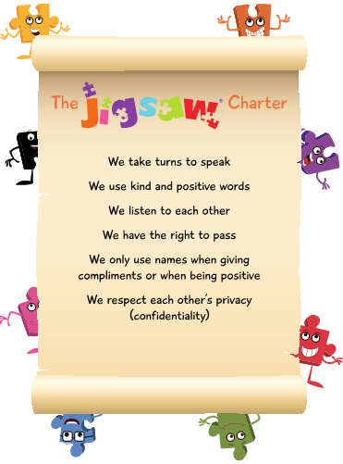

Weekly Celebrations

Week 1- Understand that everyone is unique and special.

Week 2 – Can express how they feel when change happens.

Week 3 – Understand and respect the changes that they see in themselves

Week 4 – Understand and respect the changes that they see in other people.

Week 5 – Know who to ask for help if they are worried about change.

Week 6 – Are looking forward to change.