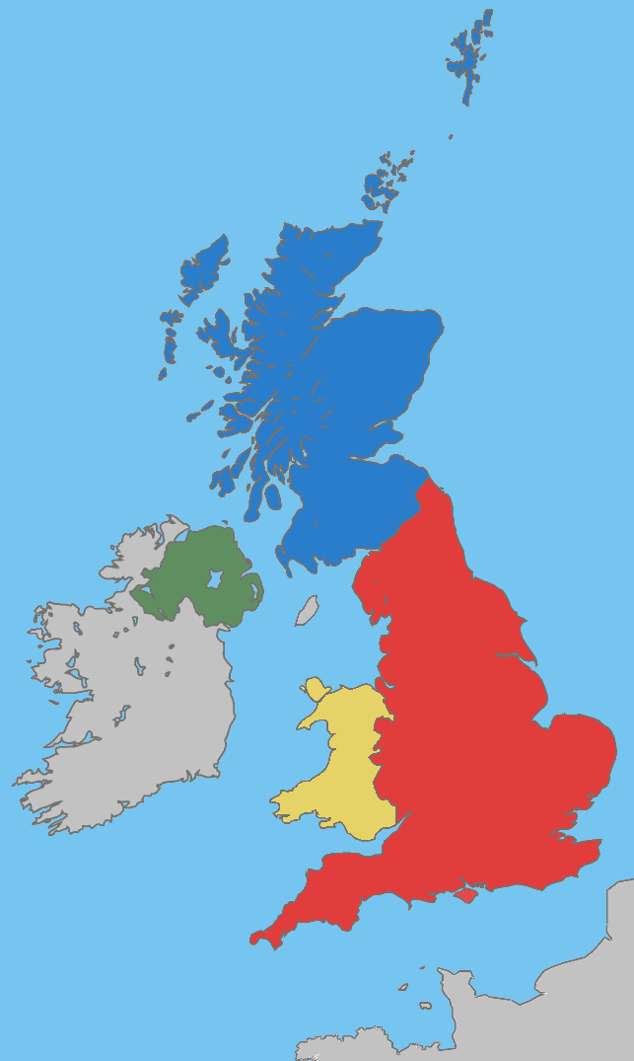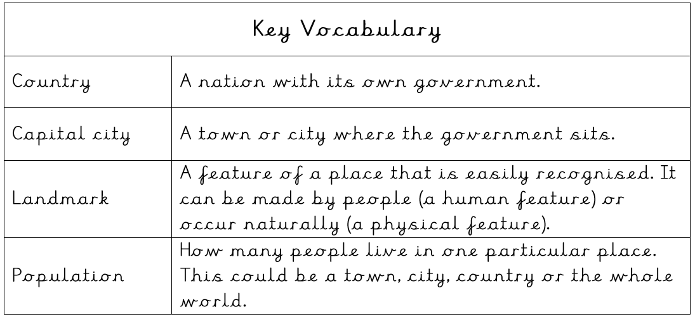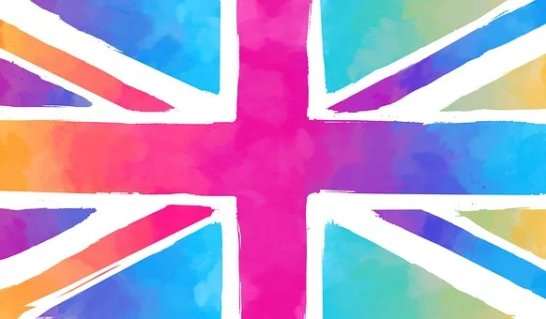

**Scotland**

A country in the North of the UK. Edinburgh is the capital city. Scotland has large mountains including Ben Nevis, which is the largest in the UK.

**Northern Ireland**

The smallest country in the UK. Belfast is the capital city. One of the most famous landmarks is Giant’s Causeway.

**Wales**

The most mountainous country in the UK. Cardiff is the capital city. Wales has its own language – Welsh.

**England**

The largest country in the UK. London is the capital city. Many parts of England are flat but there is also lots of rural countryside with rolling hills and valleys in the north.

**Geography Knowledge Organiser**

**Term 2 - Frogs Class**

**Our Country**