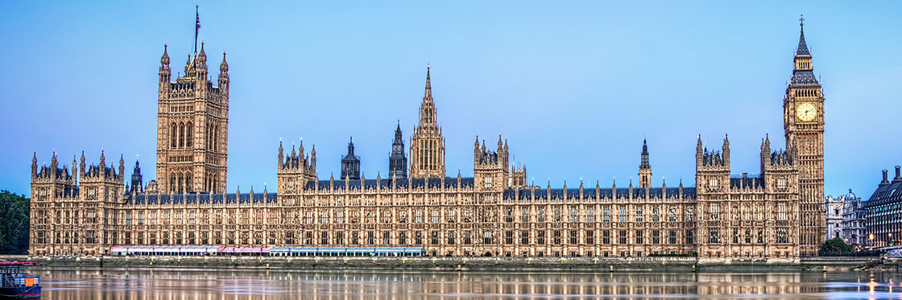

**Remember, remember…**

Remember, remember,

The 5th of November,

Gunpowder, treason and plot,

I see no reason,

Why gunpowder treason,

Should ever be forgot.

**The Houses of Parliament**

**Key vocabulary**

**Key events**

**Key people**

**History Knowledge Organiser**

**Term 2 - Frogs Class**

**The Gunpowder Plot**