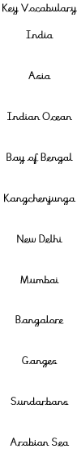
Human Geography
The area that is now India was ruled for several hundred years by powerful local empires. In its more-modern history, it was a part of the British Empire. Throughout the 20th Century, India became an independent nation.
Population | 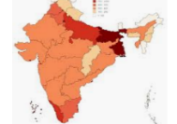 | With around 1.35 billion people, India is the 2nd most popular country in the world.
Settlements | 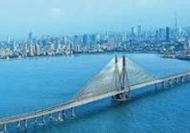 | The capital city of India in New Delhi. New Delhi is apart of the wider city of Delhi, containing 11 million people. However, it is not the most popular city in India, as Mumbai has around 12.4 million people. The most popular city is Bangalore, with 8.4 million people.
Economic Activity | 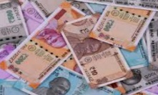 | The  Indian Rupee is the national currency of India. India is a land of great disparity, with some of the richest people in the world, but also millions of people living in poverty. India has the world’s 5th largest economy.
Resources/Trade | 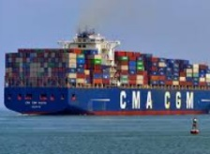 | India’s biggest exports include petroleum, gems and jewellery, pharmaceutical products, transport equipment, machinery and instruments, ready-made garments, metals, electronics, rubber/glass and products, cotton, yarn and fabrics.
Knowledge Organiser – India
Overview
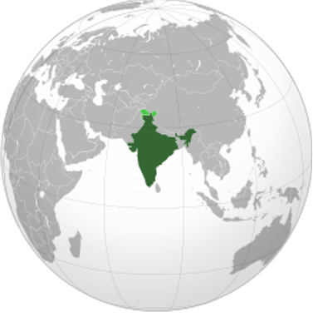
- India is a country in south Asia.
- It shares borders with Pakistan, China, Nepal,
Bhutan, Bangladesh and Myanmar.
- India has coastlines on the Indian Ocean (south),
the Arabian Sea (south – west) and the Bay
Bengal (south – east).
- India also includes several islands in the Indian
Ocean.
- With an area of 3,287,263km², India is the 7th
largest country in the world.
- About 1.35 billion (1,350 million) people live in
India. It is the 2nd most populated country in
the world, after China. It is thought that the
population of India will soon overtake that of China.

Comparison with the UK
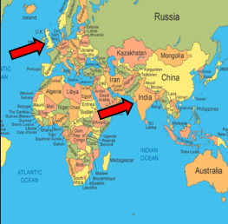
- The UK is in Europe, whilst India is in Asia. The UK and
India are both in the northern hemisphere.
- The UK has a temperate climate, whilst India’s climate is
varied, with many different biomes and climates.
- India is larger than the UK – 3,287,673sq km compared to
243,610sq km.
- Far many people live in India than the UK – 1.35 billion
people compared to 66 million in the UK.
- Delhi and Mumbai are both more poplar than the largest
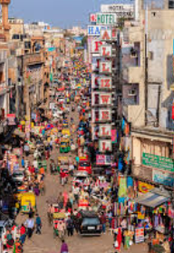
city in the UK: London.
- The UK is an island country, whilst India is on the Asian continent.
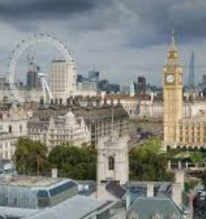

Physical Geography
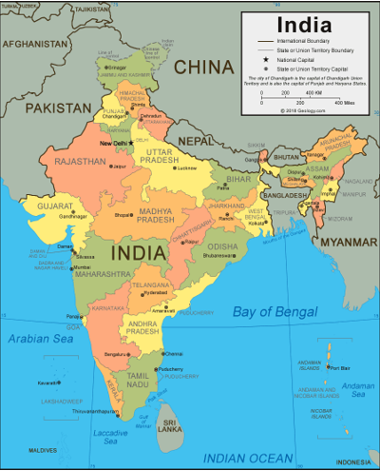
- India is bordered to the north by the Himalayan
mountains – the highest mountain range in the world.
- The highest mountain in India is Kangchenjunga, the
third highest mountain in the world at 8,586m.
The peak of the mountain lies directly on the border
between India and Nepal.
- The Ganges is the longest river that flows through
India, at 2,601km.
- The climate of India varies from place-to-place, with
- arid desert
climates in the west, temperate areas in the north and tropical and
sub-tropical regions in the south.
