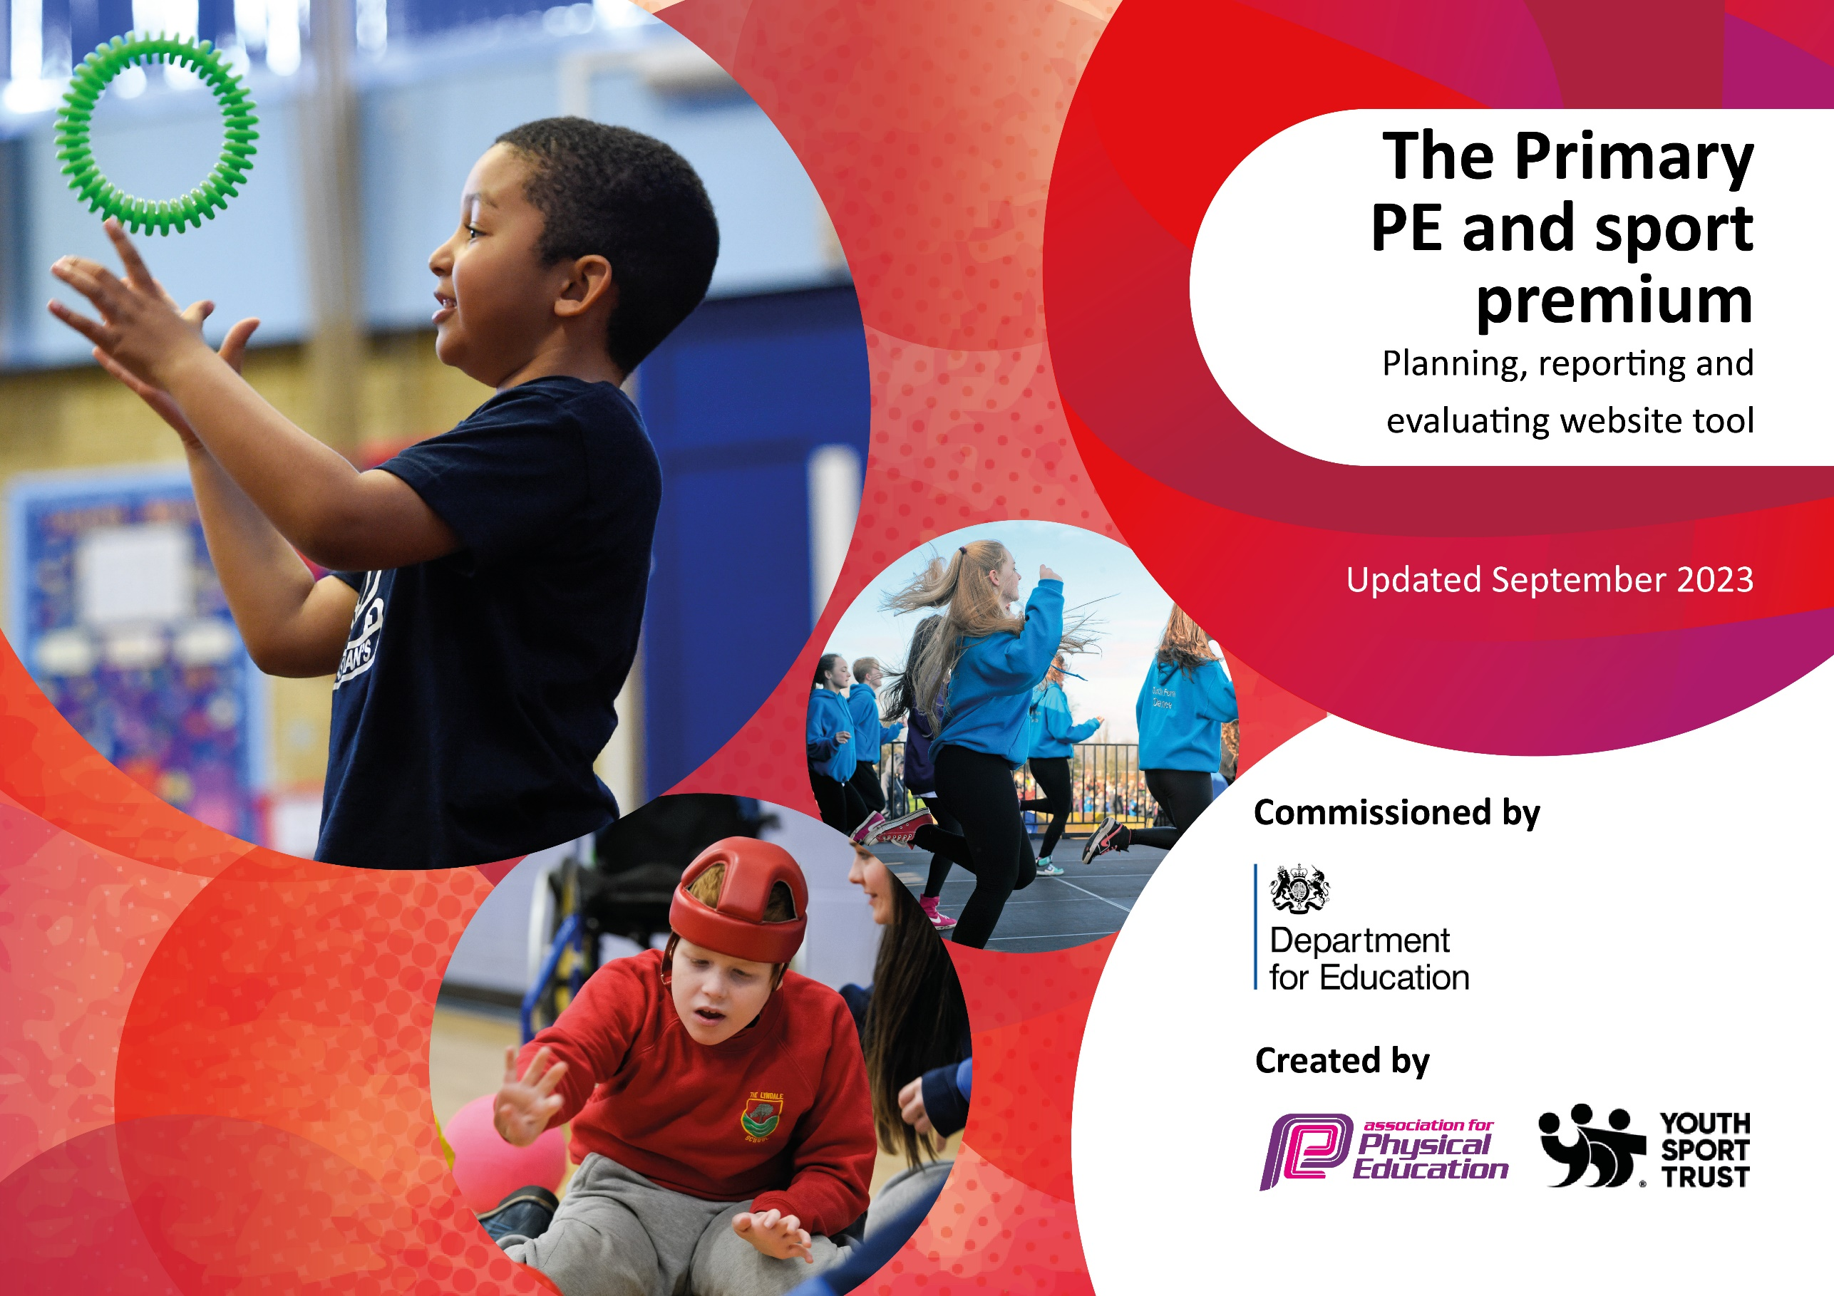

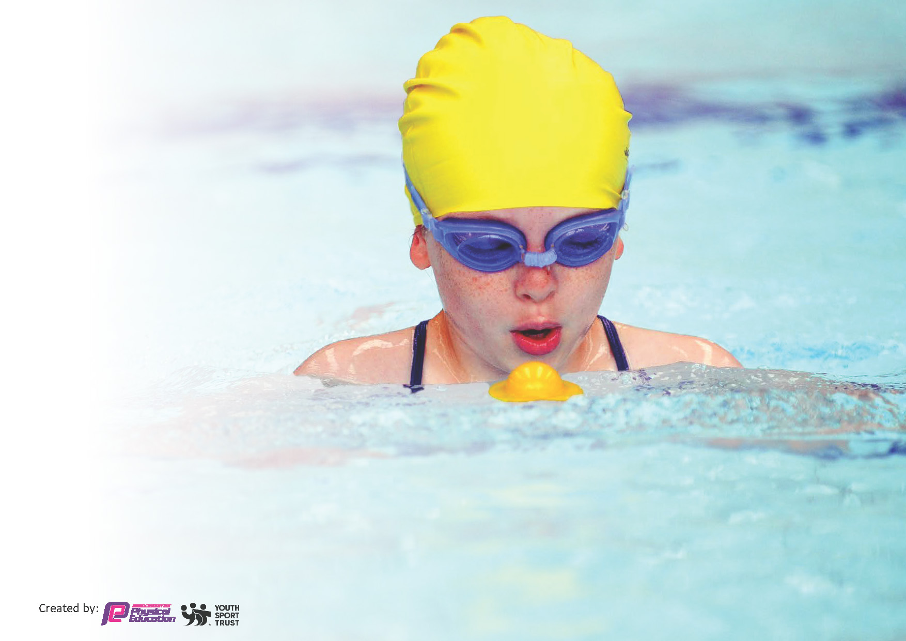
This template can be used for multiple purposes:
by:
- It enables schools to effectively plan their use of the Primary PE and sport premium
- It helps schools to meet the requirements (as set out in guidance) to publish information on their Primary PE and sport premium
- It will be an effective document to support Ofsted inspections enabling schools to evidence progress in Physical Education (PE) and evidence swimming attainment, which forms part of the PE National Curriculum. We would recommend schools consider
the Intent, Implementation and Impact of any spend, as examined within the Education Inspection Framework.

It is important that your grant is used effectively and based on school need.

Schools must use the funding to make additional and sustainable
improvements to the quality of the PE, School Sport and Physical Activity (PESSPA)
they offer. This means that you should use the Primary PE and sport premium to:

- Build capacity and capability within the school to ensure that improvements made now will benefit pupils joining the school in future years
- Develop or add to the PESSPA activities that your school already offers.

The Primary PE and sport premium should not be used to fund capital spend projects; the school’s core budget should fund these. Further detail on capital expenditure can be found in the updated Primary PE and sport premium guidance.

The Primary PE and sport premium guidance, outlines 5 key priorities that funding should be used towards. It is not

necessary that spending has to meet all the key priorities, you should select the priorities that you aim to use any funding towards.

Although completing this template is not a requirement for schools, schools are required to publish details of how they spend this funding. Schools must also outline what the impact this funding has had on pupils’ PE and sport participation and attainment and how any spending will be sustainable in the future. All funding must be spent by 31st July 2025.

The Department for Education has worked closely with the Association for Physical Education (afPE) and the Youth Sport Trust (YST) to develop this template and encourages schools to use it. This template is an effective way of meeting the reporting requirements of the Primary PE and sport premium.
Review of last year’s spend and key achievements (2023/2024)

We recommend you start by reflecting on the impact of current provision and reviewing your previous spend.

Activity/Action | Impact | Comments
Participate in the Daily Mile for four days a week.  Daily after school clubs to ran by Premier Sport.  Every break and lunch, children have access to the equipment that has been fixed or ordered.  PE lead to continude to drop in to lessons and gather pupil voice. Give support and feedback, if needed.  Children tried new sports they might not do in their PE lessons. This happened during sports week.  Whole school: Big Top Days came into school to allow the whole school to experience the circus tent and skills.  Whole school climbing wall and caving experience for KS2  PP and SEN children to work together with team building opportunities. H5 came in to deliver this. | Children do the daily mile when the teacher sees fit. This allows the children to concentrate when in their lessons.  Every child in the school has been offered an after-school club. This has allowed all children to experience knew sports.  Basketballs, skipping ropes, floor basketballs and mini goals have been used for all children to play with at lunch times.  Teachers sent videos of PE outcomes to PE lead as part of monitoring.  Children experienced sports including skateboarding, golf and hockey in Sports Week and completed a Healthy Lifestyle project.  Children enjoyed a circus workshop and had the opportunity to try out circus skills.  Children loved the opportunity to participate in a caving experience.  PP/SEN children enjoyed the teambuilding experience by H5 within school. | Paid clubs have also been offered to children and we subsidised PP children so they could join.  Bookings need to be made for the next Sports Week.

Key priorities and Planning
This planning template will allow schools to accurately plan their spending.

Action – what are you planning to do | Who does this action impact? | Key indicator to meet | Impacts and how sustainability will be achieved? | Cost linked to the action
Premier Sport to deliver 4 after school clubs and 2 Fun fitness sessions a week.  Swindon Town Football Club to deliver 2 lunchtime clubs a week. | Allows all pupils to participate  In clubs, which are paid for by  the school.  To support children and  enhance their skills in a smaller PE session.  Encourages children to participate in a sport with their friends. To allow the children to learn new skills from a professional. | Key indicator 2 -The engagement of all pupils in regular physical activity – the Chief Medical Officer guidelines recommend that all children and young people aged 5 to 18 engage in at least 60 minutes of physical activity per day, of which 30 minutes should be in school.  Key indicator 4: Broader experience of a range of sports and activities offered to all pupils.  Key indicator 2 and 4 | More pupils meeting their daily physical activity goal, more pupils encouraged to take part in PE and Sport Activities.  All year groups to take part in a sport during lunch time. More pupils encouraged to take part in PE and sports. | £10,060 for the whole academic year.  £3,040 for the whole academic year,

Continue with GETSET4PE to guide new staff and allow CPD sessions off the website.  To replenish and order new PE equipment.  To continue with Sports Week and to get companies in to deliver a variety of different sports.  In-house competitions  House captain projects. | Guides and supports staff to be confident in delivering PE sessions.  To ensure all our equipment is up to date and safe for all children to use.  To open up opportunities for children to try new sports.  To bring the 4 houses together and to participate in sports against each other.  To get the house captains to work within their houses to create a sponsor or fundraising event. This will encourage children to be active. | Key Indicator 1: Increased confidence, knowledge, and skills of all staff in teaching PE and sport.  Key indicator 1,2 and 3.  Key indicator 2,3 and 4.  Key indicator 2,4 and 5  Key indicator 2 | Primary teachers more confident to deliver effective PE supporting pupils  All children have the right equipment to participate in their lessons.  Children can try new sports and take them up out of school. Opportunities to invite companies for after – school clubs.  Children to be competitive and opportunities to work as part of a team.  Children to work together and come up with ideas from a small budget. | £0  £1000  £1000  £0  £100

Key achievements 2024-2025
This template will be completed at the end of the academic year and will showcase the key achievements schools have made with their Primary PE and sport premium spending.

Activity/Action | Impact | Comments
Premier Sport to deliver 4 after school clubs and 2 Fun fitness sessions a week.  Swindon Town Football Club to deliver 2 lunchtime clubs a week.  To replenish and order new PE equipment.  To continue with Sports Week and to get companies in to deliver a variety of different sports. | Every child in the school has been offered a free school club. They have learnt many skills and this has shown throughout their PE sessions too.  Key stage 2 children have enjoyed playing with Swindon Town and we have the repour with them. The children have enjoyed learning off professionals and this has helped them in the football tournament.  Children have received new equipment which has improved and helped them in their lessons.  The children enjoyed wheelchair basketball, rugby and freestyle football. They enjoyed the new experiences. | We have booked them in for next year.  Swindon Town will be continuing with teaching the children the football skills for the children. They may also be setting up an after-school club for us.  Sports week will be booked in for next year.

Swimming Data
Meeting National Curriculum requirements for swimming and water safety.
Priority should always be given to ensuring that pupils can perform safe self-rescue even if they do not fully meet the first two requirements of the National Curriculum programme of study

Question | Stats: | Further context  Relative to local challenges
What percentage of your current Year 6 cohort can swim competently, confidently and proficiently over a distance of at least 25 metres? | 80% | This year, the pool we have used has cancelled some lessons due to staffing. Even though the children have completed their right amount of lessons, there were long gaps in between.
What percentage of your current Year 6 cohort can use a range of strokes effectively [for example, front crawl, backstroke, and breaststroke]? | 80% | This year, the pool we have used has cancelled some lessons due to staffing. Even though the children have completed their right amount of lessons, there were long gaps in between.

Signed off by:

Head Teacher: | Eleanor Rushen-Gough
Subject Leader or the individual responsible for the Primary PE and sport premium: | Billie Phillips
Governor: | Lauren Hargreaves
Date: | 16/07/25

