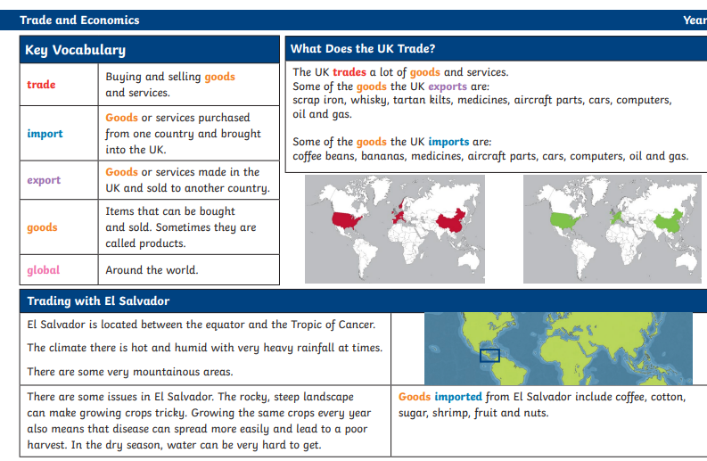

Trade and Economics – Year 5/6

Design and technology

Plan and make a three course meal taking into account the impact on the carbon footprint.

Maths and computing

* Statistics
* Data handling

Geography

In this unit, the children find out about how goods and services are traded around the world. They will explore the UK's trade links today and in the past, finding out about goods imported and exported and the methods of transport used. Through a more detailed look at one of the UK's trade partners, the children will learn about the benefits of trading internationally, as well as the risks to this area. The children will also learn about fair trade and why it is important in a global market.

English

* Persuasive leaflets
* Non chronological reports
* narrative