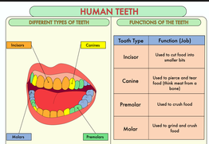
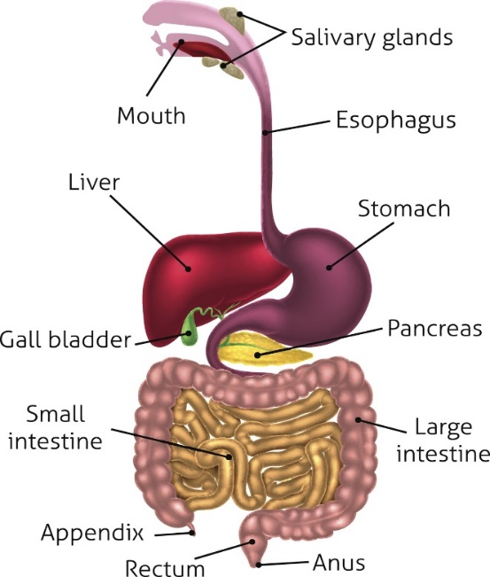
Knowledge Organiser: Science – ANIMALS, INCLUDING HUMANS.
Scientific vocabulary:
Challenge
Enamel - the hard glossy material that covers the tooth
Oesophagus - a long, muscular tube that connects your mouth to your stomach
Stomach - the pouch into which food passes from the oesophagus for mixing and digestion before passing to the small intestine
Small intestine – its job is to absorb most of the nutrients from what we eat and drink
Large intestine – its job is to absorb water.
Rectum - the outermost portion of the large intestine.
Anus - the opening where your bowel movements (also known as faeces) come out.
Food chain - shows how each living thing gets food, and how nutrients and energy are passed from creature to creature
Oral Hygiene Cleaning teeth, eating the right foods, and regular visits to the dentist help to keep our teeth and gums healthy
Subject Specific
Saliva - a clear liquid secreted into the mouth by the salivary glands and mucous glands of the mouth.
Digestion system - parts of the body that work together to turn food and liquids into the building blocks and fuel that the body needs.
Digestion – the process of digesting food.
Faeces – body waste that comes out of the anus
Incisor - a narrow-edged tooth at the front of the mouth, adapted for cutting
Canine - a pointed tooth between the incisors and premolars used to pierce and tear food
Molar - a grinding tooth at the back of a mammal's mouth.
Premolars - teeth used to crush food
Herbivore - an animal that feeds on just plants
Carnivore – an animal that feeds on meat
Omnivore – an animal that eats plants and meat
Producer – plants that make their own food
Predator – animals that eat other animals
Consumer – animals that eat plants and other animals
Prey – animals eaten by other animals

Scientific knowledge
Food enters the body through the mouth. Digestion starts when the teeth start to break down the food. Saliva is added and the tongue rolls the food into a ball. The food is swallowed and passes through the oesophagus to the stomach.

Here the food is broken down further by being churned around and other chemicals are added. The food passes into the small intestine. Here nutrients are removed from the food and leave the digestive system to be used elsewhere in the body. The rest of the food then passes into the large intestine. Here the water is removed for use elsewhere in the body. What is left is then stored in the rectum until it leaves the body through the anus when you go to the toilet.

Human teeth.

Tooth Decay:
Poor Oral Hygiene, not brushing your teeth regularly, allows plaque to build up and attack the tooth enamel.
Plaque is caused when bacteria, acid, food particles, and saliva all combine in your mouth.

BRUSH YOUR TEETH TWICE A DAY!

Key objectives:

- describe the simple functions of the basic parts of the digestive system in humans

- identify the different types of teeth in humans and their simple functions

- construct and interpret a variety of food chains, identifying producers, predators and prey.

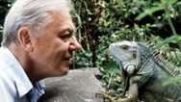
Homework challenges:

Develop a guide to teeth brushing
Create your own food chain using research to help you
Record the teeth in your mouth (make a dental record)

Famous people/jobs:

Sir David Frederick Attenborough is an English broadcaster who studies animals and plant life, presenting a range of BBC programs such as Planet Earth.

Scientific knowledge
Construct and interpret a variety of food chains, identifying producers, predators and prey.

