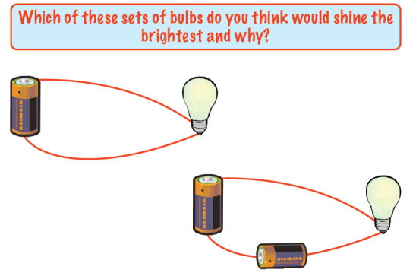
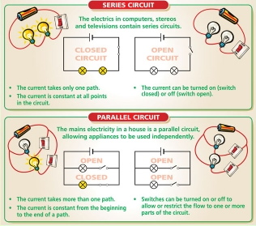
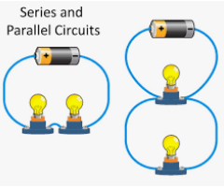
Knowledge Organiser: Science – Electricity
Scientific vocabulary:

Challenge vocabulary:
Series Circuit –A single pathway for the electricity to flow through
Components – Parts of the circuit such as a bulb, battery, buzzer
Parallel Circuit –One that has two or more pathways for the electricity to flow,
Circuit - A complete pathway for electricity to flow through
Circuit diagram –A drawing that represents the electrical circuit
Voltage – It is the 'push' that causes electricity to move in a wire
Amps– Measures the flow of electricity
Current – The flow of electricity
Conductor – Something that electricity can flow through.
Insulator – Something electricity can’t flow through.

Subject Specific vocabulary:
Cell – Another name for a battery
Electricity A type of energy that can build up in one place or flow from one place to another.
Motor – A machine that spins when electricity flows through it.
Switch – Can stop or start the flow of electricity.
Buzzer – Makes a buzzing sound when electricity flows through it.
Bulb - Lights up when electricity flows through it

Key objectives:

Associate the brightness of a bulb or the volume of a buzzer with the number and voltage of cells used in the circuit

Compare and give reasons for variations in how components function, including the brightness of bulbs, the loudness of buzzers and the on/off position of switches

Use recognised symbols when representing a simple circuit in a diagram.

Scientific knowledge:

Associate the brightness of a bulb or the volume of a buzzer with the number and voltage of cells used in the circuit.

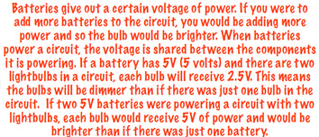

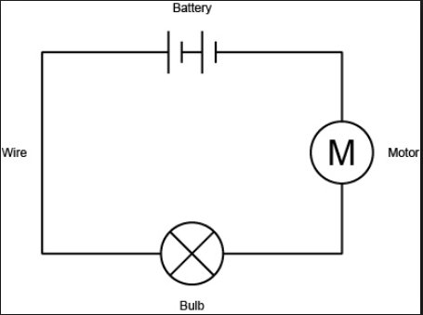
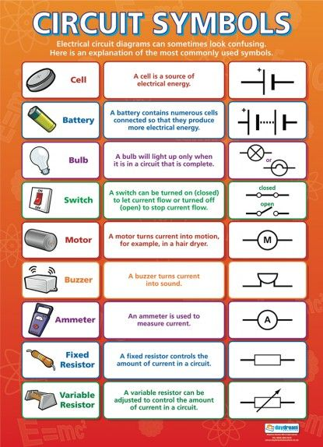
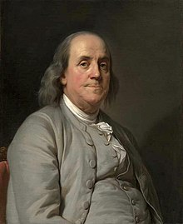
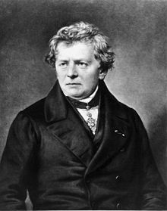
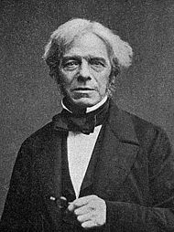
Scientific knowledge:

Use recognised symbols when representing a simple circuit in a diagram.

Famous people/jobs

Electricity is a form of energy and it occurs in nature, so it was not “invented.” As to who discovered it, many misconceptions abound. Some give credit to Benjamin Franklin for discovering electricity, but his experiments only helped establish the connection between lightning and electricity, nothing more.

Michael Faraday invented the
electric motor in 1821,
and Georg Ohm mathematically
analysed the
electrical circuit in 1827

Homework challenges:

I can explore and describe the components of a torch.
I can label a circuit diagram using symbols.
I can create an online circuit diagram using http://www.cleo.net.uk/consultants_resources/science/circuitWorld/circuitworld.html

