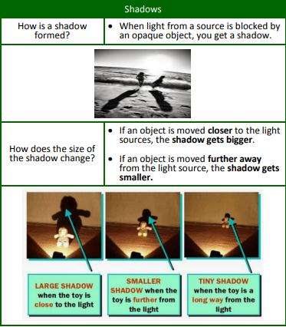
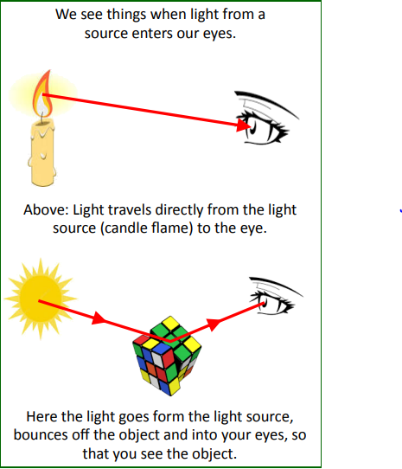
Knowledge Organiser: Science –Light
Scientific vocabulary:

Challenge Vocabulary
Light source - Something that makes
its own light.
Opaque An object you are not able to see through.
Transparent –light can pass through so that objects behind can be clearly seen.
Translucent – Allows some light through but not all of it so objects can’t be seen clearly on the other side.
Angle of incidence – The angle where the light ray hits the surface.
Angle of reflection – The angle at which the light ray bounces off the surface.

Subject specific Vocabulary
Reflection When light bounces of a surface.
Shadow - An area of darkness, caused by light being blocked by something.
Reflection - The throwing back of light, after bouncing off an object.
Shiny – reflecting light, typically because very clean or polished.
Matt - Dull and flat surface; without a shine.

Other words:
Mirror, sunlight, straight, dangerous, light, darkness.
Key objectives:
- Recognise that light appears to travel in straight lines
- Use the idea that light travels in straight lines to explain that objects are seen because they give out or reflect light into the eye
- Explain that we see things because light travels from light sources to our eyes or from light sources to objects and then to our eyes
- Use the idea that light travels in straight lines to explain why shadows have the same shape as the objects that cast them.
Scientific knowledge:

Things you need to know about light
• Light travels in straight lines
• Light travels very, very fast - 186,282 miles per second. (that’s like travelling around the world over 7 times in a second)
• If something gets in the way of light, a shadow is formed.

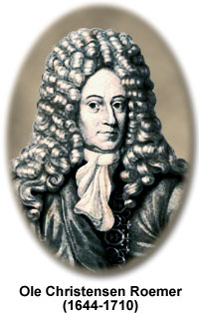
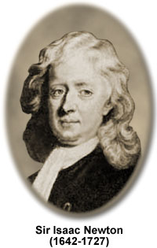
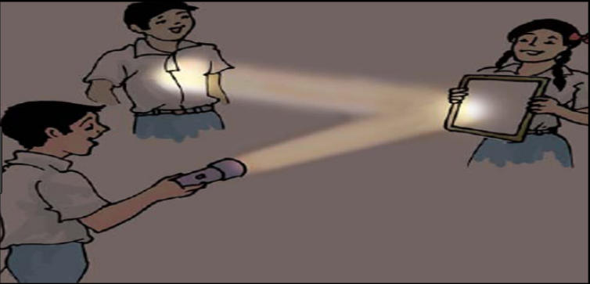
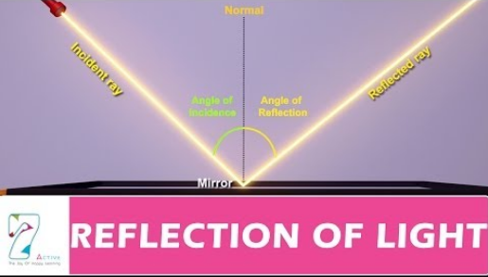

Homework challenges:

I can experiment to find out how the length of shadows can change with the seasons. (Caused by the earth’s tilt).
I can create a shadow puppet theatre with size of shadow changes for bigger characters.
Famous people/jobs:

Sir Isaac Newton: He conducted several experiments to understand light and how
light is composed of several wavelengths. In his book, Newton described how he
used prisms to disassemble and reassemble light.

Olaus Roemer: It was the Danish astronomer, Olaus Roemer, who, in 1676, first
Successfully measured the speed of light. His method was based on observations
of the eclipses of the moons of Jupiter.
Scientific knowledge:

We can change the direction of the
light beam by using mirrors

