Knowledge Organiser: Science – Healthy Eating, Exercise and Hygiene YEAR 2: Autumn 2
Scientific knowledge:

Diet and Exercise
The common food types are:
(fruits, vegetables, carbohydrates, fats and sugars, protein, dairy).

Typical food types for each group are:
Fruits- apples, banana, oranges.
Vegetables- carrots, broccoli, peas.
Carbohydrates- pasta, bread, rice.
Protein- meat, fish, eggs and nuts.
Dairy- milk, cheese and yogurt.
Fats and sugars- sweets, chocolate, cake, ice-cream and biscuits.
Our bodies ned foods from all of the food groups above to remain healthy.
It is important that we eat the right amount of foods from each group.( The diagram overleaf shows the proportions of each food necessary to make a healthy balanced diet).
Our bodies need at least five different types of fruits and vegetables each day. Fruits and vegetables contain many vitamins and minerals.

Some foods we eat are ‘composite foods’ containing foods from different types of food groups.

Foods contain calories and our body needs calories to give us energy. The calories we eat but don’t use up are stored in our body as fat.

Exercise is important to keep our bodies healthy.

Exercising our body uses up extra calories.
Hygiene

It is important to keep our bodies clean and to wash our hands regularly, especially after every visit to the toilet.

It is important to maintain good hygiene when handling food.
I understand that we can’t see germs but they are all around us.

I know that some germs can make us ill.

Key objectives:

Describe the importance for humans of:
- exercise.
- eating the right amounts of different food types,
- hygiene.

Scientific vocabulary:
Basic
Fruit—a food group including, bananas, apples grapes and oranges.
Vegetable- a food group including, carrots, broccoli, cabbage and sprouts.
Sugar- a food group containing added sugar and sugar naturally present in different foods such as fruit sugars.

Subject Specific
Dairy –a food group including, milk, cheese, cream, yoghurt.
Protein- a food group including, meat, nuts, eggs and fish.
Carbohydrate- a food group including bread, rice, pasta
Fats- a food group including, cooking oils, animal fat and butter.
Vegetarian—a person who chooses to eat only vegetables.

Challenge
Energy balance- The energy we use up is equal to the energy we get from our food and drink.
Calorie- a unit of energy
Hygiene- keeping our bodies clean
Composite foods-__ foods containing more than one food group.

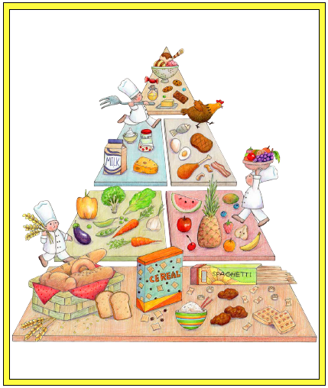
Food Groups
Homework challenges:
Keep a food diary for a few days. Identify the food groups you are eating.
Plan a healthy packed lunch.
Exercise every day.

Famous people/jobs:
Chef—Jamie Oliver
Exercise— sports personalities, athletes

Carbohydrates
Vegetables
Fruits
Proteins
Dairy
Fats and Sugars

