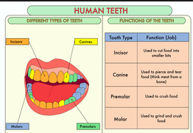[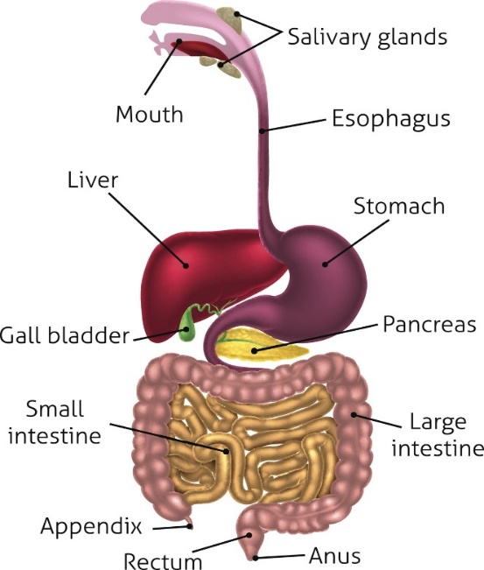](https://www.google.co.uk/url?sa=i&rct=j&q=&esrc=s&source=images&cd=&cad=rja&uact=8&ved=2ahUKEwi68vC5w_feAhWlB8AKHQzoBUcQjRx6BAgBEAU&url=https://bodytomy.com/digestive-system-function&psig=AOvVaw1rM4Cy0lAokUxqLOn7EqsV&ust=1543509573205648)Knowledge Organiser: **Science – ANIMALS, INCLUDING HUMANS.**

**Scientific vocabulary:**

**Challenge**

**Enamel - the** hard glossy material that covers the tooth

**Oesophagus** - *a long, muscular tube that connects your mouth to your stomach*

**Stomach** - *the pouch into which food passes from the oesophagus for mixing and digestion before passing to the small intestine*

**Small intestine** – *its job is to absorb most of the nutrients from what we eat and drink*

**Large intestine** – *its job is to absorb water*.

Rectum - *the outermost portion of the large intestine.*

**Anus** - the opening where your bowel movements (also known as faeces) come out.

**Food chain** - *shows how each living thing gets food, and how nutrients and energy are passed from creature to creature*

**Oral Hygiene** Cleaning teeth, eating the right foods, and regular visits to the dentist help to keep our teeth and gums healthy

**Subject Specific**

**Saliva** - a clear liquid secreted into the mouth by the salivary glands and mucous glands of the mouth.

**Digestion system** - *parts of the body that work together to turn food and liquids into the building blocks and fuel that the body needs.*

**Digestion** – *the process of digesting food.*

Faeces *– body waste that comes out of the anus*

**Incisor** - *a narrow-edged tooth at the front of the mouth, adapted for cutting*

**Canine** - *a pointed tooth between the incisors and premolars used to pierce and tear food*

**Molar** - *a grinding tooth at the back of a mammal's mouth.*

**Premolars** - *teeth used to crush food*

**Herbivore** - *an animal that feeds on just plants*

**Carnivore** – *an animal that feeds on meat*

**Omnivore** – *an animal that eats plants and meat*

**Producer** – *plants that make their own food*

**Predator** – *animals that eat other animals*

**Consumer** – *animals that eat plants and other animals*

**Prey** – *animals eaten by other animals*

**Scientific knowledge**

Food enters the body through the mouth. Digestion starts when the teeth start to break down the food. Saliva is added and the tongue rolls the food into a ball. The food is swallowed and passes through the oesophagus to the stomach.

Here the food is broken down further by being churned around and other chemicals are added. The food passes into the small intestine. Here nutrients are removed from the food and leave the digestive system to be used elsewhere in the body. The rest of the food then passes into the large intestine. Here the water is removed for use elsewhere in the body. What is left is then stored in the rectum until it leaves the body through the anus when you go to the toilet.

**Human teeth.**

**Tooth Decay:**

Poor Oral Hygiene, not brushing your teeth regularly, allows plaque to build up and attack the tooth enamel.

Plaque is caused when bacteria, acid, food particles, and saliva all combine in your mouth.

**BRUSH YOUR TEETH TWICE A DAY!**

**Key objectives:**

* *describe the simple functions of the basic parts of the digestive system in humans*
* *identify the different types of teeth in humans and their simple functions*
* *construct and interpret a variety of food chains, identifying producers, predators and prey.*

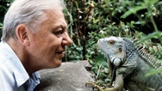

**Homework challenges:**

*Develop a guide to teeth brushing*

*Create your own food chain using research to help you*

*Record the teeth in your mouth (make a dental record)*

**Famous people/jobs:**

**Sir David Frederick Attenborough** is an English [broadcaster](https://en.wikipedia.org/wiki/Broadcasting) who studies animals and plant life, presenting a range of BBC programs such as [Planet Earth](https://www.bbc.co.uk/programmes/b006mywy).

**Scientific knowledge**

Construct and interpret a variety of food chains, identifying **producers, predators and prey**.

