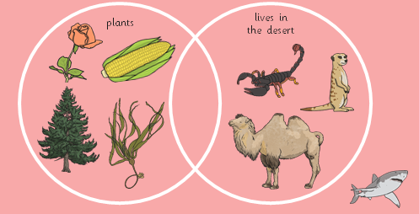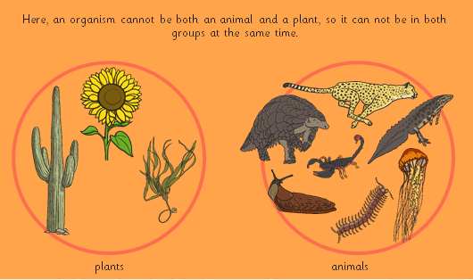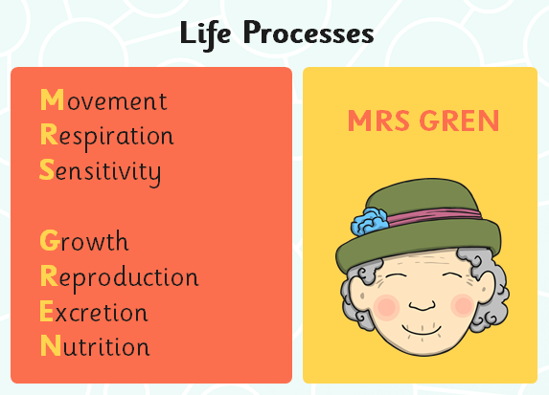Knowledge Organiser: **Science – Living things and their habitats**

**Scientific vocabulary:**

**Challenge**

**Segmented** – divided into sections

**Classification** - *the arrangement of animals and plants in taxonomic groups according to their observed similarities*

**Human Impact** – *the impact on the environment directly or indirectly by humans, including global warming, mass extinction and biodiversity loss*

**Migrate** – *when an animal moves from one region or habitat to another according to the seasons.*

**Extinction** – *types of animals having no living members*

**Subject Specific**

**Pincers –** claws of a crab

**Classification key** - *a set of questions about the characteristics of living things.*

1. **Environment -** *the surroundings or conditions in which a person, animal, or plant lives or operates.*

**Habitat -** *the natural home or environment of an animal, plant, or other organism.*

**Vertebrates -** animals that have a backbone or spinal column

**Invertebrates –** animals without a backbone or skeleton

**Basic**

Living things

Grouping

Plants

**Key objectives:**

* *recognise that living things can be grouped in a variety of ways*
* *explore and use classification keys to help group, identify and name a variety of living things in their local and wider environment*
* *recognise that environments can change and that this can sometimes pose dangers to living things*

**Scientific knowledge**

Recognise that living things can be grouped in a variety of ways.

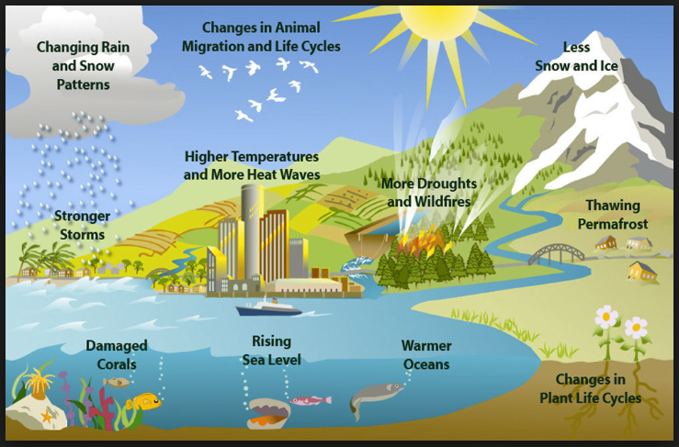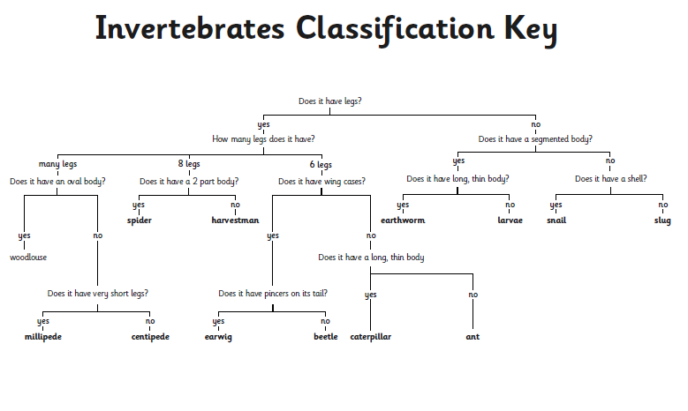

**Famous people/jobs:**

Environmental Health Officer: *They are responsible for investigating incidents that affect health such as pollution, accidents at work, noise control, toxic contamination, pest infestations, food poisoning and waste management. They work with government agencies, individuals, businesses and specialists. A large amount of time is spent away from the office visiting properties such as farms, shops, food outlets, private/public accommodation, commercial premises, manufacturers and industrial organisations.*

**Scientific knowledge**

Explore and use classification keys to help group, identify and name a variety of living things in their local and wider environment

Recognise that environments can change and that this can sometimes pose dangers to living things

**Useful websites for further reading:**

<https://www.bbc.com/bitesize/articles/z9cbcwx>

<https://www.bbc.com/bitesize/topics/zbnnb9q>

**Homework challenges:**

*Create a guide of how to protect the environment*

*Organise a litter pick to keep our environment clean and tidy*

*Grow a plant of your choice and observe the changes over time by writing a diary/taking pictures or create a graph.*