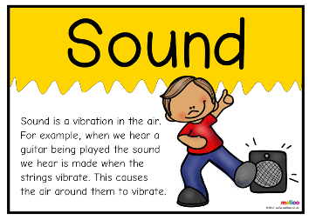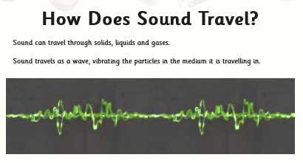Knowledge Organiser: **Science – Sound**

**Scientific vocabulary:**

**Challenge**

**Sound -** *vibrations that travel through the air or another medium and can be heard when they reach a person's or animal's ear.*

1. **Source -** *a place, person, or thing from which something originates*

**Travel -** *move, typically in a constant or predictable way.*

**Pitch (high, low) -** *the quality of a sound governed by the rate of vibrations producing it; the degree of highness or lowness of a tone.*

1. **Subject Specific**
2. **Vibrate -** *move continuously and rapidly to and fro.*

**Vibration -** *an instance of vibrating.*

**Basic**

Loud, quiet, soft, hard, volume, faint sounds, block

**Key objectives:**

* *identify how sounds are made, associating some of them with something vibrating*
* *recognise that vibrations from sounds travel through a medium to the ear*
* *find patterns between the pitch of a sound and features of the object that produced it*
* *find patterns between the volume of a sound and the strength of the vibrations that produced it*
* *recognise that sounds get fainter as the distance from the sound source increases.*

**Scientific knowledge**

**Sounds and vibrations**

Sound can travel through solids, liquids and gases. Sound travels as a wave, vibrating the particles as it is travelling.

A sound source produces vibrations which travel through a medium from the source to our ears. Solids, liquids and gases can carry sound but sound cannot travel through a vacuum (an area empty of matter). The vibrations cause parts of our body inside our ears to vibrate, allowing us to hear (sense) the sound.

The loudness (volume) of the sound depends on the strength (size) of vibrations which decreases as they travel through the medium. Therefore, sounds decrease in volume as you move away from the source. A sound insulator is a material which blocks sound effectively.

Pitch is the highness or lowness of a sound and is affected by features of objects producing the sounds. For example, smaller objects usually produce higher pitched sounds.



[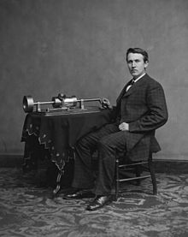](https://en.wikipedia.org/wiki/File:Edison_and_phonograph_edit1.jpg)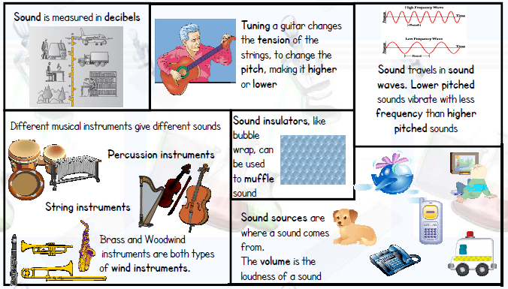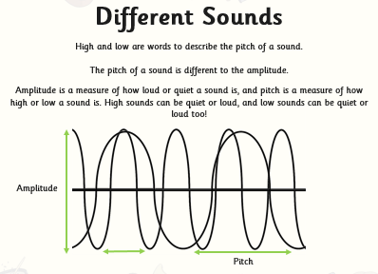

**Famous people/jobs:**

**Thomas Edison**

*"I was never so taken aback in my life--I was always afraid of things that worked the first time." (Thomas A. Edison on hearing his voice play back to him from his first tin foil phonograph.)* Thomas Edison invented the phonograph (also known as a gramophone) in 1877. While other inventors had produced devices that could record sounds, Edison's phonograph was the first to be able to reproduce the recorded sound.

**Useful websites for further reading:**

<https://www.bbc.com/bitesize/articles/zstr2nb>

<https://www.bbc.com/bitesize/articles/z3j3jty>

<https://www.bbc.com/bitesize/articles/zqtdpbk>

**Homework challenges:**

*Make a musical instrument using resources from home.*

*Design and make a string telephone*

**Scientific knowledge**

Find patterns between the pitch of a sound and features of the object that produced it