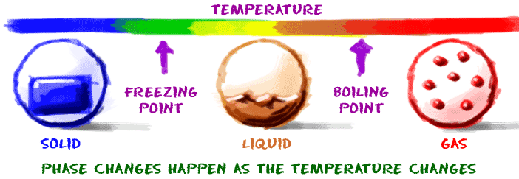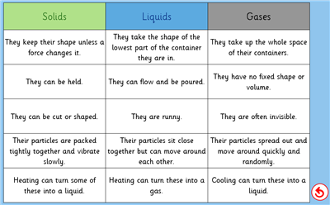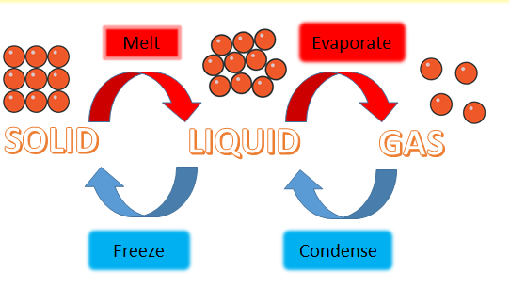Knowledge Organiser: **Science – States of Matter**

**Scientific vocabulary:**

**Challenge**

**Change of state -** Matter can change from one state to another if it is heated or cooled. If ice (a solid) is heated it changes to water (a liquid). This change is called melting. If water is heated, it changes to steam (a gas).

**Transpiration**- water carried through plants.

1. **Subject Specific**

**solid –** *something that holds its shape and has a fixed volume*

**liquid -** *A liquid fills up the shape of the bottom of a container. It forms a pool, not a pile and also has a fixed volume*

**gas** *- A gas can escape from an unsealed container. It fills up the space it is in, and does not have a fixed volume*

**matter** *- Objects that take up space and have mass are called matter. Everything around you is made up of matter*

**melting –** *when a solid becomes a liquid when heated.*

**freezing –** *below 0°C and matter becomes a solid*

**melting point -** *the temperature at which a given solid will melt.*

**boiling point –** *the temperature at which water boils: 100 degrees Celsius (°C)*

**evaporation -** *changing from a liquid to a gas*

**water cycle -** *the complete journey that water makes, from one place to the other, and from one state to the other.*

**Basic.**

Temperature, liquid, gas, solid.

**Key objectives:**

* *compare and group materials together, according to whether they are solids, liquids or gases*
* *observe that some materials change state when they are heated or cooled, and measure or research the temperature at which this happens in degrees Celsius (°C)*
* *Identify the part played by evaporation and condensation in the water cycle and associate the rate of evaporation with temperature.*

**Scientific knowledge**

Compare and group materials together, according to whether they are solids, liquids or gases

Observe that some materials change state when they are heated or cooled, and measure or research the temperature at which this happens in degrees Celsius (°C)

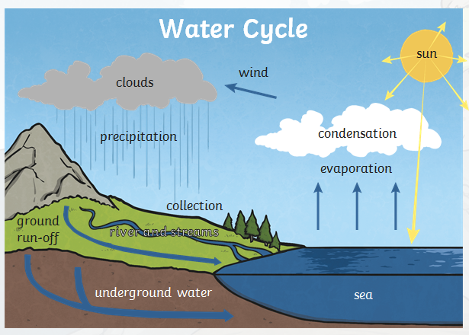

**Scientific knowledge**

Evaporation and condensation in the water cycle and associate the rate of evaporation with temperature.

Evaporation

Energy from the sun heats up the surface of the Earth, causing the temperature of the water in our rivers, lakes and oceans to rise. When this happens, some of the water “evaporates” into the air, turning into a gas called “vapour“. Plants and trees also lose water to the atmosphere through their leaves. This process is known as “transpiration“.

Condensation

As water vapour rises up high into the sky, it cools and turns back into a liquid, forming clouds. This process is called “condensation“. Currents high up in the air move these clouds around the globe.

Precipitation

When too much water has condensed, the water droplets in the clouds become too big and heavy for the air to hold them. And so they fall back down to Earth as rain, snow, hail or sleet, a process known as “precipitation“.

**Famous people/jobs:**

Famous cooks such as Jamie Oliver or Gordon Ramsay experiment with states of matter when cooking.

Meteorologist – study the weather

**Useful websites for further reading:**

<https://www.bbc.com/bitesize/articles/zsgwwxs>

<https://www.bbc.com/bitesize/articles/z9ck9qt>

<https://www.bbc.com/bitesize/articles/z3wpp39>

<https://www.bbc.com/bitesize/articles/zydxmnb>

**Homework challenges:**

*Crossword challenge.*

*Investigate how to melt ice more quickly.*

*Observe the changes when baking a cake with your family.*