Knowledge Organiser: **Science – FORCES AND MAGNETS**  **YEAR 3:** Spring 1

**Key objectives:**

* compare how things move on different surfaces
* notice that some forces need contact between two objects, but magnetic forces can act at a distance
* observe how magnets attract or repel each other and attract some materials and not others
* compare and group together a variety of everyday materials on the basis of whether they are attracted to a magnet, and identify some magnetic materials
* describe magnets as having two poles
* predict whether two magnets will attract or repel each other, depending on which poles are facing

**Scientific knowledge:**

Forces

* a force is a push or pull on an object
* a force can cause something to…
  + change speed
  + change shape
  + change direction
* when an object moves on a surface, the texture of the surface and the object affect how it moves
* it may help the object to move better e.g. ice skate on ice
* or it may hinder its movement (make it difficult) e.g. walking boot on rough ground

Click [HERE](https://www.bbc.com/bitesize/articles/zywcrdm) to watch a video clip about forces

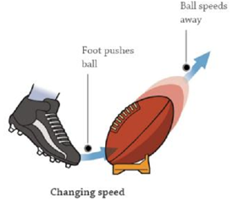

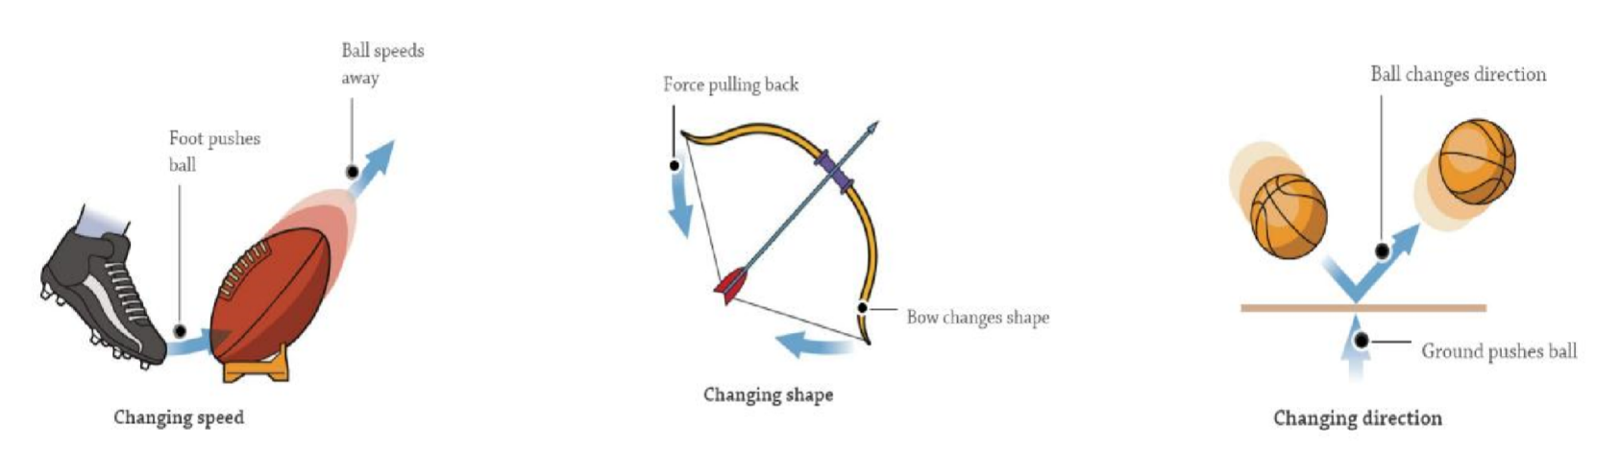

**Scientific vocabulary:**

**Challenge:**

**Contact Force –** any force that needs contact to happen e.g. a hand opening a door, the wind pushing the trees

**Non-Contact Force –** a force which acts on an object without coming into contact with it e.g. the north poles of two magnets repelling

**Magnetic Force –** a force between two magnets or between a magnet and a magnetic material

**Magnetism –** an invisible force around a magnet

**Subject Specific:**

**Attract –** apply a force on an object, causing it to approach or prevent it from moving away

**Repel –** apply aforce on an object, causing it to move back or away

**Button Magnet –** a flat, round magnet

**Horseshoe Magnet –** a u-shaped magnet

**Magnetic Material –** metals (e.g. nickel, iron, cobalt) and any materials containing these metals (e.g. steel) that are attracted to a magnet

**Non-magnetic Material –** metals e.g. copper, gold, aluminium and other materials (e.g. plastic, wood, glass and wool) that are not attracted to a magnet

**Nickel –** a silvery-white magnetic metal

**Iron –** a hard, strong, silvery-grey magnetic metal

**Cobalt –** a hard, silvery-white magnetic metal

**Steel –** a hard, strong, grey magnetic alloy (a metal made from two or more metals)

**Copper –** a red-brown, non-magnetic metal

**Gold –** a precious, yellow non-magnetic metal

**Aluminium –** a light, silvery-grey, non-magnetic metal

**North / South Pole –** either end of a magnet where the magnetism is strongest

**Basic:**

**Push, Pull, Twist, Metal, Plastic, Wood, Glass, Wool**

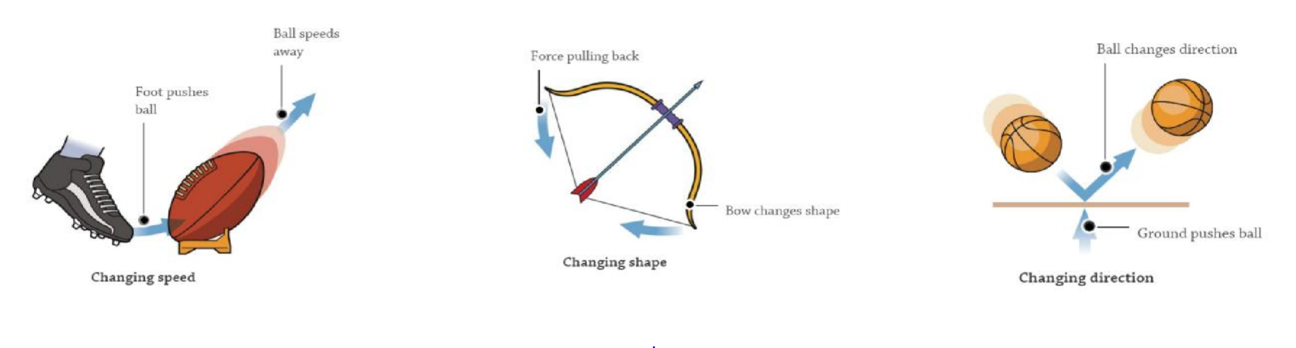

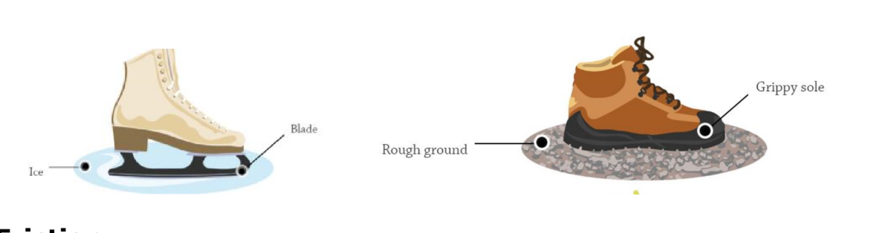

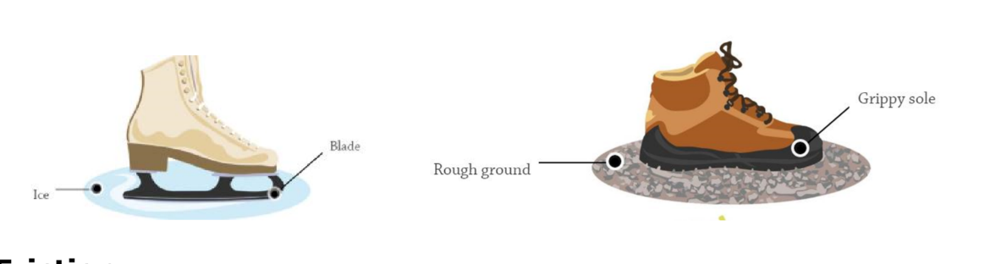

**Scientific knowledge:**

Magnetic Poles

* the strongest part of a magnet are the poles
* magnets have two poles – north and south

**Same poles repel**

* if two like poles, e.g. two south poles, are brought together they will push away from each other – repel

**Different poles attract**

* if two unlike poles, e.g. a north and south, are brought together they will pull together – attract
* for some forces to act there must be contact e.g. a hand opening a door, the wind pushing the trees
* some forces can act at a distance e.g. magnetism
* the magnet does not need to touch the object that it attracts

Click [HERE](https://www.bbc.com/bitesize/articles/zpvcrdm) to watch a video clip about magnetic poles

**Scientific knowledge:**

Magnets

* a magnet is a material or object that produces a magnetic field
* the magnetic field has an invisible force called magnetism which attracts magnetic material and attracts or repels other magnets

Magnetic Materials

* magnetic materials are always metals but only a few metals are magnetic
* nickel, iron, cobalt, and any materials containing these metals, are magnetic
* for example, steel contains iron, so a steel paper clip will be attracted to a magnet
* most other metals, such as copper, gold and aluminium are not magnetic
* for example, an aluminium drinks can will not be attracted to a magnet
* all other materials, such as plastic, wood, glass and wool are not magnetic
* for example, a plastic bottle will not be attracted to a magnet

Click [HERE](https://www.bbc.com/bitesize/articles/zw889qt) to watch a video clip about magnetic materials



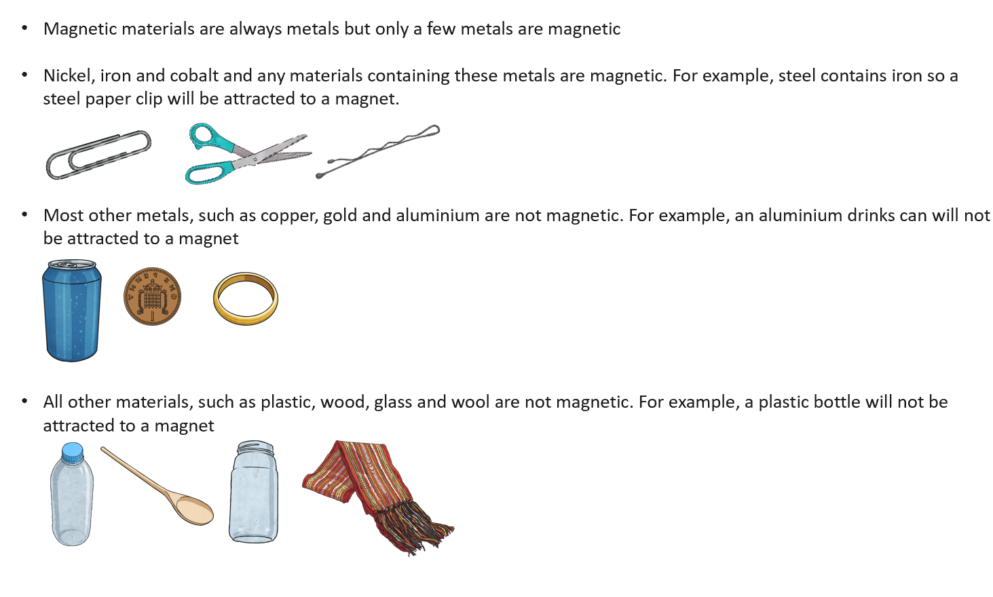







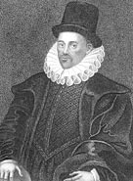

**Famous people/jobs:**

* William Gilbert was born on May 24th 1544 in Essex, England
* he was one of the first researchers into magnetism
* he became the most famous man of science in England during the reign of Queen Elizabeth I
* after years of experiments, he discovered how compasses work
* he was first to use the terms electric attraction, electric force and magnetic pole

**Useful websites:**

* [BBC Bitesize](http://www.bbc.co.uk/bitesize/ks2/science/physical_processes/magnet_springs/read/1/)
* [Science Kids](http://www.sciencekids.co.nz/gamesactivities/forcesinaction.html)
* [Britannica Kids](https://kids.britannica.com/kids/article/Magnet-and-Magnetism/353411)

**Homework challenges:**

* I can find examples of forces in everyday life
* I can draw diagrams using arrows to show the attraction and repulsion between the poles of magnets