Knowledge Organiser: **Science – ROCKS** **YEAR 3:** Autumn 1

**Scientific knowledge:**

Rocks

* rock is a naturally occurring material
* there are different types which have different properties:
  + hard or soft
  + shape and size (stones, pebbles, boulders)
  + size of grain or crystal
  + permeable or impermeable.
* the differences between them is to do with how they are formed
* Igneous rocks
  + formed when magma (hot, runny material found in the earth’s crust) erupts
  + it cools quickly, forming a solid

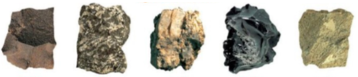

basalt gobbro granite obsidian pumice

* Sedimentary rocks
  + formed from sediment
  + it piles up to create layers, usually at the bottom of lakes and oceans
  + this sediment can include the remains of dead plants and animals, sand and mud
  + older layers are pressed together and become hard
  + over an extremely long period of time, they turn to rock
* Metamorphic rocks
  + formed from existing rocks (igneous, sedimentary or metamorphic)
  + when they are exposed to extreme heat and pressure in the earth’s surface for a long time

Click [HERE](https://www.bbc.com/bitesize/articles/zsgkdmn) to watch a video clip about how igneous, sedimentary and metamorphic rocks are formed

**Key objectives:**

* compare and group together different kinds of rocks on the basis of their appearance and simple physical properties
* describe in simple terms how fossils are formed when things that have lived are trapped within rock
* recognise that soils are made from rocks and organic matter

**Scientific vocabulary:**

**Challenge:**

**Durable –** able to withstand wear, pressure, or damage; hard-wearing

**Permeable –** allows water to easily pass through it

**Impermeable –** does not allow water to easily pass through it

**Subject Specific:**

**Grain –** the tiniest bit of something

**Crystals –**  a special solid material where the molecules fit together in a repeating pattern which causes it to form a variety of unique shapes

**Layers –** a thickness of something that is spread out over a surface

**Texture –** the feel or look of a surface

**Fossil –** the remains or trace of a living animal or plant from a long time ago. Fossils are found embedded in earth or rock

**Granite –** a hard, impermeable igneous rock made up of large crystals. It is used for making buildings, monuments and sculptures

**Chalk –** a soft, permeable sedimentary rock made up of small grains. It is formed from the skeletons of sea creatures

**Sandstone –** a soft, permeable sedimentary rock made up of small grains. It is formed mostly of sand cemented together

**Marble –** a hard, impermeable metamorphic rock made up of small crystals. It is used for making kitchen counters, flooring and statues.

**Slate –** a hard, impermeable metamorphic rock made up of small grains. It is easily split into smooth, flat platesused as roofing

**Peat –** a brown, soil-like substance formed by the decomposition of plants in wet areas such as bogs. It can be used as a fuel or fertiliser

**Fertiliser –** a material added to soil or land to make it better for growing plants

**Sandy soil –** a soil made up of small grains of rock and minerals

**Chalk soil –** a dry, permeable soil not suitable for growing plants or crops

**Clay soil –** a wet, sticky and impermeable soil

**Decompose –** to cause something (such as dead plants and dead animals) to be slowly destroyed or broken down by natural processes

**Basic:**

**Rock, Stone, Pebble, Boulder, Hard, Soft, Soil**

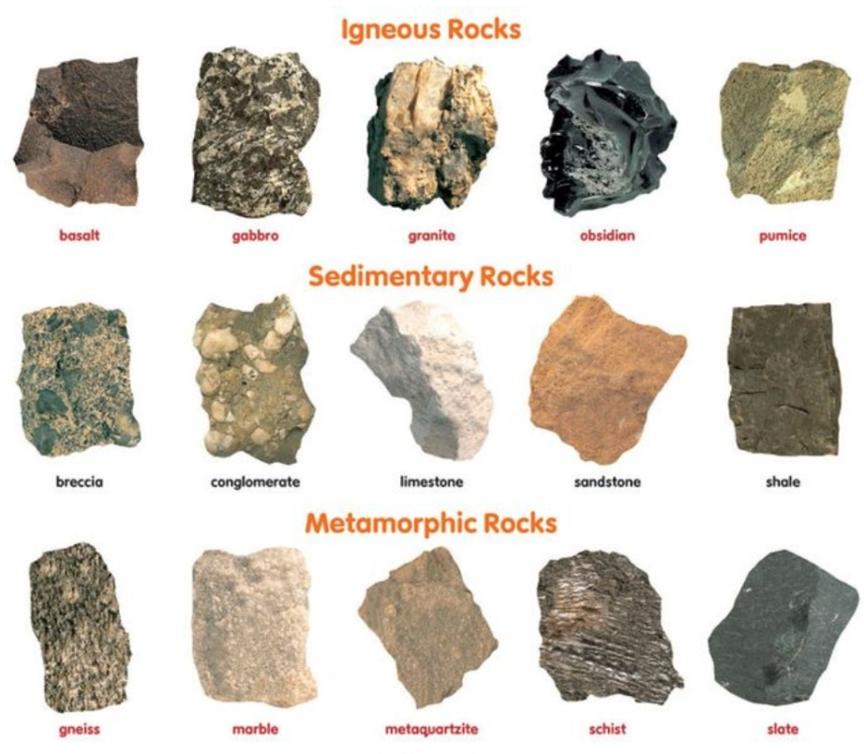

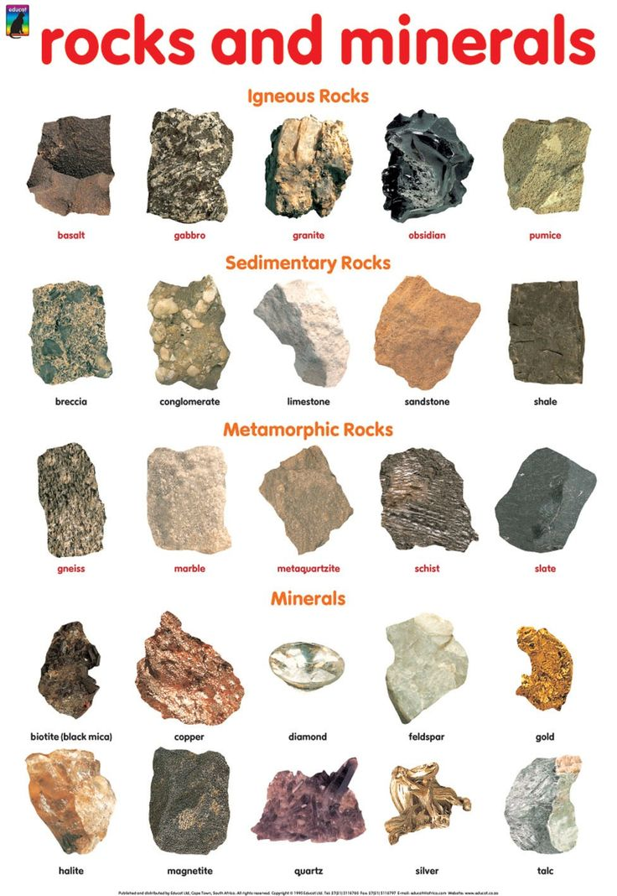

**Scientific knowledge:**

Fossils

* some rocks contain fossils; fossils were formed millions of years ago when…

Click [HERE](https://www.bbc.com/bitesize/articles/z2ym2p3) to watch a video clip about how fossils are formed

1. an animal or plant died and fell to the seabed

2. it was covered and squashed by other material

3. over thousands of years, it decomposed and was replaced by minerals from the water

4. over a long period of time, the sea moved back

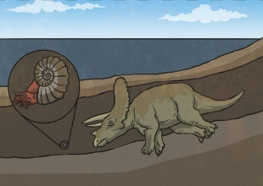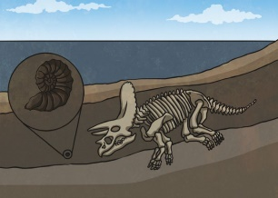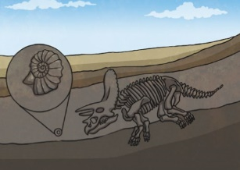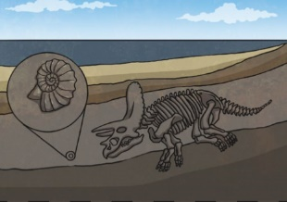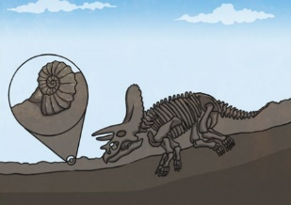

5. the rock was worn away which revealed the fossil

**Scientific knowledge:**

Soils

* soils are made up of pieces of ground down rock which may be mixed with plant and animal material (organic matter)

Click [HERE](https://www.bbc.com/bitesize/articles/ztvbk2p) to watch a video about what soil is made from

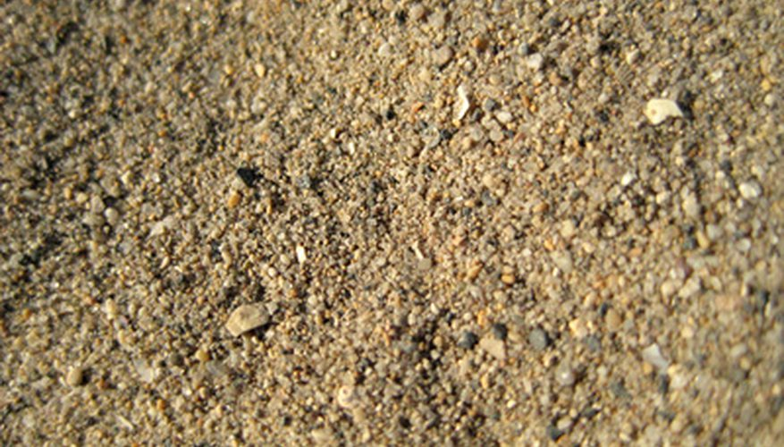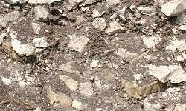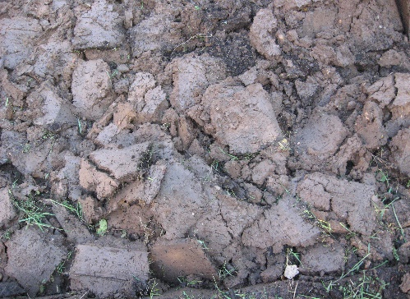

Sandy soil

Chalk soil

Clay soil

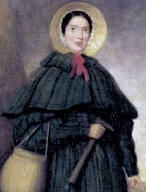

**Famous people/jobs:**

* Mary Anning is remembered as being one of the greatest fossil hunters to ever live
* she spent her time searching the Jurassic coat looking for fossils
* she made many incredible discoveries including the skull of an ichthyosaur

Click [HERE](https://www.bbc.com/teach/class-clips-video/ks1-ks2-mary-anning/zn7gd6f) to watch a video clip about Mary Anning’s life

**Useful websites:**

* [BBC Bitesize](https://www.bbc.com/bitesize/topics/z9bbkqt)
* [BBC Schools](http://www.bbc.co.uk/schools/scienceclips/ages/7_8/rocks_soils.shtml)
* [Soils 4 Kids](https://www.soils4kids.org/)
* [Kids Dinosaur](https://kidsdinos.com/what-are-fossils/)

**Homework challenges:**

* I can present my understanding of how fossils are formed in different ways e.g. in role play, comic strip, chronological report, stop-go animation