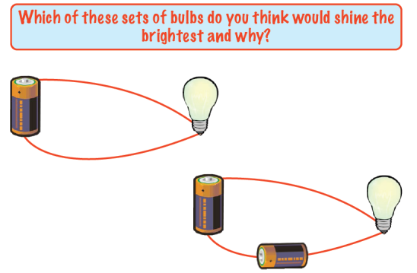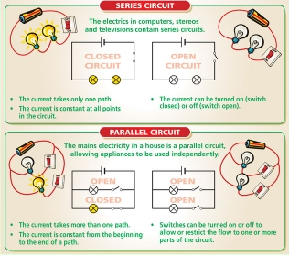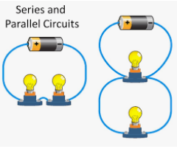Knowledge Organiser: **Science – Electricity**

**Scientific vocabulary:**

**Challenge vocabulary:**

**Series Circuit** –A single pathway for the electricity to flow through

**Components –** Parts of the circuit such as a bulb, battery, buzzer

**Parallel Circuit** –One that has two or more pathways for the electricity to flow,

**Circuit -** A complete pathway for electricity to flow through

**Circuit diagram** –A drawing that represents the electrical circuit

**Voltage** – It is the 'push' that causes electricity to move in a wire

**Amps**– Measures the flow of electricity

**Current –** The flow of electricity

**Conductor –** Something that electricity can flow through.

**Insulator –** Something electricity can’t flow through.

**Subject Specific vocabulary:**

**Cell –** Another name for a battery

**Electricity** A type of energy that can build up in one place or flow from one place to another.

**Motor –** A machine that spins when electricity flows through it.

**Switch** – Can stop or start the flow of electricity.

**Buzzer** – Makes a buzzing sound when electricity flows through it.

**Bulb -** Lights up when electricity flows through it

**Key objectives:**

*Associate the brightness of a bulb or the volume of a buzzer with the number and voltage of cells used in the circuit*

*Compare and give reasons for variations in how components function, including the brightness of bulbs, the loudness of buzzers and the on/off position of switches*

*Use recognised symbols when representing a simple circuit in a diagram.*

**Scientific knowledge:**

Associate the brightness of a bulb or the volume of a buzzer with the number and voltage of cells used in the circuit.

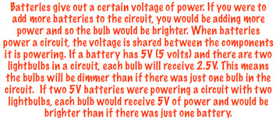

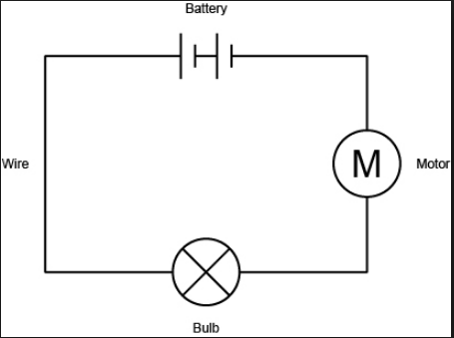[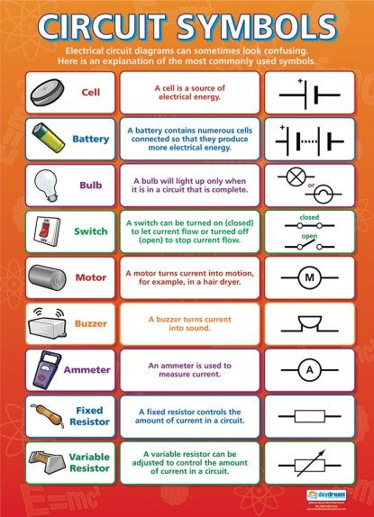](https://www.daydreameducation.co.uk/circuit-symbols-poster)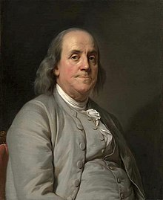 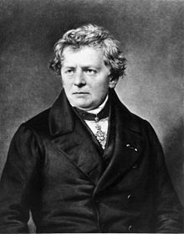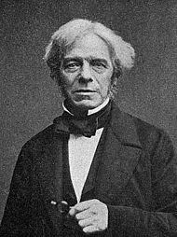

**Scientific knowledge:**

Use recognised symbols when representing a simple circuit in a diagram.

**Famous people/jobs**

Electricity is a form of energy and it occurs in nature, so it was not “invented.” As to who discovered it, many misconceptions abound. Some give credit to **Benjamin Franklin** for discovering electricity, but his experiments only helped establish the connection between lightning and electricity, nothing more.

Michael Faraday **invented** the

**electric** motor in 1821,

and Georg Ohm mathematically

analysed the

**electrical** circuit in 1827

**Homework challenges:**

*I can explore and describe the components of a torch.*

I can label a circuit diagram using symbols.

I can create an online circuit diagram using <http://www.cleo.net.uk/consultants_resources/science/circuitWorld/circuitworld.html>