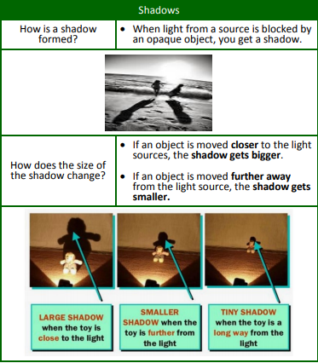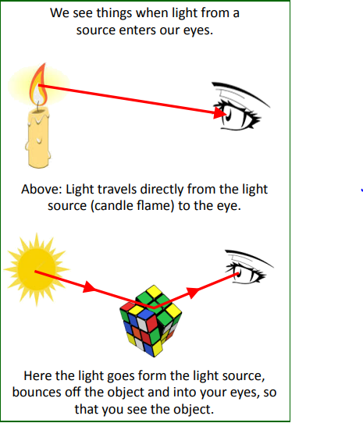Knowledge Organiser: **Science –Light**

**Scientific vocabulary:**

**Challenge Vocabulary**

**Light source -** Something that makes

its own light.

**Opaque** An object you are not able to see through.

**Transparent** –light can pass through so that objects behind can be clearly seen.

**Translucent** – Allows some light through but not all of it so objects can’t be seen clearly on the other side.

**Angle of incidence** – The angle where the light ray hits the surface.

**Angle of reflection** – The angle at which the light ray bounces off the surface.

**Subject specific Vocabulary**

**Reflection** When light bounces of a surface.

**Shadow** - An area of darkness, caused by light being blocked by something.

**Reflection** - The throwing back of light, after bouncing off an object.

**Shiny** – reflecting light, typically because very clean or polished.

**Matt** - Dull and flat surface; without a shine.

**Other words:**

*Mirror, sunlight, straight, dangerous, light, darkness.*

**Key objectives:**

* Recognise that light appears to travel in straight lines
* Use the idea that light travels in straight lines to explain that objects are seen because they give out or reflect light into the eye
* Explain that we see things because light travels from light sources to our eyes or from light sources to objects and then to our eyes
* Use the idea that light travels in straight lines to explain why shadows have the same shape as the objects that cast them.

**Scientific knowledge:**

**Things you need to know about light**

• Light travels in straight lines

• Light travels very, very fast - 186,282 miles per second. (that’s like travelling around the world over 7 times in a second)

• If something gets in the way of light, a shadow is formed.

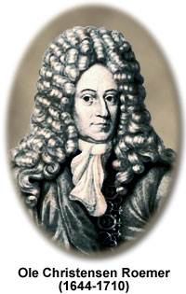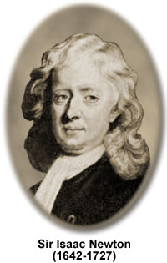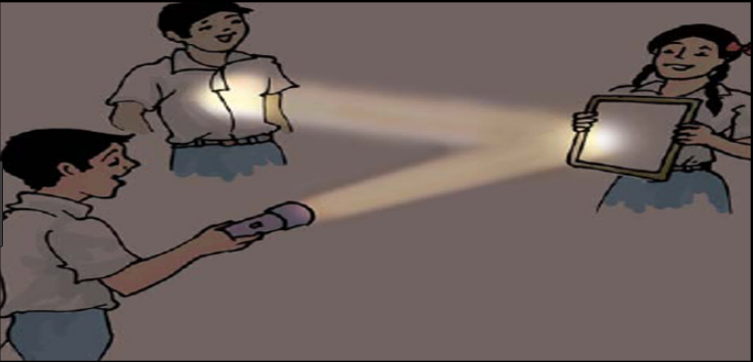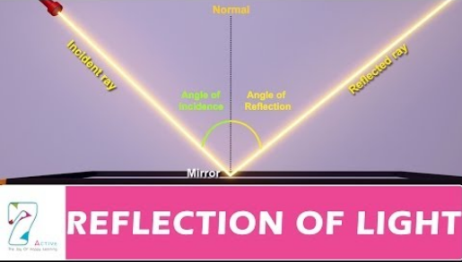

**Homework challenges:**

I can experiment to find out how the length of shadows can change with the seasons. (Caused by the earth’s tilt).

I can create a shadow puppet theatre with size of shadow changes for bigger characters.

**Famous people/jobs:**

**Sir Isaac Newton**: He conducted several experiments to understand light and how

light is composed of several wavelengths. In his book, Newton described how he

used prisms to disassemble and reassemble light.

**Olaus Roemer:** It was the Danish astronomer, Olaus Roemer, who, in 1676, first

Successfullymeasured the speed of light. His method was based on observations

of the eclipses of the moons of Jupiter.

**Scientific knowledge:**

We can change the direction of the

light beam by using mirrors