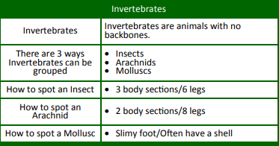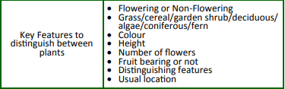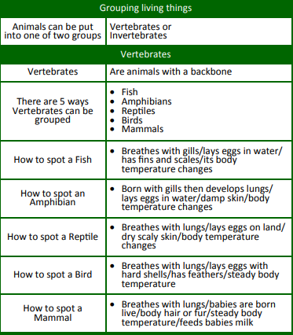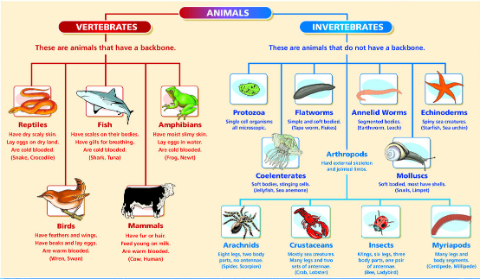Knowledge Organiser: **Science – Living Things and their habitats**

**Scientific vocabulary:**

**Challenge Vocabulary**

**Taxonomy** – The part of science focused on classification.

**Classification** Grouping something using its features.

**Vertebrates** Are animals with a backbone

**Invertebrates** Invertebrates are animals with no backbones.

**Subject Specific Vocabulary**

**Amphibian** – A cold-blooded animal that lives in water.

**Mammal** – A warm-blooded animal that has body hair or fur.

**Reptile –** Can live on land and in water. Lays eggs on land.

**Arachnid** – Part of the spider family. Has 8 legs.

**Mollusc** – Animal that has a slimy base and often a shell i.e. snail

**Crustacean** – Animal with hard outer shell ie lobster, crab.

**Flowering plant** – Produces flowers and seeds.

**Non flowering plant** – Doesn’t produce flowers or seeds.

**Cold blooded** - Animals whose body temperature varies with that of the environment.

**Warm blooded** – Animals that can keep a body temperature higher than their environment.

**Other Vocabulary:**

Bird, fish, snails, worms, insects, fins, scales, feathers, eggs, lungs, shell

**Key objectives:**

* Describe how living things are classified into broad groups according to common

observable characteristics and based on similarities and differences, including microorganisms, plants and animals

* Give reasons for classifying plants and animals based on specific characteristics

**Scientific knowledge:**

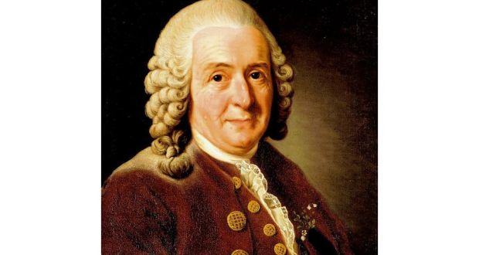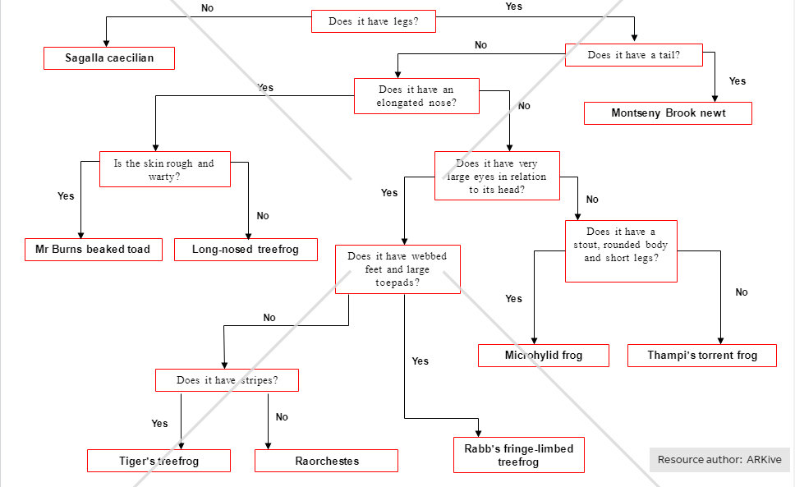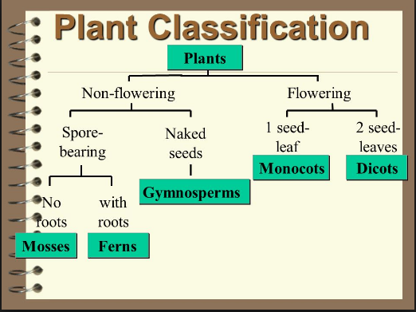

**Homework challenges:**

Locate a range of habitats on the school site and around the local area

Compare with animals from different habitats locally, in other areas in the UK and abroad.

What is the rarest animal on the school site?

Design charts and lead another year group on a bug hunt using these charts to classify.

.

**Famous people/jobs:**

3 facts about Carl Linnaeus

• Born in Sweden on 23rd May 1707

• A leading light in the field of Taxonomy

• Famous for developing the first system to classify animals effectively.

**Scientific knowledge:**