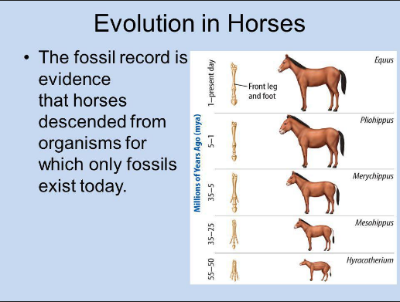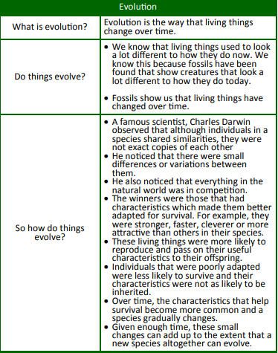Knowledge Organiser: **Science – Evolution**

**Key objectives:**

* Recognise that living things have changed over time and that fossils provide information about living things that inhabited the Earth millions of years ago
* Recognise that living things produce offspring of the same kind, but normally offspring

vary and are not identical to their parents

* Identify how animals and plants are adapted to suit their environment in different ways and that adaptation may lead to evolution.

**Scientific vocabulary:**

**Challenge Vocabulary**

**Evolution -** The way that living things

change over time.

**Species** – A group of living things.

**Variation** – Small differences.

**Characteristics** - A feature or quality belonging typically to a person.

**Adapted -** To become adjusted to new conditions.

**Evolve** - To develop and change gradually over time.

**Adaptation** - When things evolve to

overcome challenges in their

environment.

**Subject Specific Vocabulary**

**Reproduce** - To produce babies

**Inherit** - To have a characteristic from your parents when you are born.

**Offspring** - A person's child or children or an animals young

**Fossil -** The remains or impression of a prehistoric plant or animal embedded in rock.

**Organisms** - An individual animal, plant.

**Migration** - Seasonal movement of animals from one region to another.

**Scientific knowledge:**

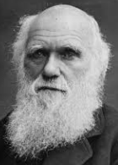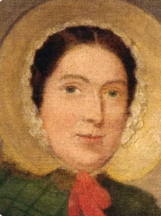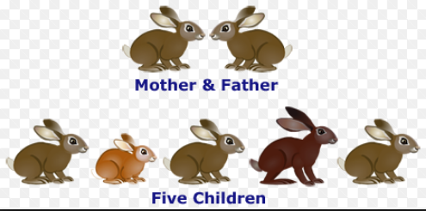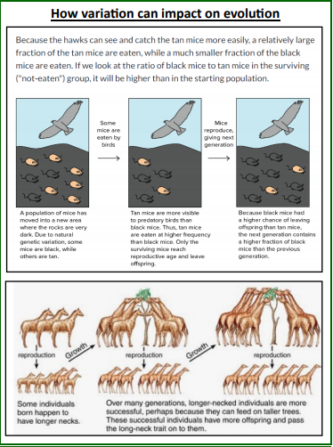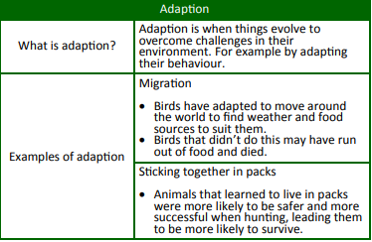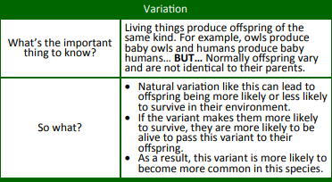

**Homework challenges:**

Investigate the work of renowned palaeontologists such as Mary Anning and how Charles Darwin and Alfred Wallace developed their ideas on evolution.

Identify examples of how animals have adapted to their environments.

**Famous people/jobs:**

**Charles Darwin.** Charles Robert Darwin is best known for his contributions to the science of

evolution. His idea that all species of life have descended over time from common ancestors

is now widely accepted.

**Mary Anning** Mary Anning was an English fossil collector who became known around the world for

important finds she made in Jurassic marine fossil beds in the cliffs along the English Channel.

**Scientific knowledge:**

**Living things produce offspring of the same kind, but**

**normally these vary and are not identical to their parents**