[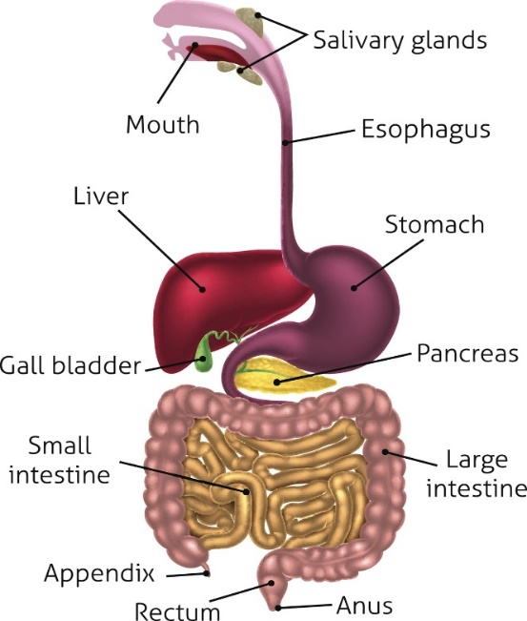](https://www.google.co.uk/url?sa=i&rct=j&q=&esrc=s&source=images&cd=&cad=rja&uact=8&ved=2ahUKEwi68vC5w_feAhWlB8AKHQzoBUcQjRx6BAgBEAU&url=https://bodytomy.com/digestive-system-function&psig=AOvVaw1rM4Cy0lAokUxqLOn7EqsV&ust=1543509573205648)Knowledge Organiser: **Science – Animals, including humans YEAR 4:** Autumn

**Scientific knowledge**

Describe the simple functions of the basic parts of the digestive system in humans

Identify the different types of teeth in humans and their simple functions *(see vocabulary definitions)*

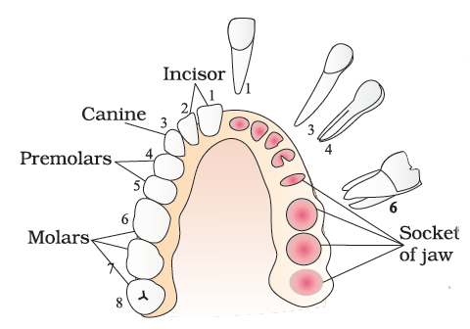

**Tooth Decay:**

Poor Oral Hygiene, not brushing your teeth regularly, allows plaque to build up and attack the tooth enamel.

Plaque is caused when bacteria, acid, food particles, and saliva all combine in your mouth. **BRUSH YOUR TEETH TWICE A DAY!**

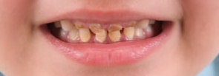

**Scientific vocabulary:**

**Challenge**

**Oesophagus** - *a long, muscular tube that connects your mouth to your stomach*

**Stomach** - *the pouch into which food passes from the oesophagus for mixing and digestion before passing to the small intestine*

**Small intestine** – *its job is to absorb most of the nutrients from what we eat and drink*

**Large intestine** – *its job is to absorb water*.

Rectum - *the outermost portion of the large intestine.*

**Anus** - the opening where your bowel movements (also known as faeces) come out.

**Food chain** - *shows how each living thing gets food, and how nutrients and energy are passed from creature to creature*

**Subject Specific**

**Saliva** - a clear liquid secreted into the mouth by the salivary glands and mucous glands of the mouth.

**Digestion system** - *parts of the body that work together to turn food and liquids into the building blocks and fuel that the body needs.*

**Digestion** – *the process of digesting food.*

Faeces *– body waste that comes out of the anus*

**Incisor** - *a narrow-edged tooth at the front of the mouth, adapted for cutting*

**Canine** - *a pointed tooth between the incisors and premolars used to pierce and tear food*

**Molar** - *a grinding tooth at the back of a mammal's mouth.*

**Premolars** - *teeth used to crush food*

**Herbivore** - *an animal that feeds on just plants*

**Carnivore** – *an animal that feeds on meat*

**Omnivore** – *an animal that eats plants and meat*

**Producer** – *plants that make their own food*

**Predator** – *animals that eat other animals*

**Consumer** – *animals that eat plants and other animals*

**Prey** – *animals eaten by other animals*

**Key objectives:**

* *describe the simple functions of the basic parts of the digestive system in humans*
* *identify the different types of teeth in humans and their simple functions*
* *construct and interpret a variety of food chains, identifying producers, predators and prey.*

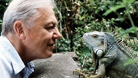

**Useful websites for further reading:**

<https://www.bbc.com/bitesize/topics/z27kng8>

<https://www.bbc.com/bitesize/articles/zsp76yc>

<https://www.bbc.com/bitesize/topics/zbnnb9q>

**Homework challenges:**

*I can create a 2D or 3D model of the digestive system that shows the process of each section.*

*I can develop a guide to teeth brushing which explains the jobs of the teeth and the importance of keeping them clean.*

**Famous people/jobs:**

**Sir David Frederick Attenborough** is an English [broadcaster](https://en.wikipedia.org/wiki/Broadcasting) who studies

animals and plant life, presenting a range of BBC programs such as [Planet](https://www.bbc.co.uk/programmes/b006mywy)

[Earth](https://www.bbc.co.uk/programmes/b006mywy).

**Scientific knowledge**

Construct and interpret a variety of food chains, identifying **producers, predators and prey**.

