Knowledge Organiser: **Science – Electricity**

**Key objectives:**

identify common appliances that run on electricity

construct a simple series electrical circuit, identifying and naming its basic parts, including cells, wires, bulbs, switches and buzzers

identify whether or not a lamp will light in a simple series circuit, based on whether or not the lamp is part of a complete loop with a battery

recognise that a switch opens and closes a circuit and associate this with whether or not a lamp lights in a simple series circuit

recognise some common conductors and insulators, and associate metals with being good conductors

**Scientific knowledge:**

Identify common appliances that run on electricity.

Construct a simple series electrical circuit, identifying and naming its basic parts, including cells, wires, bulbs, switches and buzzers.

Identify whether or not a lamp will light in a simple series circuit, based on whether or not the lamp is part of a complete loop with a battery

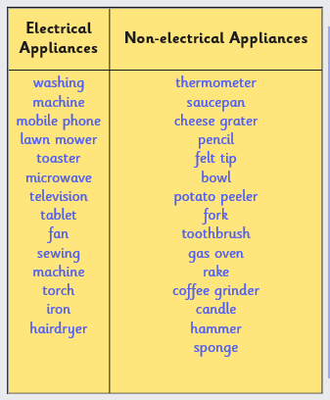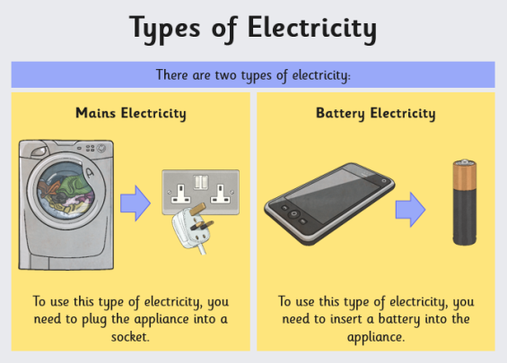

**Scientific vocabulary:**

**Challenge vocabulary:**

**Circuit –** A single pathway for the electricity to flow

**Components –** Parts of the circuit such as a bulb, battery, buzzer

**Circuit -** A complete pathway for electricity to flow through

**Current –** The flow of electricity

**Conductor –** Something that electricity can flow through.

**Insulator –** Something electricity can’t flow through.

**Subject Specific vocabulary:**

**Electricity -** A type of energy that can build up in one place or flow from one place to another.

**Electrical appliance / device -**  a device that uses electricity to perform a function

**Plug -** a device for making an electrical connection between an appliance and the mains

**Battery -** a container consisting of one or more cells, in which chemical energy is converted into electricity and used as a source of power

**Motor –** A machine that spins when electricity flows through it.

**Switch** – Can stop or start the flow of electricity.

**Buzzer** – Makes a buzzing sound when electricity flows through it.

**Bulb -** Lights up when electricity flows through it

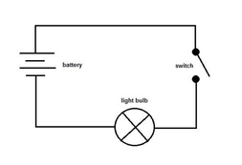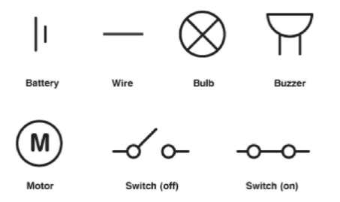

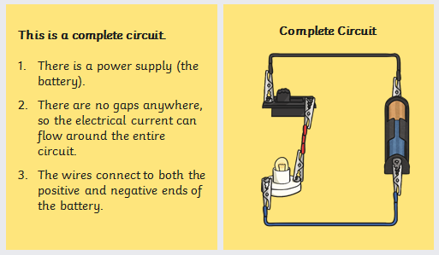

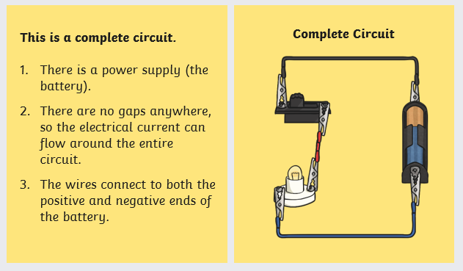

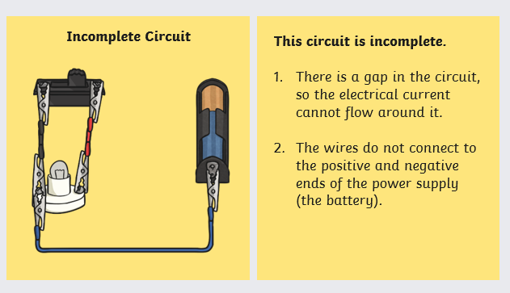

**Scientific knowledge:**

Recognise that a switch opens and closes a circuit and associate this with whether or not a lamp lights in a simple series circuit

Switches are used to control circuits. They can break a circuit - and so switch bulbs, motors and buzzers off - or complete a circuit - and so switch them on again.

Recognise some common conductors and insulators, and associate metals with being good conductors

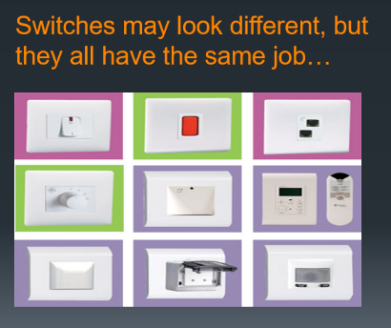

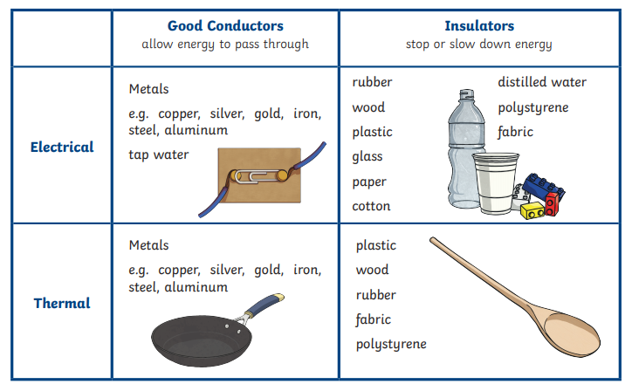

**Homework challenges:**

*I can write a set of instructions on how to create a working electrical circuit, with clear labels.*

*I can make a poster that highlights the importance of electrical safety.*

**Famous people/jobs:**

**James Watt – Inventor of the ‘watt’**

James Watt was a famous Scottish inventor who is considered one of the most important inventors in the early Industrial Revolution. He invented many different things, including the steam train, but the unit of power (watt), which powers lightbulbs, is named after him.

**Useful websites for further reading:**

<https://www.bbc.com/bitesize/clips/zpshfg8>

<https://www.bbc.com/bitesize/clips/zqb7tyc>

<https://www.bbc.com/bitesize/clips/zq3fb9q>