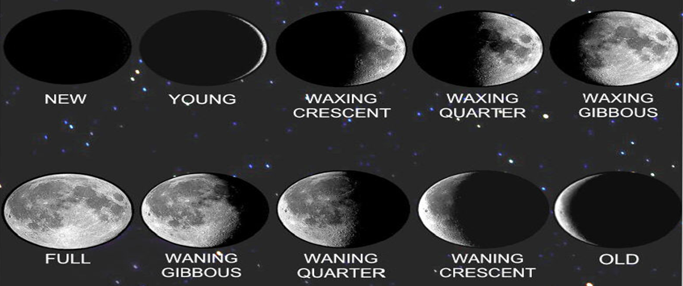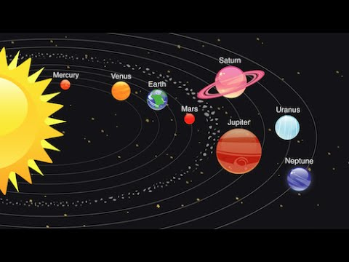Knowledge Organiser: **Science – Earth and Space** **YEAR 5:** Spring term

**Scientific vocabulary:**

**Challenge**

**Celestial** – Position relating to the sky, or outer space as observed in the astronomy

**Astronomy**- the study of the sun, moon, stars, planets, comets, gas, galaxies, gas and dust

**Solstice** - either of the two times in the year, the summer solstice and the winter solstice, when the sun reaches its highest or lowest point in the sky at noon, marked by the longest and shortest days.

**Subject specific**

**Orbit**–The regularly repeated course of a celestial object around a star or planet

**Planet** – A celestial body moving in orbit round a star

**Rotation**–The action of rotating about an axis or centre

**Solar system** – The collection of eight planets and their moons in orbit round the sun

**Meteors**- small chunks of rock that travel through space and enter a planet's atmosphere and burn up

**Lunar cycle/ phases of the Moon**- the shape of the directly sunlit portion of the Moon as viewed from Earth.

**Eclipse**- An eclipse of the sun is an occasion when the moon is between the Earth and the sun, so that for a short time you cannot see part or all of the sun. An eclipse of the moon is a time when the Earth is between the sun and the moon, so that for a short time you cannot see part or the entire moon.

**Crescents**- the curved shape of the waxing or waning moon.

**Gibbous moon-**the phase of the moon in which its illuminated part is greater than a semicircle and less than a circle

**Waning moon-** After a full moon, the moon starts becoming slimmer each night and it gradually gets smaller

**Waxing moon.** After a new moon and before a full moon, the moons illuminated area is increasing.

**Solar system -** the collection of eight planets and their moons in orbit round the sun,

**Satellite**- celestial body orbiting the earth or planet

**Basic**

Night, Moon, Sun, Reflecting, Time, Sun, Illuminated

Earth, Planets, Astronaut, Day.

**Key objectives:**

* Describe the movement of the Earth, and other planets, relative to the Sun in the solar system
* Describe the movement of the Moon relative to the Earth
* Use the idea of the Earth’s rotation to explain day and night and the apparent movement of the sun across the sky.

**Scientific knowledge:**

*Tricks to remember the planets in order:*

**My very enthusiastic mother just served up noodles**

**Phases of the moon diagram.**

The phase of the moon is how much of the moon appears to us on Earth to be lit up by the sun. Half of the moon is always lit up by the sun, except during an eclipse, but we only see a portion that's lit up. This is the phase of the moon.

Around once per month, every 29.53 days to be exact, the phases of the moon make a complete cycle. As the moon circles the Earth, we can only see a portion of the lit up side. When we can see 100% of the lit up side, this is a full moon. When we can't see any of the lit up side, this is called a dark moon or new moon.

The Moon is a natural satellite of the earth and is a place with no air, no water and no life. It has lots of craters where it has been hit by meteors. It is brightly lit in the night sky not because it gives out its own light but because it reflects the light of the Sun.

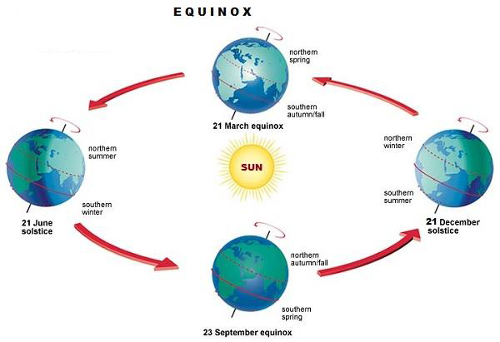

Sunrise and sunset depends on what time of year it is. The Sun rises earlier and sets later in summer, making the

days longer than in winter. This is because as well as the Earth rotating on its axis, it also orbits the Sun. It takes the Earth 365.25 days to orbit the Sun completely. Because of the tilt of the Earth’s axis, some parts of the Earth will be leaning more towards the Sun at certain times of the year than others and vice versa.

**Facts - Sun, Earth, Moon**

Sun, Earth and Moon are all spherical. The sun is by far the largest out of the three. The Sun has a diameter of 1,391,980 km. The Earth has a diameter of 12,742 km. The Moon is the smallest has a diameter of 3474 km.

**Distance away from Earth**

The Sun is much further away from Earth than the Moon. The Moon is 384,400 km away whereas the Sun is a whopping 149,600,000 km away. This means it looks like it is smaller than it is because it is so far from Earth.

**The Sun**

The Sun is the star at the centre of our solar system and is responsible for the Earth’s climate and weather. The Sun reaches temperatures of 15 million °C.

The Sun is all the colours mixed together, this appears white to our eyes.

The Sun is 4.6 billion years old and it is 109 times wider than the Earth.

**The Moon**

The Moon is the Earth's only natural satellite. It is the fifth largest moon in the Solar System. The average distance from the Moon to the Earth is 384,400 kilometres (238857 miles). The Moon orbits the Earth every 27.3 days and it 4.5 billion years old.

**The Earth**

The Earth is the only planet in the solar system that has life. Earth is the 5th largest planet in the solar system, which makes Earth the 4th smallest planet in the solar system. The Earth was formed about 4.5 billion years ago, and has existed ever since. Earth’s orbit around the sun is the 3rd fastest orbit of all the solar system planets.

**Famous people**

**Neil Armstrong.** On the 21 July 1969, Neil became the first man to walk on the Moon. His famous words upon being the first man on the Moon were "That's one small step for man, one giant leap for mankind". He collected Moon rocks and was on the Moon for over 21 hours.

**Stephen Hawking.** He developed theories of how the world began. Stephen was best known for his work on explaining the origins of the universe and black holes.

**Tim Peake.** On 15 December 2015, British astronaut, Tim Peake, left Earth to spend 173 days on the International Space Station. When he was in space he used a treadmill to run alongside the London Marathon. It only took 3 hours from the ISS back to Earth.

**Yuri Alekseyevich Gagarin** was a Soviet pilot and cosmonaut. He was the first human to journey into outer space, when his Vostok spacecraft, launched by the Soviet Union, completed an orbit of the Earth on 12 April 1961.

**Galileo**. Galileo used his telescope to study the sky and in 1610 he discovered the four moons that orbit Jupiter. He also observed 'phases' of Venus, when the planet was more visible at different times

**Homework challenges:**

*Make a planet out of paper mache creating your very own planet.*

*Research and compare planets within our solar system. Present findings in a discovery diary format.*