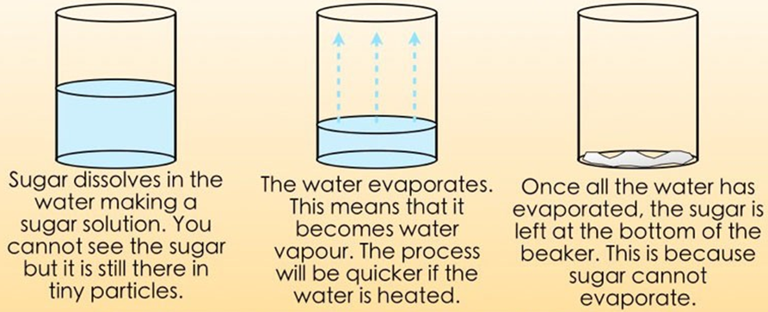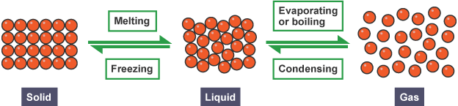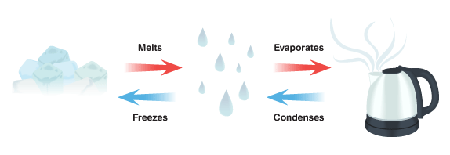Knowledge Organiser: **Science – Properties and changes of materials** **YEAR 5:** Summer Term

**Scientific vocabulary:**

***Challenge***

**Physical change-** usually reversible change in the physical properties of a substance, as size or shape

***Subject specific***

**Conductor** – a material or device which allows heat

or electricity to carry through

**Dissolve**- when something solid mixes with a liquid and becomes part of the liquid

**Evaporation**- the process of turning from liquid to vapour

**Condensation**- water which collects as droplets on a cold surface when humid air is in contact with it

**Gas** – an air-like fluid substance which expands freely to fill any space available

**Insulator** – a substance which does not readily allow the passage of heat or sound

**Irreversible** – cannot be reversed back to its original state

**Magnetic**- capable of being magnetised or attracted by a magnet

**Material** – The matter from which a thing is or can be made from

**Opaque**-not able to be seen through, not transparent

**Reversible** – able to be reversed back to its original state

**Insoluble**- does not dissolve

**Soluble** – able to be dissolved, especially in water

**Vapour**- a substance in the air, normally a liquid or solid

**Transparent** – allows light to pass through so that objects behind can be seen

***Basic***

Mixture, sieving, freezing, cooling, heating, thermal, filter, burning, rustling, change, material, dissolving, liquid, solid, and flexible.

**Key objectives:**

* Compare and group together everyday materials on the basis of their properties.
* Give reasons for the particular uses of everyday materials, including metals, wood and plastic.
* Know that some materials will dissolve in liquid to form a solution.
* Use knowledge of solids, liquids and gases to decide how mixtures might be separated, including through filtering, sieving and evaporating
* Explain that some changes result in the formation of new materials, and that this kind of change is not usually reversible.

**Scientific knowledge:**

Some materials change state when they are heated or cooled. This means that they can turn from a gas to a liquid to a solid and back again. For example, when water is at room temperature it is a liquid. If it is heated it evaporates and turns into water vapour which is a gas. To turn it back into a

liquid you need to cool the gas down again. This is called condensation. If you cool liquid water it turns into ice which is a solid. This is called freezing. As the ice heats again it melts to turn back into a liquid.

Soluble materials (materials than dissolve in water) such as sugar and salt are able to be separated from water through evaporation. When the water evaporates, it leaves the salt or sugar behind.

Mixing water with a soluble material is a **reversible** change because the change can be reversed. You can separate the materials back to their original states after they have been mixed. Melting, freezing, evaporating, condensing and dissolving are examples of **reversible** physical changes.

**Scientific Knowledge:**

**Irreversible** - Heat causes an irreversible chemical change to happen. A cooked egg cannot be cooled and turned back into a raw egg. It is a chemical change because a new product has been made and it’s irreversible because it cannot be changed back.

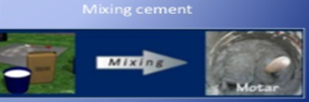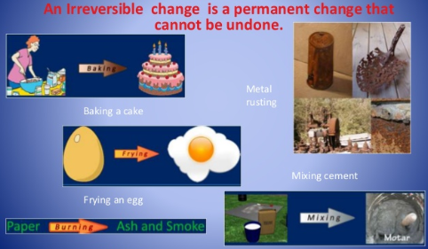



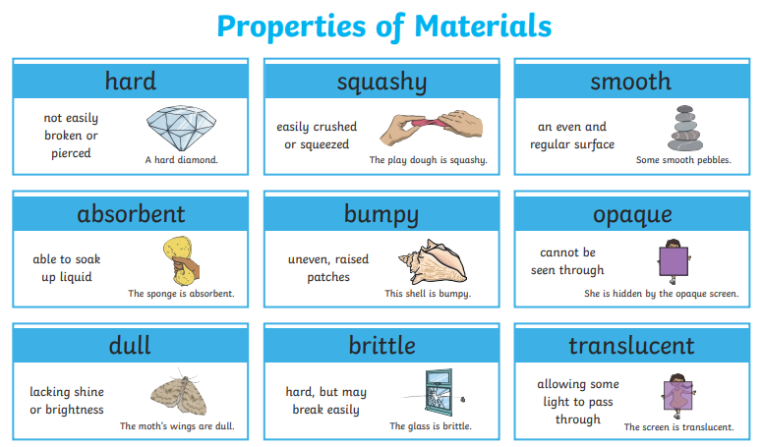

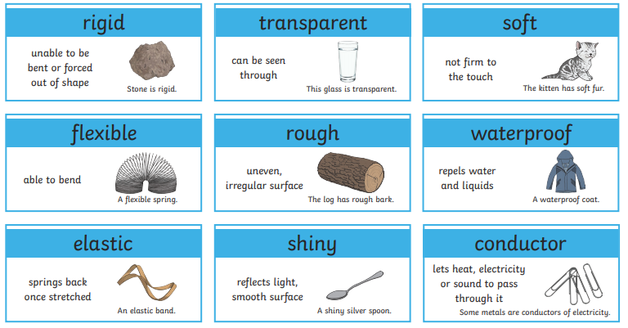

**Useful websites:**

[*https://www.bbc.com/bitesize/articles/z9brcwx*](https://www.bbc.com/bitesize/articles/z9brcwx)

[*https://www.topmarks.co.uk/interactive.aspx?cat=70*](https://www.topmarks.co.uk/interactive.aspx?cat=70)

[*https://www.bbc.com/bitesize/topics/zkgg87h*](https://www.bbc.com/bitesize/topics/zkgg87h)

**Famous people:**

**Spencer Silver** – In 1968 he invented glue that would not leave any marks when it was moved from one place to another. On the 6th

April 1980 post-it notes were introduced in American shops. Silver’s adhesive was later used for medical bandages and decorating.

**Harry Brearly** – Born in Sheffield England. On the 13th August 1913 he created the first ever stainless steel which did not rust. These

products included: cutlery, saucepans and other food related products.

**Homework challenges:**

*Choose an object from around your home or school. Draw a picture of it and label the different materials it is made from. Identify the properties these have, and why they were chosen to make the object.*

*Scientists use chemical reactions to create useful new materials. Can you create a fact file about a scientist and the new material they made? You should research the scientist and their life, such as when and where they lived, and what they did.*