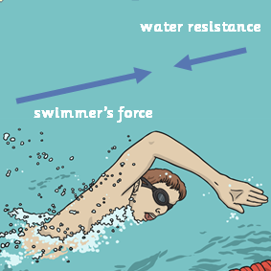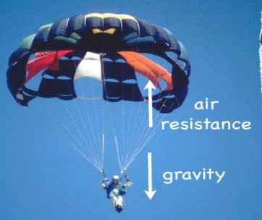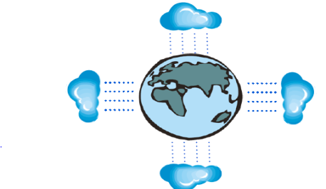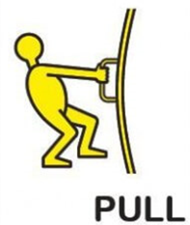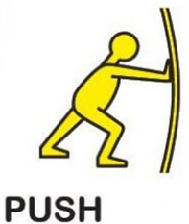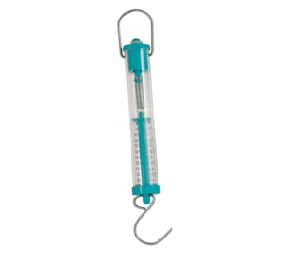**YEAR 5: Autumn Term Knowledge Organiser:** Science – **Forces**

**Scientific vocabulary:**

**Challenge**

**Causality -**the relationship between cause and effect.

**Velocity -** the speed of something in a given direction.

**State of motion**- The state of motion of an object is defined by its velocity - the speed with a direction.

**Subject specific**

**Buoyancy-** the ability or tendency of something to float in water or other fluid.

**Air resistance** – A force that is caused by air with the force acting in the opposite direction to an object moving through the air

**Force** – A push or pull upon an object resulting from its interaction with another object

**Friction** – The resistance that one surface or object encounters when moving over another

**Gears** – A toothed wheel that works with others to alter the relation between the speed of a driving mechanism (e.g. engine) and the speed of the driven parts (e.g. the wheels)

**Gravity** – The force that attracts a body towards the centre of the earth

**Levers** – A rigid bar resting on a pivot that is used to move a heavy or firmly fixed load

**Mass** – The weight measured by objects acceleration under a given force or by the force exerted on it by gravity

**Pulleys** – A wheel with a grooved rim around that changes the direction of a force applied to the cord

**Water resistance -** A force that is caused by water with the force acting in the opposite direction to an object moving through the water

**Streamline shape.** Shape something so that it can move as effectively and quickly as possible through a liquid or gas

**Average**- the average is calculated by adding all the numbers together and dividing the sum of the values in the set by their number.

**Basic**

Balanced, Unbalanced, Object, Weight, Measure

Strength, Direction, Surfaces, Simple machines

**Scientific knowledge:**

Forces are often referred to as pushes and pulls.

**Gravity**. Weight describes how heavy an object is. It is Earth’s gravitational force that causes objects to have weight and determines how heavy something is. Gravity is a force that pulls everything towards the centre of the earth. Without gravity, everything would be weightless

This is a force meter. It measures the force upon an object

and so shows how much it weighs. It measures the force in

newton’s (N). Some force meters also show how much the object being measured weighs in grams (G).

**Air resistance**. Sky divers use parachutes to land safely and prevent them from landing on the ground with a splat because air resistance acts against the gravitational force and slows the sky diver down.

**Water resistance.** Whenever an object moves through water, it experiences the force of water resistance. Water resistance pushes objects back, making it hard for them to move through water.

**Key objectives:**

* Explain that unsupported objects fall towards the Earth because of the force of gravity acting between the Earth and the falling object
* Identify the effects of air resistance, water resistance and friction, that act between moving surfaces

.

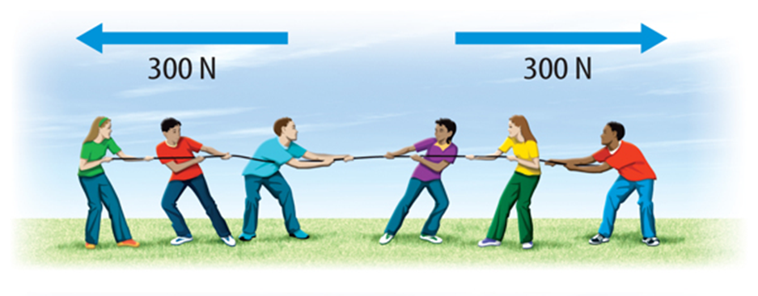

**Scientific Knowledge:**

**Balanced forces** The forces acting on an object can be balanced. If the forces pushing and pulling an object are the same strength, they are balanced. The two forces are balanced because they are of equal size and strength.

When the forces acting on an object are balanced, the object will maintain its state of motion - this means it will not start or stop moving, speed up or slow down or change direction

**Unbalanced force.**  Unbalanced forces do change the way an object is moving. The object will change its state of motion- this means it will start/ stop moving, speed up or slow down or change direction.

**Friction.** Friction is a force that acts between two surfaces or objects that are moving, or trying to move across each other. Friction always acts in the opposite direction to the moving object, and always slows a moving object down. All surfaces create friction on an object moving across them. Even very smooth surfaces like ice create some friction.

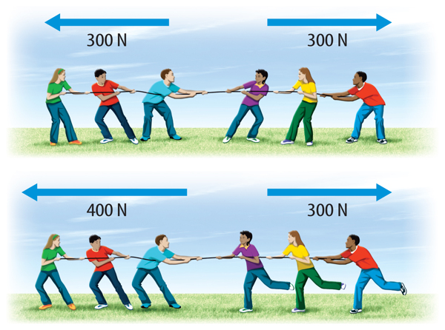

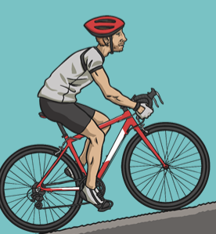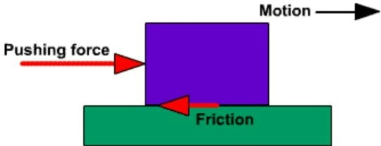

**Useful websites:**

[*http://www.sciencekids.co.nz/gamesactivities/forcesinaction.html*](http://www.sciencekids.co.nz/gamesactivities/forcesinaction.html)

[*https://www.ducksters.com/science/physics/force.php*](https://www.ducksters.com/science/physics/force.php)

[*http://interactivesites.weebly.com/physics-and-motion.html*](http://interactivesites.weebly.com/physics-and-motion.html)

**Homework challenges:**

*Make a paper helicopter or a streamline aeroplane. Investigate the effects of air resistance and gravity.*

*Research a scientist from above- create a fact file about their inventions and discoveries.*

**Famous people:**

**Aristotle** - Aristotle was an ancient Greek philosopher and scientist. He invented a new science called causality, which explained why events happen. He also devised a new way of looking at situations and events by looking for clues as to what happened.

**Sir Isaac Newton**- Isaac Newton is best known for 'discovering' gravity. The young Isaac Newton was sitting in his garden when an apple fell on his head and then he came up with his theory of gravity. Also, Newton discovered that white light is made up of a range of colours.

**Albert Einstein**. His discoveries made everything from television to garage door openers to DVD players possible. Einstein was one of the most brilliant scientists of all time and he was best known for his theory of relativity and the equation E=MC2,