Knowledge Organiser: **Science – Living Things and Their Habitats** **YEAR 2:** Spring 2/ Summer 1

**Key objectives:**  explore and compare the differences between things that are living, dead, and things that have never been alive

identify that most living things live in habitats to which they are suited and describe how different habitats provide for the basic needs of different kinds of animals and plants, and how they depend on each other

identify and name a variety of plants and animals in their habitats, including micro-habitats

describe how animals obtain their food from plants and other animals, using the idea of a simple food chain, and identify and name different sources of food.

**Scientific knowledge:**

|  |
| --- |
|  |
| Sort objects/ materials into 3 groups.   |  |  |  | | --- | --- | --- | | Alive | Dead | Never Been Alive | | Woodlouse  Tree  Black bird | Wooden objects  Feathers  Wool  Cotton | Stone  Glass  Plastic  crystals |   Habitats.  Animals and plants naturally live in habitats to which their bodies have adapted. The habitat provides for their needs. This includes food sources, protection from predators and shelter. A habitat is more than just a den where the animal lives; it is the complete environment.  In some situations the habitat may be maintained by the animals it supports. For example, the behaviour of beavers creates the pools and lakes they need for survival. All parts of the habitat are dependent on each other.  Habitats and animals we will talk about:   * The arctic, polar bears, seals/The deserts, camels, * Micro habitats—the school pond, (frogs, newts, dragon fly larvae, water fleas, water beetles, pond snails, pond weed) * Micro-habitats—the log pile (detritus, woodlice, earwigs, worms, slugs). * Oak trees—birds, insects ( beetles, flies, caterpillars pollinators) spiders.   Food Chains  Food chains operate in the habitats we have talked about.  The different elements of a food chain show the direction of energy flow. (see diagram below).  (producer, herbivore, carnivore, top carnivore) |

This is an example of a simple food chain.

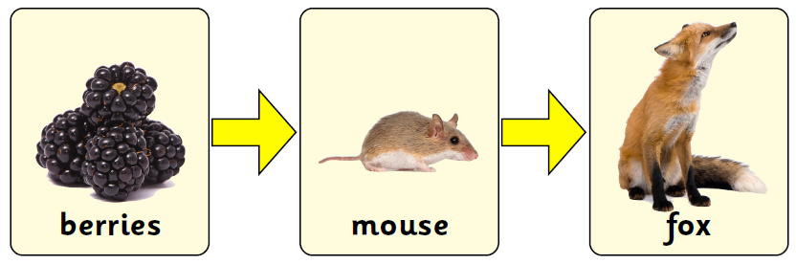

The diagram overleaf shows how energy is passed along the food chain.

**Scientific vocabulary:**

**Basic (**Feed, Food, Living, Move, Shelter, woodland**)**

**Subject Specific**

**Basic needs—**requirements of life

**Carnivore**- An animal which eats other animals

**Dead-** has ceased to live

**‘Environmental Area’—**school resource

**Food Chain—** how nutrients and energy are passed from creature to creature

**Green Plant—** a plant which is green

**Habitat—** The environment where something lives.

**Herbivore**-an animal which eats plants

**Log pile—**A pile of decaying logs

Omnivore-an animal which eats plants and animals

**Pond—**A small freshwater pool

**Suitable--** appropriate

**Suited –** adapted to

**Top carnivore**- an animal at the top of the food chain

**Challenge**

**Photosynthesis-** the means by which a green plant produces energy

**Producer—**a green plant or a part of that plant. (berry, seed).

**Famous people/jobs:**

**Conservationists, Farmers, Animal husbandry.**

**Sir David Attenborough- wildlife conservationist, TV presenter.** 

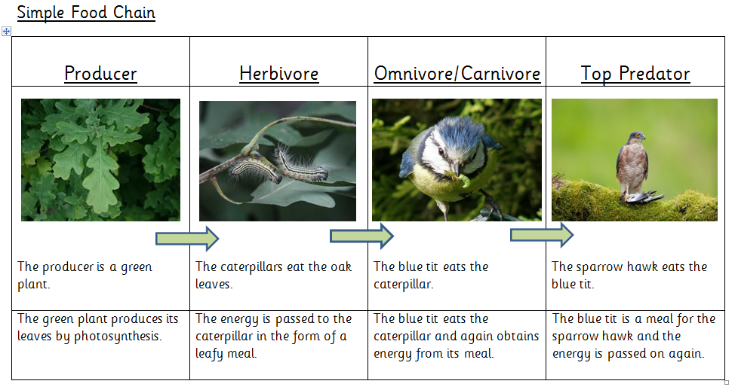

**Homework challenges:**

**How many different habitats can you think of?**

**Can you draw a food chain with yourself at the top?**

**Can you find out how green plants produce their food?**