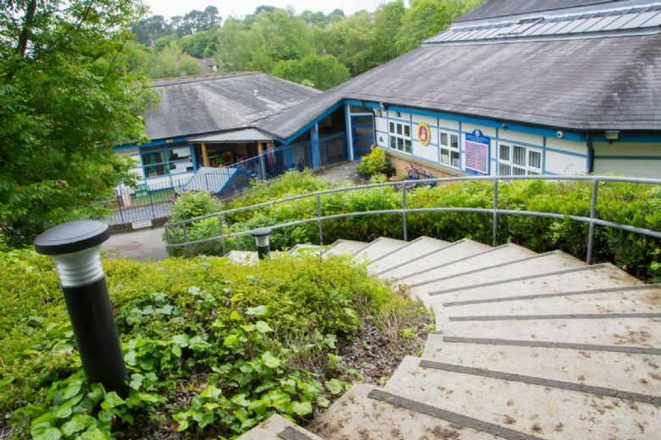

**Henbury View First School**

**Prospectus**

**2025 - 2026**

**Every Child Matters,**

**Every Moment Counts.**

Headteacher: Mrs Sally Wall

Assistant Headteacher: Mr Dan Saunders

Hillside Road,

Corfe Mullen

Wimborne

BH21 3TR

Telephone: 01202 659179

Email: office@henburyview.dorset.sch.uk

School Website: www.henburyview.dorset.sch.uk

For initial enquiries please contact:

Pupil and Parent matters e.g. admission:

Mrs Claire Elms

Extended Services and Premises matters:

Mrs Ingrid Fido

Contents

Welcome to Henbury View First School 3

School Plan 4

Equal Opportunities Statement 5

School Organisation 5

Catchment Area 6

Admissions Policy 6

Class Size 6

School Uniform 7

Crisis Payment for School Uniform 8

Jewellery & Make Up 8

Lost Property 8

The School Day 9

Emergency Closure of the School 10

Breakfast Club, After School & Holiday Clubs 10

The Playground, Safety & Sun Safety 11

Going Home Safely 12

Travelling to and from School 12

Attendance 13

Family Holidays in Term Time 14

Medical Appointments during the School Day 15

The Education Welfare Service 15

Exclusion Times for Infectious Illnesses &

Skin Conditions 15

Prevention 16

First Aid/Sickness in School 16

Head Lice 16

Administration of Medicines 17

Chair of Governors: Ms Natasha Graham

Henbury View First School is a founding school of:

The Hillary Trust

Registered Office:

Unit E

The Mill Yard,

Nursling Street,

Southampton

Hampshire

SO16 0AJ

Disability Equality Scheme 18

Medical Information & School Health Service 18

Pastoral Care 18

Pastoral Assistant 18

Family Support Outreach Worker 19

Child Protection 19

Behaviour 19

Encouraging High Standards 19

Dealing with Unacceptable Behaviour 20

School Council 20

Clubs – Extra Curricular Activities 20

Assemblies 21

Special Educational Needs & Disability (SEND) 21

What do we Teach your Child? 22

Taking Photos at a School Event 22

Charging & Remission Policy 23

Charges for Lost or Damaged Property 23

Voluntary Helpers 24

Home School Links 24

PFA 25

Security 25

Moving on to Middle Schools 25

Governing Body/Governor Meetings 26

OFSTED 27

Information about Henbury View 27

Action Plan Published 27

Privacy Notice – Data Protection Act 1998 28

Contents of Prospectus File 29

**Henbury View First School**

We are delighted you are considering sending your child to our school. We understand that choosing a school is a very important decision and we hope that this handbook and a visit to

the school will help you in making that decision.

Our community is friendly, happy and hard working. We aim to provide an education, which supports our pupils in achieving the highest standards of which they are capable, in a welcoming and safe environment.

Henbury is extremely fortunate to have a beautiful, unique building set within exceptional school grounds, which provides a multitude of opportunities for outside ‘hands-on’ learning.

Our ‘Friends of Henbury View’ enthusiastically organise social occasions, fund-raising events and support the school in whatever is needed, in and out of the classroom. They also play a part in welcoming new parents to our school.

We firmly that our partnership with parents is a key factor in our pupils making progress of which they are capable, and actively strive to listen to parents and share as much information as possible.

# *Our School Vision is…*

# 

***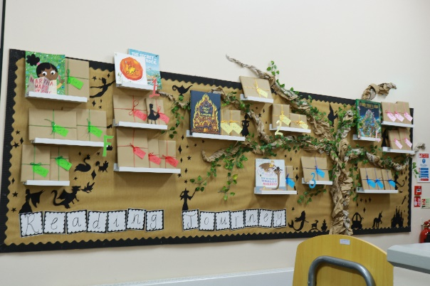*Every Child Matters, Every Moment Counts**

To develop:

* Confident, independent and valued life long leaners.
* Creative problem solvers.
* Respectful, collaborative learners.
* Partnerships in learning.

***Working together we can achieve our aims***

***Henbury View First School.***

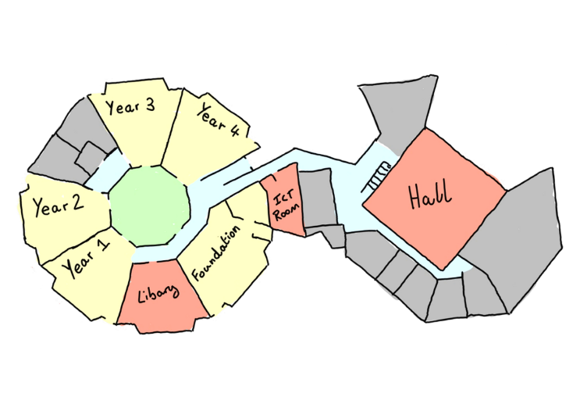

# *Equal Opportunities Statement*

At Henbury View First School we believe that every person, child and adult alike, is entitled to equality in all aspects of school life. Everyone should be respected and valued equally as individuals, regardless of any differences in age, gender, ability, race, disability, beliefs or responsibilities. No-one in our school should feel afraid or intimidated by others for any reason whatsoever. This will enable us to work towards providing a happy, secure environment where all are encouraged to reach their full potential. You can find our Equality Statement and Action Plan on our website.

# *School Organisation*

|  |  |  |
| --- | --- | --- |
| **STAGE** | **Curriculum Year Groups** | **Children’s Ages** |
| **Foundation Stage** | F2 (Reception) | 4-5 years old |
| **Key Stage 1** | Year 1  Year 2 | 5-7 years old |
| **Lower Key Stage 2** | Year 3  Year 4 | 7-9 years old |

Your child will have their own class teacher. However, children may also be taught by the other teachers in the Stage. Teachers are supported by Learning Assistants.

# *Admissions Policy*

Parents are invited to visit the school before making an application for admission for their child. Please telephone the school for an appointment (01202 659179). For admission of pupils with disabilities pleasealso see page 18.

The Governors of Henbury View First School have adopted the Dorset Council’s Admissions Policy.

* Parents will be notified annually of the final date for applications.

Further details of Dorset’s Admission Policy can be obtained:

<https://www.dorsetcouncil.gov.uk/-/starting-school-for-the-first-time#:~:text=You%20can%20apply%20for%20a,after%20the%20on%2Dtime%20round>.

***Class Size***

In Years R, 1 and 2 (ages 4 – 7 yrs.), class sizes may not exceed 30 due to national legislation contained within the Standards and Framework Act 1998.

# *School Uniform* We believe that our uniform looks smart and contributes to a feeling of belonging to our school. Parental co-operation is vital in maintaining our standards and we do appreciate your support.

Parents will appreciate that with so many identical items of clothing in school it is essential that all

clothes are clearly labelled. (Labels can be bought from various outlets.)

***Our uniform consists of:***

**Boys School Uniform**

Grey Trousers or Grey Shorts  
White Polo Shirt  
Henbury View School Jumper  
Grey Socks  
Black Shoes

**Girls School Uniform**

Grey Skirt/Pinafore Dress  
Grey Trousers or Purple/Lilac checked Summer Dress  
White Polo Shirt  
Henbury View School Jumper  
Purple Cardigan  
White Socks or Grey Tights  
Black Shoes

**PE Kit**

Henbury View Team Coloured T-Shirt  
Black PE Shorts  
Tracksuit  
Trainers

**Other items required for school**

Henbury View Book Bag  
Henbury View PE Bag  
Water Bottle for classroom

Kit should be kept in a small drawstring bag or marked with the child’s name and class. Kit should be brought to school on a Monday and go home on a Friday for washing.

# *Buying School Uniform*

Uniform can be purchased from:

It can be ordered online from <https://www.wainwrightscreenprint.co.uk/henbury-view-first-school-133-c.asp>

Non-logo items can be bought from most local supermarkets.

# *Crisis Payment for School Uniform*

A crisis payment for school uniform is now dealt with through the school. There are only a few

circumstances where this is payable. If you believe you may be eligible, please contact the office.

# *Hair, Jewellery and Make up*

School is not the place to experiment with hair, jewellery and make up.

All hair at or below shoulder length must be tied back at all times in school, but especially during PE and games lessons. Hair ties and headbands must be small and discreet. Hair should be off the face, clipped back and not obscuring sight. Hair should be no shorter than a Grade 2 cut and pupils should not wear extreme hair fashions, including dyed or streaked hair and images or lines cut into the hair.

Make up is for special occasions out of school and must not be worn in school, this includes Nail Varnish and Glitter Tattoos or temporary tattoos. Rings, earrings, necklaces and bracelets can be very dangerous both during PE lessons and in the playground. Other than small, plain ear studs, we would ask that no other items are not worn to school.

Children must remove watches and ear studs at the start of PE lessons. Earrings that cannot be removed from newly pierced ears must be covered with tape before your child comes to school to minimise possible injury. The school cannot accept responsibility for any jewellery, lost watches or earrings.

**We strongly recommend that studs and watches are not worn to school on PE days when they would have to be removed.**

***Lost Property***

Children are taught to take care of their own belongings and those of others. Lost property will be put in the cupboard in the entrance hall.

Although reasonable care will be taken, Henbury View First School cannot accept responsibility for the loss of personal items.

# *The School Day*

The two sessions of the school day are: **Morning 9:00 am – 12:00pm**

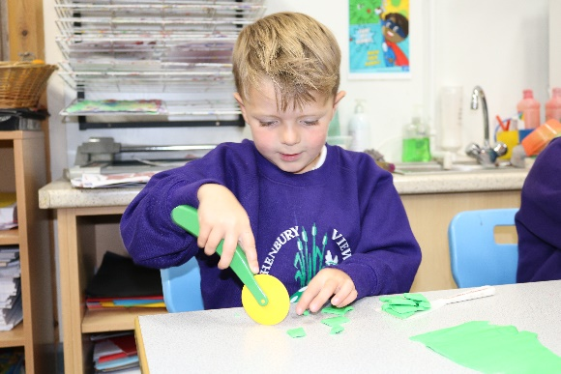

***The School Day***

The two sessions of the school day are:

**Morning** 8:50am - 12:00pm

**Afternoon** 1:00pm – 3:20pm

# *Mornings*

School opens at 8:40am when staff open the gates to allow children to come into the school and be in their classroom ready for registration at 8.50am.

The classroom doors are locked at 8:50am. If, for any reason, your child arrives late at school, they should enter the school by the main door and report to a member of staff in the school office to be signed in.

# *Break times*

All children have a break mid-morning at 10:30am until 10.45am. Key Stage 1 children also have a break in the afternoons at 2:10pm until 2:20pm. Children in Foundation Stage and Key Stage 1 have a daily snack of fruit or vegetable provided free by the Government. Children in Key Stage 2 may bring a named snack from home for morning break. This should be a piece of fresh fruit or vegetable or dried fruit e.g. raisins.

**Water to Drink:** Each key stage area has its own water filter/cooler and water is freely available during lunch. The children are encouraged to drink throughout the day and can refill their water bottles when needed.

# *Lunchtimes*

We are able to offer hot school meals on a daily basis. Our supplier is Chartwells. Please order your child’s meals by logging into your My Child at School (MCAS) app[.](https://dorset.mealselector.co.uk/) You can place your order at any time up until cut off time of **midnight on Sunday – 7 days before the full week in which the meal is to be served.** When placing your order you can order weekly or for a full half term. If your child is going on a school trip and you have ordered a meal it will be converted to a packed lunch for that day. Please note that even if your child is entitled to Universal Free School Meals or entitlement Free School Meals an order has to be placed on the website. We cannot feed a child that has not had an order placed for them regardless of their entitlement.

For those not wishing to have hot school meals, children can bring in a packed lunch. Parents are asked to send packed lunches in an appropriate container, clearly labelled with the child’s name and class. We recommend that these are stored in insulated bags with freezer blocks when required to stop the food going off as we can only store them in a shaded area. For Health and Safety reasons we request that you do **not** send your child in with glass bottles or any form of nuts and sesame seeds (the latter due to some children being allergic to them). As we are a healthy school, please do **not** include chocolate items, sweets or fizzy drinks with your child’s lunch. Children bringing in a packed lunch must place them on the trolley located in their classroom ready for their lunch time. (In Key Stage 2 fruit for morning snack should be sent in separately with the child’s name on it, so that children do not have to go to their lunch box until lunch time). Children whose families are on a low income may be eligible to apply for free school meals.

Please check: <https://henburyview.dorset.sch.uk/parents/hot-meals>

**NB: Free school meals are not granted to children whose parents receive the Working Tax Credit.**

If you believe you are eligible for free school meals please apply by filling in an application form available on the Dorset Council website:

<https://www.dorsetcouncil.gov.uk/education-and-training/schools-and-learning/at-school/free-school-meals>

# *Emergency Closure of the School*

If the weather is bad, parents are advised to look at our school website (www.office@henburyview.dorset.sch.uk[)](http://www.bearwood.poole.sch.uk/). The school will only be closed if the school building is not safe, it has no heating or water, or it has insufficient staff to operate. Please see the school website for the Emergency Closure Policy.

# *Childcare Provision at Henbury View First School*

We are pleased to extend our breakfast club for the academic year 2022-23 to start at the earlier time of 7:30am.

September 2022 – July 2023 Cost (including breakfast)

7:30am-8:40am**£5.00** per day

8am-8:40am **£3.00** per day

If you wish your child to attend they **MUST** be registered, please download and complete a [Breakfast Club Registration Form](https://www.henburyview.dorset.sch.uk/_site/data/files/users/template/files/DB7E3D03282D1A2F8B10ACC974CC347A.doc) and return it to the school office. Please also read and adhere to our [Breakfast Club Terms and Conditions](https://www.henburyview.dorset.sch.uk/page/?title=Breakfast+Club+Ts+%26amp%3B+Cs&pid=41).

Bookings can be made via MyChildAtSchool.com or using the App.

***The Main Playground***

At Henbury View First School we are continually developing our playground. It is filled with exciting and stimulating activities where children can use their imagination and develop their skills and coordination whilst benefiting from being healthy and active. Advice and inspiration for the playground has been sought from a range of people with pupils leading the development.

Lunchtime Assistants ensure a wider range of activities are on offer during the longer break at lunchtime.

***Safety***

The equipment has been chosen to ensure that it is safe to use whenever the weather is suitable for outdoor activities. The only exception to this is the ‘Adventure Trail’ and the ‘Gym Equipment’ which is not used when wet.

The activities in the playground have been designed to encourage children to be active and develop their coordination. Please ensure that your children wear suitable footwear (as described on page 7) so that they can play safely.

The playground has been designed for supervised use during school hours. It would be appreciated if you would support us in ensuring that your **children do not use the equipment before or after school. The school will not be responsible for children using the equipment at these times.**

## *Sun Safety*

We encourage our children to be safe in the sun. Please put sun tan lotion on your child **before** they come to school if necessary. Please note that sun creams are **not** allowed in school due to the risk of allergies.

# *Going Home Safely*

Children should be collected from their classroom door. Please ensure that the school are aware of any changes to your normal going home routine.

Occasionally, an emergency may make you late for collecting your child from school. Please take a few moments to telephone the school to alert us. When you arrive at school, please collect your child from the main entrance, or provide the name of another trusted adult you have given permission to, to collect your child.

If you have made arrangements for your child to be collected from school by an ‘After School Club’, please ensure that these arrangements have been communicated with school.

# *Travelling to and from School*

Henbury View First School has a ‘Healthy School’ ethos and so encourages as many children as possible to walk, scoot or cycle to and from school.

On those occasions when children have to be brought or collected by car, we ask that you park in nearby roads, without obstructing access to neighbouring properties and walk your child into school. The school car park is currently to parents.

**For the safety of all children, please drive slowly in the vicinity of the school and not above 10mph within school premises. The safety of our children and the school community is paramount.**

# *Attendance*

It is important for your child’s future that he or she makes the most of his or her time at school. This means attending regularly and turning up on time, qualities valued by employers. Good attendance is considered to be 96% plus. Every school has a legal duty to ensure children have the opportunity to achieve at school. All parents will receive a letter each half term informing them of their child’s current attendance. The Headteacher and Family Support Worker meet regularly to monitor attendance and identify all pupils whose attendance falls below 90%. The Headteacher will contact parents/carers if there are concerns about the level of attendance or punctuality at school. If there is a problem or medical condition that is likely to continue to affect attendance, please contact the Headteacher.

***Information for parents/carers*:**

* By law, you are responsible for making sure that your children are educated between the ages of 5 and 18.
* If your child is registered at school, he or she must go to school on time every day during termtime, unless there is a good reason (such as illness). If they do not go to school regularly, you may be fined.
* It is your responsibility to tell the school if your child cannot attend.
* If attendance problems do develop, the school will expect you to help their staff and the education welfare service to solve the problems.
* You do not have a right to take children on holiday in term-time. All requests for leave in term time must be considered by the school beforehand. See ‘Family Holidays in Term Time’ overleaf.

**First Day Contact**

If your child is unable to attend school, it is **the parent’s responsibility to contact the school on the first day of absence.** Please telephone the school by 8.50am (a message may be left on the answer machine) or email the school office. If we do not hear from you, we will try to make contact with you to confirm the reason for absence. **For each day of their absence you will need to call us so that we can ensure your child’s safety and prevent truancy.**

Please send a note to the class teacher on your child’s return to school to confirm the dates and the reason for absence.

Registers are legal documents that are marked at the start of the morning and afternoon sessions. The Education Pupil Registration Regulations 1997 identifies four broad classifications in attendance registers:

***Present***

*Pupil is on school premises at time of registration;*

***Approved Educational Activity***

*Pupil is engaged in an approved, supervised activity off site;*

***Authorised Absence***

*Pupil has the authority of the school to be absent, either given in advance (e.g. hospital appointment) or afterwards (e.g. on notification of illness);*

***Unauthorised Absence***

* *No explanation received or unacceptable reason given*
* *Lateness is, by law, unauthorised absence after the register closes at 9:05am*
* *Absence for no reason or for which no reason has been offered is unauthorised absence.*

Parents are reminded that the provision of a note does not in itself make the absence authorised. **Only the school, within the context of the law,** can approve absence. Your child’s attendance figures will be included in their End of Year School Report.

# *Family Holidays in Term Time*

Pupils of school age must, by law, attend school regularly. Amendments have been made to the 2006 regulations in the Education (Pupil Registration) (England) (Amendment) Regulations 2013. These amendments **came into force on 1st September 2013.** These amendments remove previous references to family holiday and extended leave as well as the statutory threshold of ten school days. The amendments also reduce timescales for paying a penalty notice from 28 days to 21 days.

This new law means that we are no longer able to authorise **any** absence from school during term time. It clearly states that the Headteacher may not grant any leave of absence during term time unless there are **exceptional circumstances AND current attendance is at least 96%.** An example of exceptional circumstances may be that a family member in the armed forces is returning home from Active Duty in term time or like previously where Police leave was cancelled at the time of the Olympics. If leave is taken without authorisation, it will be recorded in the school attendance register as an unauthorised absence. If the overall attendance level continues to be below expected standards, parents may be contacted by the Educational Welfare Officer.

# *Medical Appointments During the School Day*

Please give your child a note with details of the times and reason to hand to the class teacher or notify the office and provide a copy of the appointment letter prior to the appointment. When collecting or returning your child from an appointment during the school day, please check them in and out at the office in order to maintain an accurate register.

# *School Attendance*

Parents have a legal duty to ensure full attendance at a school where their child is a registered pupil. Where regular unauthorised absence occurs the school must refer to the school Attendance Policy. (See school website).

Through the tracking of attendance, the school will ensure that parents are informed when their child’s attendance is lower 95%. They will arrange to meet with families to discuss ways of improving attendance.

An average attendance of 90% means that a child misses the equivalent of more than a year’s education overall.

# *Exclusion Times for Infectious Illnesses and*

***Skin Conditions (as per guidance from Health Protection Agency)***

|  |  |
| --- | --- |
| Chickenpox | Six days from appearance of rash |
| German Measles (Rubella) | Until recovered from symptoms |
| Measles | Four days from appearance of rash |
| Mumps | Until swelling has subsided |
| Whooping Cough | Seven days after starting treatment |
| Conjunctivitis | Until treatment started |
| Impetigo | Until treatment started & infected area has healed over |
| Verruca | Cover infected area when participating in barefoot activities |
| Scabies | Until treatment started |
| Ringworm | Until treatment started |
| Head Lice | Until treatment started (the whole family should be treated with the recommended lotion which is available at any chemist). |

# *Prevention*

We take particular care to prevent outbreaks of tummy upsets. Please keep your child off school for **48 hours after** the last attack of diarrhoea or vomiting. This is important to stop the spread of infection.

Younger children who have had a disturbed night for whatever reason need to be kept home the next day.

Please remind your child to wash his/her hands after going to the toilet and before eating their lunch.

# *First Aid/Sickness in School*

The school has a number of qualified First Aiders among teaching and non-teaching staff. First Aid in school is intended for minor ailments, nosebleeds, bumps and grazes only. It provides for an otherwise healthy child to continue their day in school.

Children who complain of feeling unwell, or who need more specialist attention will be sent home. **It is therefore essential that the school has a current daytime telephone number for this purpose and two alternative persons to contact should you be out.**

# *Bumped Heads*

If your child has bumped their head at School a call will be made to the parent to advise. The child will also be given a ‘Bumped Head note’ so that all staff are aware.

# *Head Lice*

Head lice are a community based problem. Parents need to be aware of what to look for and how to treat.

Head lice are tiny creatures, just one or two millimetres in size. Children and adults can catch them and contrary to popular myth, these small insects are not attracted to dirty hair. They feed on blood from the scalp and the warmth incubates new eggs which are cemented to strands of hair. They are spread by head to head contact. After some weeks of infestation itching will occur. Your GP or local pharmacist can advise you on appropriate methods of treatment.

Prevention: Ensure your child’s hair is thoroughly combed daily and check the hair regularly to spot any infestation early.

**Parents are responsible for checking their own child/children,** but help can be accessed from the School Health Team ([dhc.snadmin.hub@nhs.net](mailto:dhc.snadmin.hub@nhs.net) Tel: 01929 557558), Practice Nurses, Chemists and Health Visitors.

# *Administration of Medicines*

There may be occasions when a child returns to school after an illness when a course of treatment is not finished. Medicines prescribed for 3 times a day should be given at home; morning, afternoon and bedtime. **Medicines will only be administered at school, where more than 3 doses a day are required and on completion of the ‘Request for Medication to be administered at school’ form.**

All medicines requiring 4 doses a day may have the second dose at 12 noon. **This must be prescribed medication and have the original prescription labels detailing the child’s name and dose.** Medication should be handed into the school office each morning and collected at the end of the day.

**Please note that school staff supervise children taking medicines as a courtesy and not as a duty. Responsibility for children’s medication remains with the parents.**

Children are encouraged to keep their own inhalers in a safe place in their classroom so that they are easily accessible when required. These inhalers should be labelled with their name and class.

**For those medications that need to be administered on a long term basis, please contact the Headteacher for advice.**

***Up to date contacts***

It is essential that you keep the school updated with any changes to your contact details in order that we may contact you in case of an emergency. This includes having a minimum of 3 emergency contact numbers recorded for your child.

It is also extremely important that the school is notified of any change of circumstances regarding**:**

**Health**

**Address**

**Telephone Number**

**Parental Responsibility**

You can do this by amending your details via the My Child at School (MCAS) app that you can download to your phone or by visiting the website. The link is on the Home page of the school website.

# *Disability Equality Scheme*

The school will make arrangements for the smooth admission of pupils with disabilities whenever possible (see also page 6), and take steps to ensure that disabled members of the school community are not treated less favourably than others. The school premises are on one level and fully accessible by pupils with disabilities. Disabled parking spaces are provided in our car park. Parents of pupils with disabilities are requested to complete a Healthcare Plan (see below) and provide additional information as appropriate. Parents and carers with disabilities are also given the opportunity to share accessibility needs with the school so that everyone feels welcomed and valued.

# *Medical Information*

Parents must complete a school medical form for all children who have a long term medical need. **Contact details must be up to date at all times.** When the school may need to make different provision for a child with a long term medical need, parents will be contacted by the school nurse to complete a more detailed healthcare plan.

# *School Health Service*

Your child will be medically examined during the first year at School. You will be notified when this examination will take place, so that you can be present.

# *Pastoral Care*

We regard the school as a large family where the children are encouraged to take pride in themselves and their environment, to show consideration and respect for each other and to be trustworthy and hard working. The class teacher, who knows each child well, is responsible for the pastoral care of the children in his or her own class.

**Should you have any concerns about your child’s well-being, please contact your child’s class teacher in the first instance, either in person at the end of the day; by sending in a note or contacting the office for an appointment.**

# *Family Support Worker*

At Henbury View we are fortunate to have a Family Support Worker whose role is to monitor the social, emotional and well-being of pupils. She provides advice and guidance to parents on a range of family issues such as relationship issues, sleep, bedwetting and attendance. Her role is to signpost to outside agencies. She also supports family relationships, debt, mental health, domestic violence and alcohol abuse. Please contact the school office if you would like a meeting.

We have a fulltime family support worker who is a member of our pastoral support team. Their role is to offer advice and guidance to parents and staff within school on behavioural and emotional problems, relationship difficulties in school, bedwetting and soiling. She also supports families with issues which may affect children and their education including family relationships, debt, mental health, domestic violence and alcohol abuse.

# *Child Protection*

School staff are governed by very clear rules about child protection. These are laid down in a Government Circular 10/95 “Protecting Children from Abuse: The role of the Education Service”. Where school staff see signs that cause them concern they should seek information from the child with tact and sympathy. **School staff have a professional responsibility to share relevant information about the protection of children with other professionals, particularly the investigation agencies.**

School staff should act within procedures established by the local Child Protection Committee. The Headteacher or another senior member of staff is designated as having responsibility for liaising with the local Social Services Department and other agencies over cases of abuse.

**The designated teacher for the school is Mrs Wall. In her absence the designated people are Mr Saunders, Mrs Saunders and Mr Guppy.**

School staff should report all cases of suspected abuse to the designated teacher. The designated teacher must refer to the local Social Services Department.

# *Behaviour Encouraging High Standards*

Good Behaviour is a goal we are all working towards. At school we reward success and good behaviour. Achievement is recognised through praise and the award of stickers, badges and certificates. Work is displayed around the school. Individual and group achievement is celebrated in special assemblies and in newsletters. Please see our behaviour policy on the school website

We aim to help children acquire self-discipline and an increasing awareness of the needs of others. We follow a programme of PSHCE (Personal, Social, Health & Citizenship Education called ‘Jigsaw’) and ‘Circle Time’ which helps the children to understand themselves and the needs of others.

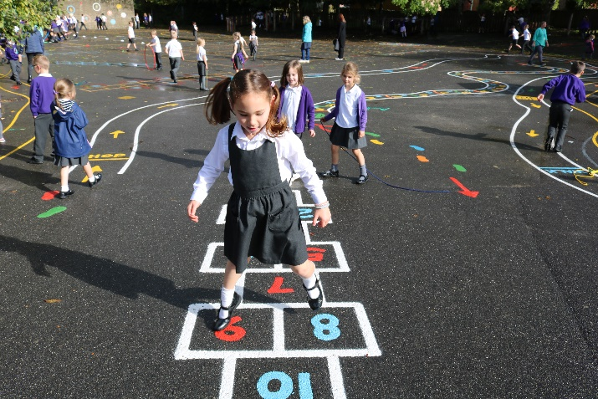***Dealing with Unacceptable Behaviour***

It is important that children understand why certain behaviour is considered unacceptable. Misdemeanours are dealt with by staff on the spot and, depending on the seriousness of the matter; children can be referred to senior members of staff for further action, often in consultation with parents.

For normal incidents we:

* Investigate to establish circumstances, and responsibility, if any.
* Talk it through with the children involved. Obtain an apology if appropriate. If necessary ‘time out’ is given or removal of privileges e.g. playtime.

Parents are consulted as early as possible in order that problems can be discussed, usually in the presence of the child. It is our aim to establish common understanding of acceptable behaviour between home and school. There is no place in our school community for the following examples of misbehaviour: bringing harmful substances into school, bullying, dishonesty, disobedience, poor effort and distracting others, racial abuse, rudeness, spitting, swearing, truancy, violence and vandalism.

# *Clubs – Extra Curricular Activities*

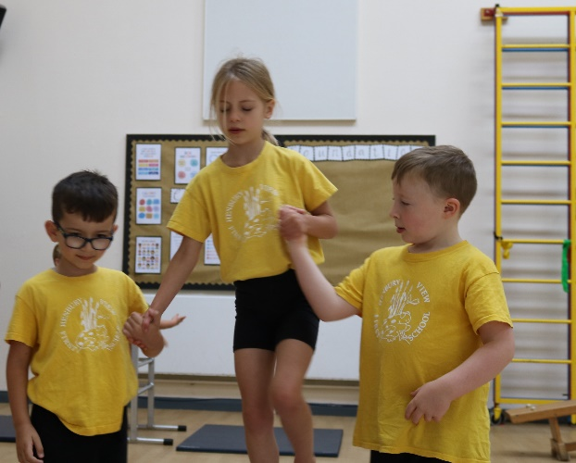Henbury View offer a variety of extra-curricular activities. This is seen as a valuable contribution to a child’s education. Some activities are offered voluntarily by staff who run them in their own time; some activities are provided by other agencies with a charge. Activities take place at lunchtime or after school. Children and parents will be notified termly of the activities available to the children and how they can participate. These are also available on the school website.

If an after school activity has to be cancelled at short notice, i.e. on the day itself – due to staff sickness or other unforeseen circumstance – we will endeavour to contact you to arrange for your child to be collected at normal time.

# *Our School Council*

At Henbury View First School, we value the ideas and opinions of our children. In order to provide a forum for all children to have a ‘voice’ we have Class Councils weekly which take place in each class with all the children and their teacher. All the children are trained at holding meetings, taking minutes and setting agendas.

Being a school council rep is considered to be an important role in school, thus the children are encouraged to think carefully before committing themselves to a year in ‘office’.

Hustings are held, where the children can explain to their class mates why they feel they would make a good school rep. Elections are then held, with each child being given the opportunity to vote for their chosen candidates.

The School Council meet throughout the year to work on themes raised from class councils by members of the staff or community with some issues being quicker to resolve and others taking a longer period of time.

# *Assemblies*

Children at Henbury View First School participate in assemblies daily.

The school has a Celebration Assembly when individual children are celebrated for Respect or Learning. Their names and work are displayed in the hall. We also celebrate good routines that underpin learning such as attendance, punctuality, homework and PE kit.

Parents may withdraw their children from all or part of the collective worship provided. These parents should put their request in writing and discuss their wishes and alternative provision with the Headteacher.

# *Special Educational Needs and Disability (SEND)*

At Henbury View First School we believe that each child is special and should be valued and responded to as an individual. When we use this term ‘special needs’ at school, however, we are referring to the legal definition.

**COP 2014 definition**

* A pupil who has significantly greater difficulty in learning than the majority of others of the same age.
* A pupil who has a disability which prevents or hinders them from making use of the educational facilities of a kind generally provided for others of the same age in mainstream education.

Provision for identifying, assessing, monitoring and providing for pupils with special educational needs is stated in the SEN and Disability Policies. Provision at Henbury View First School is overseen by the Governors and Headteacher, and implemented by the SEN Co-ordinator.

Once a potential SEN is identified the class teacher and SENCo will analyse pupil’s needs. In collaboration with parents, they will plan intervention and support to help the pupil both at home and school. Provision will be reviewed and if a pupil is not making progress, a referral may be made to an outside agency. The outside agency will provide additional advice to the class teacher for meeting the learning needs of the pupil.

The school uses its SEN and Disability budgets flexibly to support the identified needs within the school. During the last year, the Behaviour Support Service, Educational Psychology Service, Speech and Language Therapy, Literacy and Numeracy Support Service and the Vision Impairment Unit have all provided support to the staff and children.

A reference copy of the full Special Educational Needs and Disability policies are available on the school website. The Special Needs Co-ordinator can answer any queries on these policies.

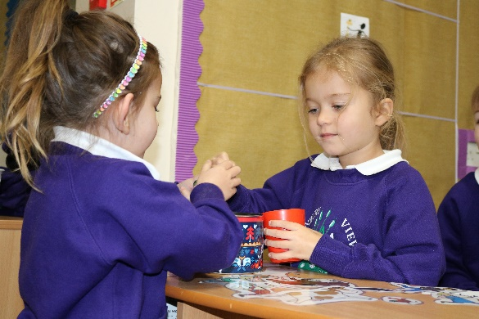***Teaching your Child***

Members of staff use a variety of teaching styles and techniques, which relate to the task and the needs of the children in the classroom. These include whole class teaching and group work; both mixed ability groups and groups organised according to ability; working in pairs and individually.

## The Curriculum

The curriculum your child is taught is based on the Foundation Curriculum for pupils in the Nursery and Reception Years and the New National Curriculum 2014 for pupils in Years 1 – 4. We have mapped out the curriculum we teach in each class to ensure that it is progressive. For parents who have access to the internet, you may also find the DFE website of interest – [www.education.gov.uk.](http://www.education.gov.uk/)

## D:\DCIM\100CANON\IMG_9862.JPGMonitoring Pupil Progress

The school tracks the progress of every child. Their progress in Reading, Writing and Maths is formally reviewed termly and this is used by teachers to inform next steps in learning.

## Home Learning

Our curriculum included a programme of home learning activities designed to reinforce or extend the work taught in school.

## Religious Education (RE)

Parents may withdraw their children from all or part of the religious education and collective worship provided. Parents should put their request in writing and discuss their wishes and alternative provision with the Headteacher.

**Internet Access**

A copy of our policy and permission form are available on our school website.

## Taking Photos at a School Event

Parents may take photos and video at school events for their own personal use – **and such photos must not be posted on any internet site.**

# *Charging and Remission Policy*

Charges for activities and events organised by the school may be requested for the following:

* Ingredients and materials used in school (e.g. cooking, model construction) when the parents express the desire to own the finished product;
* Activities which take place in school hours (e.g. visiting speaker);
* Extended visits which take place during the school day and beyond (e.g. theatre visits, field trips, residential visits);
* Activities which take place after school hours (e.g. sports tournaments, discos, concerts);
* Instrumental tuition provided by specialist providers, including the cost of hiring the instrument.

Each visit or activity will only take place if sufficient voluntary contributions are received to enable us to fund it.

In cases of family hardship (e.g. where parents are in receipt of income support or E.S.A) the Governors may be prepared to meet all or part of the cost of visits and activities. Parents requiring such assistance should apply, in confidence, to the Headteacher.

If the shortfall on voluntary contributions is so great that the visit or activity is cancelled, all monies collected will be returned.

If a child is unable to take up their place on a visit due to illness or other unforeseen circumstances, the school will be unable to refund any payment which has already been made to another organisation.

These visits and activities enhance and support the school’s curriculum and we rely on our close partnership with parents to help us provide the best opportunities for the children in our care.

It should be noted that:

* Parents will always be notified of occasions when children will be taken off school premises for educational purposes though permission will not be required.
* The school reserves the right to leave behind any child whose behaviour is a danger to him/herself or to others.

# *Charges for lost or damaged property*

Children are taught to take good care of school property including library books which children can take home.

A nominal charge of £5.00 is made towards replacing the book should a library book be lost or damaged.

Similarly, parents are asked to make a donation towards any deliberate damage of school resources/premises.

# *Voluntary Helpers*

Some parents and friends have time during the school day when they are able to come into school and help with a variety of activities, such as listening to children read, helping with activities in the classroom, making materials and displaying work. Other parents who have time in the evenings or at weekends help with making materials and learning games. A small number of parents assist with out of school clubs and sports activities. From time to time parents assist teaching staff on educational outings and residential trips. Children benefit enormously from working with adults. If you would like to help regularly or occasionally, please contact the school office.

Please note that volunteers will need to complete an application form and they will be checked by the DBS (Disclosure and Barring Service). The school office staff will assist you in this.

# *Home – School Links*

We believe that parental attitude to a child’s schooling is a very important factor in the success of that child’s education. At this School we lay great stress on the value of home/school co-operation. Our Home-School agreement sets out ways in which we can support each other, and includes reference to our Home Learning and Behaviour policies which are enclosed with this School Prospectus.

If we are concerned about your child’s progress, happiness or behaviour we will contact you. Likewise, would you please contact us if there should be any circumstances that may affect your child’s happiness, behaviour or progress?

You can update your child’s teacher by sending a note in with your child, emailing the class email or contacting the school office. It will often be possible to see the teacher at the end of the school day when you collect your child. Please try to avoid before the school day when the teachers are setting up lessons for the day and whenever possible provide any information in writing.

Class teachers welcome parents at any mutually convenient time. To contact us please send a note to your child’s class teacher or telephone for an appointment and give some indication of the matter you wish to discuss. We will get back to you to arrange a meeting within 24 hours.

We also invite all parents to Parents’ Consultation Evenings in the Autumn and Spring terms. You will also receive a written End of Year Report in July.

There will be many opportunities to be an active partner in your child’s education. Spending a few minutes daily to talk about the day and understand what your child is doing at school, supporting a good home learning routine, attending class assemblies, school performances, visiting the library and places of interest to special events like sports days.

# *PFA*

Henbury View First School has a Friends of Henbury. The objectives of the Association are to advance the education of the pupils in the School by:

* Engaging in activities that support School.
* Providing and assisting in the provision of facilities or items for education at School (not provided for from statutory funds).

Developing more extended relationships between staff, parents and other associated with, or interested in, the School.

The Friends have provided our school with funds towards equipment for our School Playground; purchased reading books, live drama performances, contributions to trips etc

The Annual General Meeting of the Friends takes place each year in the Autumn Term when a new Committee is formed and constitutional changes can take place.

All members of the school community are automatically members of the Friends. New ideas for fund raising and social events and offers of help are always welcome.

The Henbury Friends committee can be contacted through the school office.

# *Security*

It is the right of every child and member of staff to feel safe and secure whilst in school. Parents and visitors are reminded to always enter the building via the main entrance and report to the office. **All visitors to the school need to sign in at the office in the presence of a member of staff.** They are given a security badge which must be worn at all times. Visitors wearing other badges e.g. Poole Local Education Authority will also be required to sign in and wear a school security badge.

# *Moving on to Middle Schools*

At the end of Year 4, children leave Henbury View First School and move on to a Middle School. Currently many children choose to go to Lockyers, the nearest school, whilst others will choose to attend an alternative school within Dorset

Details about the application process are provided in the summer term, one year before children start Middle Schools.

Once places at Middle Schools have been confirmed, senior teachers visit the school each year to talk to the children about their school.

# *Governing Body*

The Governing Body makes decisions about how the School is run. It has many legal duties, powers and responsibilities, including the selection of staff, the oversight of the curriculum and the organisation of the school budget.

**School Governors include:**

* Parents

* Staff

* Persons appointed by the Local Authority

* Community representatives

**Parent Governors:**

* Have a child in the school;

* are elected by the parents of the school;

* serve, as do other governors, for a term of 4 years.

Parent Governors bring a parent viewpoint to the governing body but they speak as individuals. They are not delegates of the parents. An up to date list of governors is available on the school website.

# *Governor Meetings*

The full Governing Body meets at least once a term. A copy of the Minutes of Governing Body Meetings are available by request at the school office.

# *OFSTED*

Henbury View First School was inspected in 2023 as part of the national programme of school inspections. The purpose of such inspections is to look at the work of the school and the judgements the school is making about how well it is doing and what its improvement priorities are. Henbury View First School were awarded an Outstanding rating.

## OFSTED Inspection Report

Dates of Inspection: 29th and 30th November 2023.

Reporting Inspector: Jen Southall

A copy of the full Inspection Report is available on the school website or at [www.ofsted.gov.uk.](http://www.ofsted.gov.uk/)

# *Information about Henbury View First School*

Information about Henbury View First School, including performance tables can be found at [www.education.gov.uk](http://www.education.gov.uk/)

***Privacy Notice – Data Protection Act 2018***

We, **Henbury View First School,** are a data controller for the purposes of the Data Protection Act. We collect information from you and may receive information about you from your previous school and the Learning Records Service. We hold this personal data and use it to:

* Support your teaching and learning;
* Monitor and report on your progress;
* Provide appropriate pastoral care, and
* Assess how well your school is doing.

This information includes your contact details, national curriculum assessment results, attendance information and personal characteristics such as your ethnic group, any special educational needs and relevant medical information.

***We will not give information about you to anyone outside the school without your consent unless the law and our policies allow us to.***

We are required by law to pass some information about you to the Local Authority and the Department for Education (DFE).

If you want to see a copy of the information about you that we hold and/or share, please contact **Mrs C Elms** office@henburyview.dorset.sch.uk

If you require more information about how the Local Authority (LA) and/or DfE store and use your information, then please go to the following websites:

<https://www.dorsetcouncil.gov.uk/w/family-information-service-privacy-notice?redirect=%2Fyour-council%2Fabout-your-council%2Fdata-protection%2Fservice-privacy-notices>

<http://www.education.gov.uk/researchandstatistics/datatdatam/b00212337/datause>

If you are unable to access these websites we can send you a copy of this information.

**We welcome your feedback on our Prospectus and Website. Does it contain the information you need to know? Is it clear? Is there anything else you would like to be included? Please contact the school office by letter or email with your comments.**