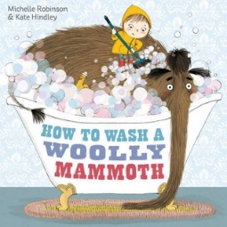
English
Writing
In English, we will start by building on the skills learnt in Year 2 to create a detailed set of instructions. We will use the book ‘How to wash a woolly mammoth’ by Michelle Robinson to help us learn about the genre for our own imaginative instructions. Through this learning journey, we will be focusing on using organisational devices, prepositions of place, time adverbials and identifying when to use ‘a’ or ‘an’.
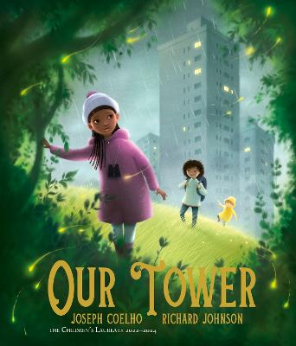
Our fictional piece of writing will look at the book ‘Our Tower’ by Joseph Coelho and Richard Johnson. We will use the book to develop our understanding of subordinate clauses, possessive apostrophes and paragraphs and then write our own fantasy stories using inspiration from the book.

Spelling
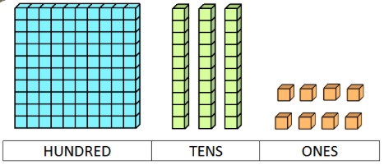
This half term we will look at consolidating the Year 2 spelling rules. Our spelling sessions will involve us continuing with the Read Write Inc scheme; please continue to use the spelling logs to help your child re-visit our spelling focus each week. We would ask if you could ensure that your child’s spelling log is in their book bag on a Friday as this is when we will update them with the current week’s list of words for you to practise at home.
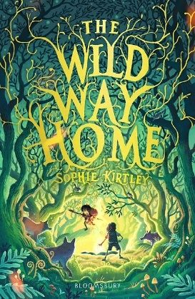
Reading
Within our reading sessions this half term, we will be looking at the text ‘The Wild Way Home’ by Sophie Kirtley. We will be working on word reading and fluency as well as comprehension using 4 types of questioning; retrieval, interpret, choice and thinking.
Within the classroom, we will also build in lots of opportunities to promote a love of books and reading. This might include time in the book corner to read independently, discussions around books and whole class story times.

Maths

In Maths, we will start by looking at 2-digit and 3-digit place value. We will be using the terminology of hundreds, tens and ones to help describe the value of each digit in these numbers. We will start by using multiple concrete and pictorial representations to help identify, represent and estimate numbers (for example, dienes, place value counters, number lines, etc.) before moving onto problem solving contexts, such as comparing and ordering 3-digit numbers.

It is vital that children are secure in this area as this is fundamental when teaching more formal methods of addition and subtraction as well as other areas of maths.
Every day, the children will be taught and have time to practise times tables, followed by a dedicated Maths lesson every Friday focused on multiplication and division facts.

Homework and Home Learning

Homework: Each week, the children will have a small piece of homework to complete. Please hand this in on a Wednesday and new homework will be sent home on a Friday.
Reading: Please continue to read as much as possible at home and record at least 3 reads per week in the homework diary.
Spelling: Please practise the words in the spelling log each week.
Times Tables: Please practise your child’s step on the ‘Maths Rockstars’ log as this will be quizzed each week to see if the children are ready to progress. To do this, you could use Times Tables Rockstars (logins stuck in front of Reading Logs).
Wider Curriculum Home Learning: You will receive a separate sheet of home learning ideas that could support the learning that we are doing in school. However, please only take these as inspiration and follow the children’s interests if they have their own ideas.

Wider Curriculum

History
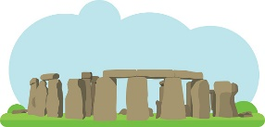
Our history this half term transports us back into life during the Stone, Bronze and Iron Age. We will learn about how life changes between the periods, from hunter-gathering to a life revolved around farming. We will discover places of importance in our locality (e.g. Stonehenge, Badbury Rings) and understand what these sites can teach us about the past.

Science
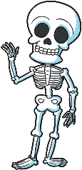
In Science, we will be learning about animals, including humans. We will look more deeply at the human skeleton, naming bones and identifying their uses. We will explore why we have skeletons and identify animals that have different types of skeletons. We will learn about the role of muscles and create models showing how they allow us to move.
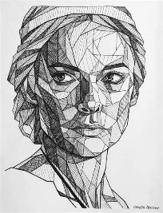
Art
Art this half term is focused around developing our drawing knowledge. We will use the work of artist Chowwai Cheung to explore geometric line as well as monochromatic and neutral colours. We will experiment with using tone to create form and apply this to create a geometric portrait.
PE
We will be starting this year with fundamentals and gymnastics. Warm clothing for outdoor PE is recommended when it starts to get colder. We ask that the children bring their PE kits into school on a Monday and we will send them home on a Friday.
The PE days for this half term are:
- Thursday (PM): Gymnastics (inside)
- Friday (AM): Fundamentals (outside)


French
As the children have now moved into Key Stage 2, we will begin to introduce weekly French lessons into our curriculum. This half term, the children will start by learning simple greetings and saying how we feel.

Snacks
In Year 3, the children are no longer provided with a free piece of fruit at snack time. Please send your child to school with a snack if you wish to, and we ask that this is still a healthy choice.
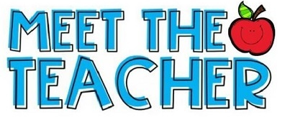

Thursday 10th September @ 3:30pm
There will be a ‘Meet the Teacher’ meeting in the Year 3 classroom where we will share information regarding the year ahead and take any questions you may have.
Welcome to Year 3!
Autumn 1 Curriculum Leaflet



Mrs Nicoll Miss Stainton
Mr Guppy

Welcome to Year 3! We are all excited to be working with you and your children this year. We hope you find this information helpful and useful.

If you have any questions, or need to speak to us, please email either the school office or us directly at:
year3@henburyview.dorset.sch.uk

Dates for the Diary
Thursday 10th September @ 3:30pm: Meet the Teacher
Tuesday 15th September: Individual Photos
Tuesday 6th October: IEP Meetings
Friday 16th October: Friends Disco
Thursday 22nd October: Year 3 & 4 Harvest Performance

