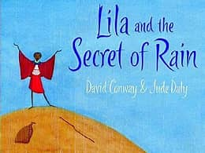
English
Writing
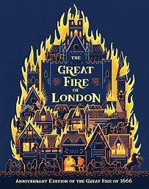
In English, we will start by consolidating and building on the skills learnt in Year 1. We will explore a new book, Lila and the Secret of Rain. We will continue to apply our knowledge of accurate sentences, descriptive vocabulary and conjunctions in order to write a new story based on the book.

We will then use the book ‘the Great Fire of London’ by Emma Adams and James Weston Lewis as an inspiration for some non-fiction writing. This will help us to learn some key vocabulary for our writing and to support our learning in History. Our non-fictional piece of writing will be a set of instructions for fire safety. We will use a range of examples of instructions to develop our understanding of their format and structure.

Phonics and Spelling
This half term we will start by consolidating our Year 1 phonics, spelling rules and red words. Please continue to use the spelling logs to help your child re-visit our spelling focus each week. We would ask if you could ensure that your child’s spelling log is in their book bag on a Friday as this is when we will update them with the current week’s list of words for you to practise at home.

Reading
This half term, Year 2 will have a range of opportunities to develop both their reading fluency and their comprehension skills. We will focus on 4 types of comprehension skills: prediction, inference, retrieval and sequencing.
Within the classroom, we will also build in lots of opportunities to promote a love of books and reading. This might include time in the book corner to read independently, discussions around books and whole class story times.
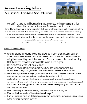
Also, please continue to read at home with your children as much as possible- it really does help to not only promote this love of reading but also develop both fluency and understanding.

Home Learning

You will receive a separate sheet of home learning ideas that could support the learning that we are doing in school. However, please only take these as inspiration and follow the children’s interests if they have their own ideas. Please continue to read as much as possible at home and practice the words in the spelling log each week.

Maths
In Maths, we will start by looking at the place value of numbers to 100. We will be using the terminology of tens and ones to help describe the value of each digit in these numbers. We will start by using concrete and pictorial representations to help identify and represent numbers (for example, dienes, place value counters, number lines, etc.) before moving onto abstract representations.
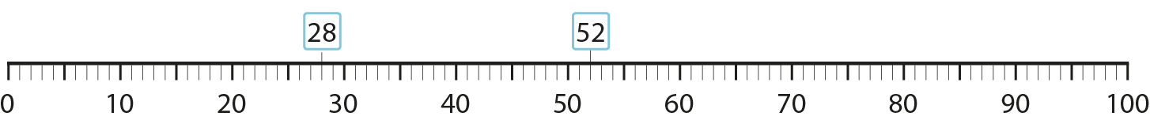
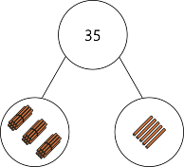
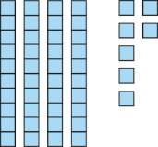

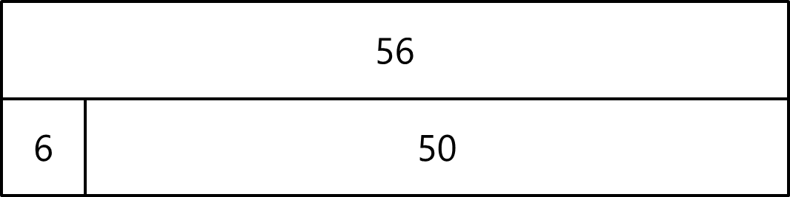

Later in the half term, we will revisit addition and subtraction, extending the children’s current knowledge to include 2-digit and 1-digit numbers.


Times Tables
Times tables are vitally important for progress in lots of areas of mathematics. By the end of Year 2, children are expected to recall multiplication facts for the 2x, 5x and 10x tables. This half term, we will be starting our ‘Maths Rockstars’ challenges and introducing TTRockstars. More information about this will be shared at Meet the Teacher meetings. We would appreciate any practise of times tables at home!

Wider Curriculum

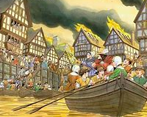
History
Our history this half term transports us back into 1666 and the Great Fire of London. We will learn about the events during the Great Fire and explore what led to the event and what the consequences were. The children will learn about the key people involved in the event and will consider who was at fault. After comparing the Great Fire with similar events and exploring the causes of the fire, the children will think about the precautions that can be taken to ensure it never happens again.

DT
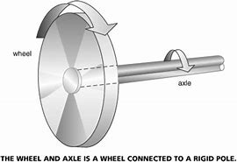
In DT this half term, Year 2 children will become the designers of a new type of fire engine! After examining various current products, the children will identify the most effective materials for their design. The children will then learn about wheels and axles and select tools to accurately measure and cut dowel for their axle. They will learn how to work safely when cutting and joining their materials.

PSHE
This half term, our PSHE lessons have a focus on ‘Being Me in My World’. We will be exploring the children’s hopes for the future, as well as discussing any worries they may have. We will be focusing on our rights and responsibilities, both inside and outside of school. This will help the children to understand their role in ensuring their classroom is a safe and happy place, and the impact their choices can have on this.

Science
In Science, we will be learning about everyday materials. We will revise our knowledge from Year 1 about the properties and names of different types of materials. We will then think scientifically to solve problems using our knowledge.

PE
We will be starting this year with fundamentals and gymnastics. Warm clothing for outdoor PE is recommended when it starts to get colder. We ask if the children can bring their PE kits into school on a Monday and we will send them home on a Friday.
The PE days for this half term are:
- Monday (AM): Gymnastics (inside)
- Wednesday (PM): Fundamentals (outside)

Welcome to Year 2!
Autumn 1 Curriculum Leaflet

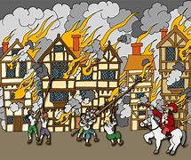
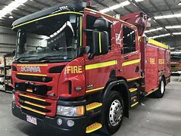

Miss Biles Mrs Connor

Welcome to Year 2! We are excited to be working with you and your children this year. We hope you find this information helpful and useful. If you have any questions, or need to speak to us, please email either the school office or us directly at:
year2@henburyview.dorset.sch.uk

Dates for the Diary
15th September: Individual school photos
15th October – Yr 1 and 2 Harvest Assembly @2.45pm
23rd October: Half term holiday
2nd November: INSET
Please check the newsletter for further dates

