Intent
This half term, we will be spending time becoming familiar with the classroom, school and each other. We will be exploring what makes us all unique as well as the similarities with have with each other. We will begin to build our fundamental knowledge across the Early Learning Goals as well as supporting each other to feel safe and valued in our class. We will spend dedicated time getting to know each other, our families and our immediate environment.
Key lines of inquiry:
Who am I? What makes me special? Where do I live? What do I know about Autumn? Who is in my family? What are my hopes and dreams? What is the past, present and future? What similarities and differences are there between us?

Communication & Language
This half term, we will be focusing on becoming more confident talking to our friends and communicating with adults. We will give the children opportunities to share things whole class, in small groups and individually depending on their confidence level and look at ways our questioning can encourage the children to respond with more detail and accuracy. 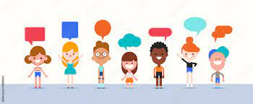

Literacy
In Literacy, we will be developing a love for writing through using quality texts and our interests to provide meaningful writing opportunities. We will give meaning to the marks we make, learn to hold a pen/pencil using a tripod grip and use some print and letter knowledge to start writing at the top of a page and identify the initial sound in a word.

Phonics – Daily Practice
We will begin our phonics journey by learning our set 1 sounds from Read Write Inc. We are learning the pure sound each letter makes and how we write that sound. We will then learn to blend sounds together to read words.
Every week a link will be sent via MCAS to a video that teaches a quick phonics lesson for a particular sound. These are to watch at home and support phonics development.

PSHE
Jigsaw Jenie will support our PSHE learning this half term during our focus on ‘being me in my world’. We will be looking at how we manage our feelings and interact with our new friends in school.

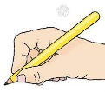

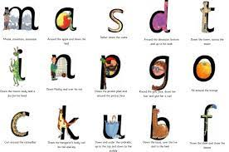



Maths
This half term we will begin our maths journey on mastering number. We will identify when a set can be subitised and when counting is needed. We will also begin to match the number symbol with a number of items and look at different ways these can be arranged.

Expressive Arts and Design
We will be developing our drawing and colouring skills, creating a self-portrait and understanding that a line is made by a dot that moves. We will also be looking at texture and being able to describe different textures and how they feel.
We will create structures using different materials, including Duplo, Lego, blocks and junk modelling. We will explore how structures stay up and how to join objects together.
Throughout the half term we will be learning a range of nursery rhymes and developing our singing voices.



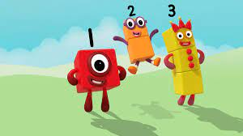



Physical Development
We will be looking at two PE units this half term, starting with an introduction to PE. We will spend time learning how to find a sensible space, freezing on command, using and sharing equipment, and working individually, with a partner or in a group. We will then move onto our fundamentals unit. We will learn about fundamental movement skills, including balancing, running, changing direction, jumping, hopping, and travelling.
Our fine motor skills will focus on developing muscle control using a range of tools in preparation for using a tripod pencil grip. Our gross motor skills will involve developing correct posture for sitting for sustained periods, rolling, throwing, and kicking a ball.

Reminders
Please ensure everything the children bring to school is named. A snack is provided for break time. However, if your child has a particular fruit or vegetable that they eat, they can bring that to school.
Please bring PE kits to school every Monday and they will be sent home every Friday. Our PE days are Thursday and Friday.
Our library slot is on a Friday and this is when we get the chance to change our love for reading book.

Understanding
The World
This half term we will developing our understanding of the world by focusing first on where we live and our own lives. We will discover our similarities and differences with one another.
We will discuss who our immediate family are, looking at photographs of our families and people close to us. We will also use photos to understand the concept of the past, as well as predicting what the future might like.
We will look at different types of maps, go on a bear hunt using a map of the school, as well as observing the features of our local area.
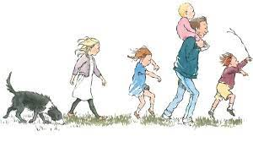
We will begin to look at religion by first talking about who is special to me and what makes me special, as well as the role models within our lives and community.
We will also begin to learn who Jesus was and why he was important to Christians.

New Beginnings
Autumn 1

Foundation Team
Mr Harmon
Mrs Martin
Mrs Taylor
Timings
Morning drop-off: 8:40-8:50 Pick up: 3:20
Dates
Thursday 17th September- Phonics meeting at 3pm in the hall
Tuesday 15th September- School photos
Thursday 24th September- Flu immunisations
Tuesday 20th October- Foundation Harvest festival
If you need to contact us: foundation@henburyview.dorset.sch.uk

