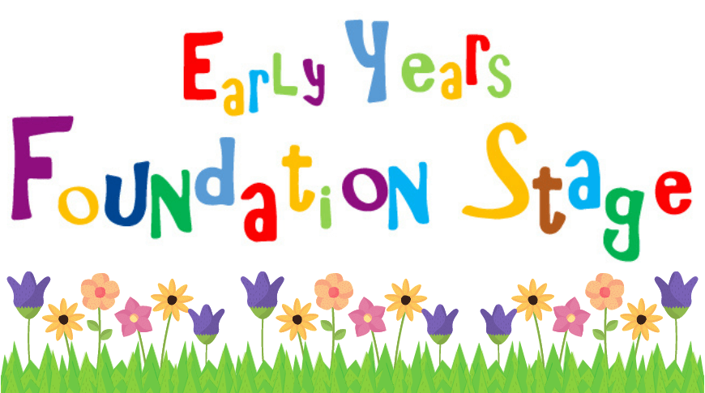

You could draw a map or picture of your bedroom. Try and include your furniture and some of your favourite toys, you could even label them.
You could make a collage of photos that show how you have grown, e.g. a photo or two for every year you’ve been alive. You could talk about what has changed and what has stayed the same.
You could create your own structure using junk modelling, this could be a tall tower, a car, a castle etc. How many different materials can you use to create it?

Draw a picture of your favourite toy. Why is it special? Who gave it you?
You can use the video links sent out by MCAS to watch phonics lessons at home for the sounds we learn each week.
You can also practise your handwriting using your handwriting booklet each week. Remember to use a tripod grip!
Can you write a shopping list with your adult when you next go shopping? Try and write the initial sound for the word, e.g. a for apples, t for tomatoes.
Can you practise counting objects at home? How many pieces of vegetables do you have for dinner?
You can also practice writing your numbers to 5.
Can you create a repeating pattern using 2 or 3 colours?

These are just ideas of where the children could take their learning but feel free to let their imagination run wild! We can’t wait for them to share it in the classroom!
New beginnings Foundation - Home Learning ideas

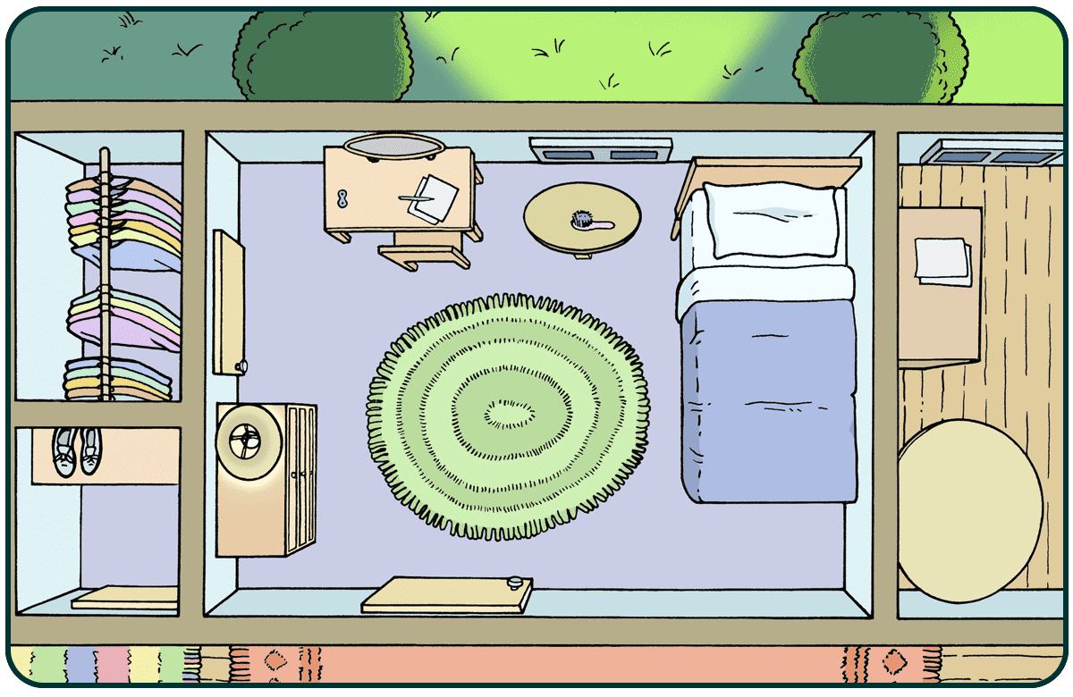

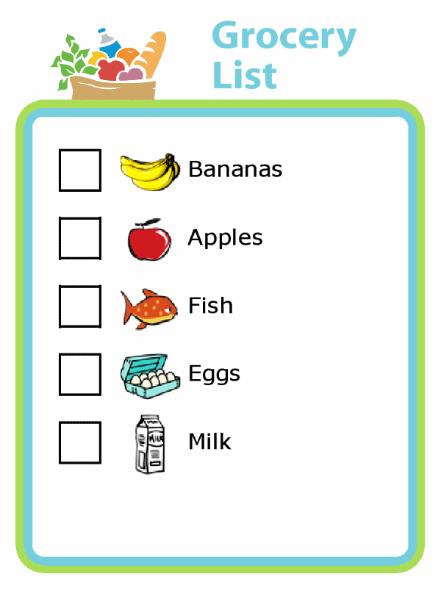


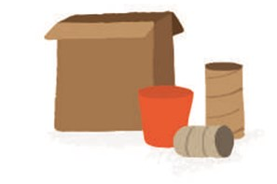

1 2 3 4 5

