

Behaviour Policy



Adopted: July 2026 Review: July 2027

INTRODUCTION

1.1 The purpose of this policy is: -
- To create an environment which encourages and reinforces good behaviour;
- To promote values which foster and encourage good behaviour;
- To establish clear guidelines and rules, based on common sense and safety, by which the school will operate;
- To encourage consistency of response to both positive and negative behaviour;
- To provide information to parents in order to achieve consistency in the messages children receive about appropriate and inappropriate behaviour;
- To ensure that the school’s expectations and strategies are widely known and understood.

1.2 Children should begin to learn about good behaviour at home before compulsory school age. Building on this foundation and in partnership with parents we aim to create a happy, friendly, safe and caring environment where children grow to respect: -
- one another
- themselves
- all staff and other adults working in school, e.g. volunteer helpers
- parents and carers
- school property
- visitors to and neighbours of the school
- the rules and ethos of the school
- everyone has the right to go home fulfilled

1.3 This policy sets out: -
- what we mean by good behaviour and inappropriate behaviour
- contact with parents
- the role of Year 6 pupils
- rewards for good behaviour
- appendices – conduct codes, reflection sheets, behaviour grid

  - It is a statutory requirement for schools to have such policies and to publish them on the school’s website.

  - This policy will be reviewed annually by the Senior Leadership Team (SLT) and Governing Body.

SCHOOL ETHOS

2.1 The adults encountered by the children at school have an important responsibility to model high standards of behaviour, both in their dealings with the children and with each other, as their example has an important influence on the children.

2.2 As a school community we will create a sanctuary of kindness through connection and support.

2.3 As adults we will: -
- offer each other and the children a welcoming smile;
- be authentic, listen, engage and connect with every child;
- model our expectations (section 3 and 5);
- show appreciation of the efforts and contribution of all;
- be consistent.

By doing this we will:
- create a positive climate with realistic expectations;
- emphasise the importance of being valued as an individual within the group;
- provide a caring and effective learning environment;
- model and encourage relationships based on kindness, respect and understanding of the needs of others;
- ensure fair treatment for all regardless of age, gender, race, ability and disability.

OUR VALUES

Our school encourages children to value themselves, to become caring members of the community by taking responsibility for themselves, their actions and choices. Our core Christian Values are:

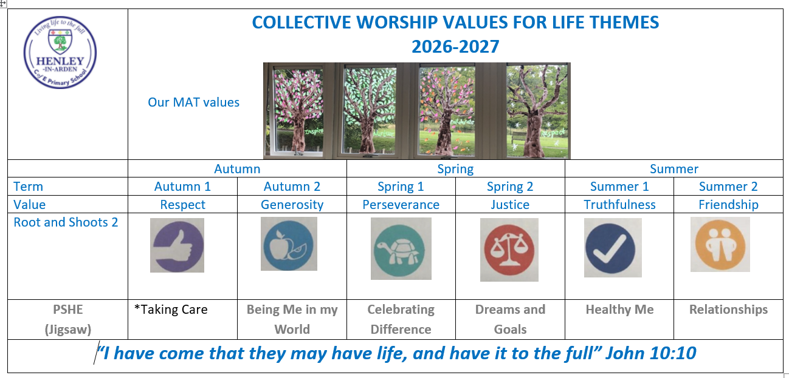

THE CURRICULUM AND LEARNING

4.1 Our School’s curriculum is built around children developing learning behaviours which enable them to be actively engaged and involved in their own learning. A creative and well-structured curriculum that ensures effective learning will contribute to good behaviour.

4.2 Lessons have clear learning objectives which the children can understand. They are differentiated to meet the needs of all abilities.

4.3 Marking (including verbal comments) should be used to provide positive feedback to children on their progress and next steps to achieve. This feedback should signal to children that their efforts are valued and that progress matters.

4.4 Teachers will be at the door ready to welcome children into each lesson with a smile and ensure that appropriate resources are prepared and ready.

4.5 Classrooms are set up to promote high quality learning (see learning environment non-negotiables) Children are seated appropriately and given maximum opportunity to achieve.

OUR RESPECT CODE (Appendix 2)


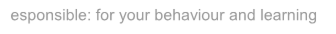

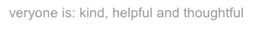

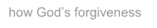

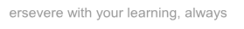
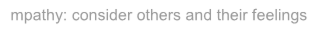

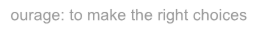
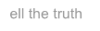
Responsible: for your behaviour and learning
Everyone is: kind, helpful and thoughtful
Show God’s forgiveness
Persevere with your learning, always
Empathy: consider others and their feelings
Courage: to make the right choices
Tell the truth

GOOD BEHAVIOUR

6.1 It is our expectation that everyone: -
- Follows our school Respect Code
- Shows courtesy, consideration and respect for others
- Respects our Christian Values
- Is honest and truthful
- Works and plays together cooperatively
- Cares for one another
- Moves about the school in a quiet, orderly manner
- Has respect for school property and the property of others
- Uses common courtesy (‘please’, ‘thank-you’, ‘sorry’ etc)

6.2 It is the policy of our school that those who go above and beyond these expectations are consistently acknowledged and praised by teaching and support staff.

THE RESTORATIVE APPROACH

7.1 A restorative approach is not based on punishment but offers an alternative way of addressing inappropriate behaviour. The table below compares the differences between the Authoritarian approach and the Restorative approach.

Authoritarian Approaches The focus is on: | Restorative Approaches The focus is on:
Rule-breaking | Harm done to individuals
Blame or guilt | Responsibility and problem-solving
Adversarial processes | Dialogue and negotiation
Punishment to deter | Repair, apology and reparation
Impersonal processes | Interpersonal processes
and, as a result;
The needs of those affected are often ignored | The needs of those affected are addressed
The unmet needs behind the behaviour are ignored | The unmet needs behind the behaviour are addressed
Accountability = being punished | Accountability = putting things right

RESTORATIVE APPROACHES TO SUPPORT INAPPROPRIATE BEHAVIOUR

8.1 Throughout the school year, teachers regularly remind their classes of the Respect Code. For the majority of our children, this reminder from a member of staff will be all that is necessary during their time at the school.

8.2 RIP – Reprimand In Private. Reprimands by staff will be made in reference to the RESPECT code and wherever possible in private (i.e. not in front of other children) in a way that does not humiliate the child

8.3 The school has a stepped restorative approach to support behaviour:

- Polite reminder – a clear verbal caution delivered in private (RIP)
- Second verbal warning – clearly stating the consequences if they continue. (RIP)
- At this stage the child is required to stay behind at the end of the session to reflection on their behaviour.
- Time out – may be used outside the classroom (or side of the playground during break) for the child to calm down.
- Repair – Child to complete a reflection sheet. Discussion with the child to establish: What happened? What were you thinking at the time? What have you thought since? How did this make people feel? Who has been affected?

8.4 Meeting with parents – this meeting will focus on the support that is available for the child. This meeting may include the SENDCo who may support the class teacher in developing a behaviour plan.

OTHER SANCTIONS AND RECORD KEEPING

9.1 Where work is incomplete due to inappropriate behaviours, the work may be sent home in an envelope for children to complete at home. Parents are asked to sign to show they are aware of this.

9.2 The headteacher may consider more serious sanctions, e.g. banned from extra-curricular activities or PTA events

9.3 Exclusion from school during lunchtimes (recorded as half day fixed term exclusion) particularly if a pattern of challenging behaviour takes place at this time.

9.4 Exclusion from school, for a fixed term or permanent exclusion.

9.5 Exclusion from school takes place only in exceptional circumstances and normally when all other options have been exhausted. (Please see the Exclusion Policy for more information regarding this).

9.6 A reflection sheet will be completed for low level incidents (see appendix 1). These reflection sheets are then used to track times, frequency and the nature of the incident.
Level 2 behaviours will be recorded onto CPOMS (Child Protection Online Management System).A Behaviour Support Plan (BSP) may be written to explain how this behaviour will be supported in consultation with the parents.

9.7 Where high incidents involve extreme violence and/or the use of restraint or classroom evacuation, this will be recorded in more detail either directly into CPOMS or by completing an incident form which is handed to the Headteacher.

9.8 SLT will review medium and high incidents and report to Governors through the termly Headteacher’s Report.

MANAGING CLASSROOM BEHAVIOUR

10.1 Where needed, teachers/teaching assistants will follow the steps listed in section 8 when addressing inappropriate behaviour.

10.2 Children will be praised on the effort that they demonstrate, not how well they attain.

10.3 The school promotes learning based initiatives such as 3B4ME, and growth mindsets. Class teachers will focus on a ‘learning behaviour’ in a lesson or throughout the school day (e.g. collaboration, perseverance) children demonstrating this will be celebrated on the classroom display.

10.4 Teachers may select children demonstrating learning behaviours to see SLT to share their learning and receive a learning stamp/Headteacher Award.

LUNCHTIME

11.1 Midday supervisors will support the RESPECT code through modelling positive play and supporting children to interact appropriately with each other.

11.2 When necessary, Midday Supervisors are to ask children to complete reflection sheets if level 1 behaviour occur despite a polite and serious warning.

11.3 Midday Supervisors will follow the five steps outlined in section 8.

11.4 Promoting positive behaviour at lunchtime is discussed during half-termly meetings involving a member of the SLT.

MONITORING CHALLENGING BEHAVIOUR
12.1 The school monitors behaviour to identify patterns, areas of concerns and/or triggers of challenging behaviour in order to implement appropriate strategies of support.

12.2 The Senior Leadership Team will monitor children’s behaviour. Serious incidents of challenging behaviour, such as violence or aggression towards children or staff, rude or abusive language or vandalism will be recorded as stated in section 9.

CONTACT WITH PARENTS

13.1 A positive partnership with parents is crucial to building trust and developing a common approach to behaviour expectations and strategies for dealing with problems.

13.2 Parents can expect to be kept informed of their child’s behaviour at school and staff will contact parents to share positive messages as well as any concerns.

13.3 In the case of persistent misbehaviour or, more rarely a serious misdemeanour, discussions with parents will take place to establish ways of helping the child improve. For example, it may be necessary to devise an action plan in conjunction with the parents. In some cases behavioural problems may be linked to the social, emotional and mental health of a child and could lead to the involvement of external agencies to support both at school and in the home.

13.4 Parents who have concerns about behaviour in the school should make an appointment to speak with the class teacher in the first instance. Where concerns are not being addressed or the nature of the concern is more serious parents should ask to see the Headteacher.

YEAR 6 PUPILS

14.1 We recognise the very special contribution that the Year 6 pupils can make to the organisation and daily routine of the school. Each September all Year 6 pupils take a more senior role at the school and are expected to assume additional responsibilities. They award certificates to fellow pupils if they have been spotted following the Respect Code. They are expected to set good examples by helping and supporting younger pupils and demonstrating responsible behaviour.

REWARDS FOR GOOD BEHAVIOUR

15.1 A child can earn a certificate (awarded in Celebration Worship) for going ‘above and beyond’ linked to the Respect Code or our values. This includes: good manners, being polite, considering others feelings and positive behaviour. House points are awarded when children follow the respect code.

CERTIFICATE OF ACHIEVEMENT
16.1 Certificate of Achievement are nominated by class teachers for learning. These are awarded during the weekly Celebration Worship on Friday mornings and parents/carers are invited to share in the celebration.

DRESS CODE

17.1 It is our expectation that children are neatly and appropriately dressed for all school activities in accordance with the guidelines published in the school uniform policy.

17.2 The Headteacher may, on occasion, direct pupils to wear school uniform or non-uniform for specific functions or events.

PLAYGROUND AND FIELD

18.1 It is our expectation that children will play sensibly with due care for themselves and others.

18.2. Children are expected to engage with an OPAL play activity during lunchtime. Games such as tag are not permitted. Football can be played as a special reward with consent from the headteacher.

  - Play on the field is permitted if children have access to wellington boots. Children can access the OPAL play activity which is open that day.

  - The Monkey Bars are only to be used during specified times and to be accompanied by a member of staff.

MOVEMENT AROUND SCHOOL

19.1 Everyone will ‘walk tall’ everywhere. ‘Walking tall’ is walking with pride in a meaningful and respectful way.

19.2 Everyone must keep to the footpaths.

VALUABLES

20.1 Children should not bring items of value to the school (money, games, toys, etc). Pupils who need to have mobile phones in school MUST hand them in to the school office on entry to the school (see Mobile Phone Policy).

20.2 Children who need to bring money to school are responsible for this and it should be a sensible amount.

20.3 Children are responsible for their own watches during P.E. and other sporting activities. Fitbits are permitted in school.

20.4 Pupils must not interfere with other children’s belongings in the classrooms or cloakrooms.

FOOD

21.1 Healthy snacks from home, Fresh fruit, raw vegetables, tuck from the school kitchen are all permitted as a morning snack.

21.2 Drinks (non-fizzy) may be brought as part of a packed lunch but not in cans or glass bottles.

21.3 Sweets and chewing gum are prohibited.

21.4 Nuts are NOT permitted in school due to staff and pupils having serious allergies.

RESTRAINING PUPILS

22.1 According to the DfE document Behaviour and Discipline in Schools, Advice for headteachers and school staff, staff should only restrain children in the following situations:-
- If the child is at risk of harming themselves or others;
- If the child is causing significant damage to property; • If the child is disrupting the good order of the school; • If the child is committing an offence.

  - If a member of staff or supervisor requires assistance, a red triangle should be sent to a team teach trained staff member. Red triangles are located in each classroom.

  - Restraining does not automatically mean a child should be sent home or excluded
– this decision will be made at the Headteacher’s discretion in consultation with the class teacher.

22.4 Please see the Physical Contact and Restraint Policy for more detailed information.

Appendix 1
Behaviour level grid
Behaviour | Support Offered / Sanctions | Recording
Low (level 1)  - Interrupting or distracting others  - Ignoring instructions  - Pushing/shoving  - being unkind  - Not engaged with learning  - Deliberately and consistently creating distraction  - Damage through carelessness  - low level inappropriate physical contact | - Stepped Approach:  1.Polite reminder  2.Serious warning  3.Reflection sheet  4.Repair (Restorative conversation)  Incomplete work sent home in envelope  Verbal reminders and modelling positive behavior  Praise and reinforcement of expected conduct  - Use of time out in a calm space | Reflection sheet completed and kept in class folder (KS1 and KS2)
Medium (level 2)  - Persistent disruptive behaviour  - Deliberate refusal to follow instructions  - Deliberate damage  - Leaving class without permission  - Verbal confrontation  - Swearing  - Physical fighting | - Stepped Approach (as above)  - Action Plan with Parent, Pupil and Teacher  - Incomplete work sent home  - Discussion with SENDCO  - Phone call to parents  - Possible use of time-out spaces  - Sanctions:  • Time owed at break/lunch  • Removal from extra-curricular events/PTA events  • Catch-up tasks or practical reparation | - Staff record on CPOMs  - Discussion with parents by class teacher  - Headteacher informed
High (level 3)  - Persistent breaches of ‘medium’ level behaviours  - Persistent bullying  - Racist abuse  - Leaving school grounds  - Theft  - Vandalism  - Extreme violence towards staff/adults/children  - Acts of extreme danger  - Very serious challenge to authority | - Involvement of Headteacher and SENDCO  - Regular meetings with parents  - Behaviour Action Plan (BAP) or Pastoral Support Plan (PSP)  - External agency support  - Sanctions:  • Suspension (fixed-term)  • Lunchtime suspension (recorded as half-day)  • Permanent exclusion (only in exceptional cases)  • Removal from trips/PTA events  • Positive Handling (if safety is at risk, by trained staff only)  • Work sent home or isolated provision as appropriate | - Recorded on CPOMs  - Letter home  - Incident forms (e.g. Positive Handling)  - Racist incident report if applicable

Appendix 2
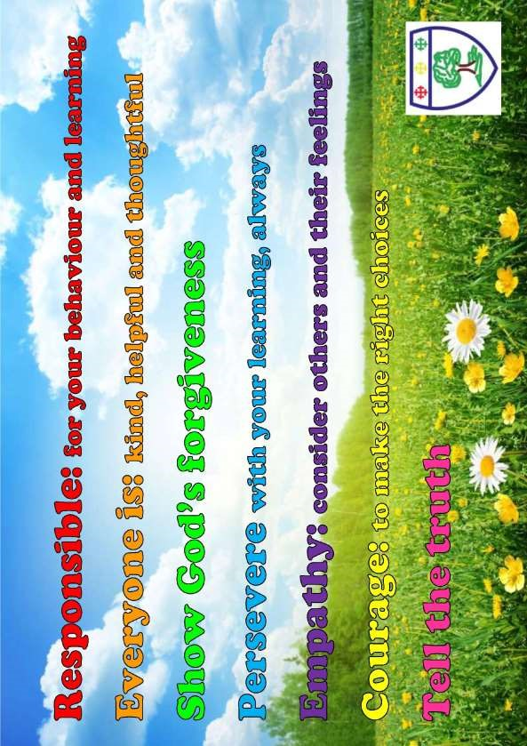

Henley-in-Arden

