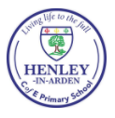 | COLLECTIVE WORSHIP VALUES FOR LIFE THEMES  2022-2023  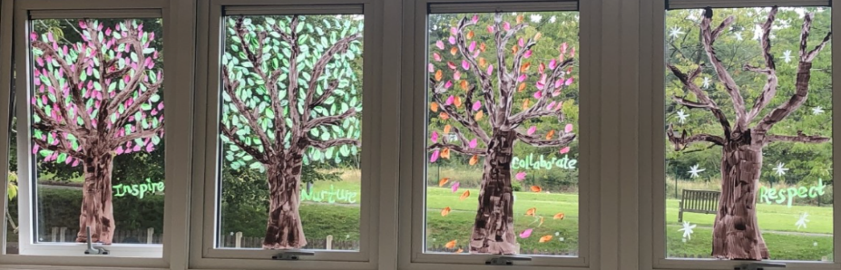  Our MAT values
 | Autumn |  | Spring |  | Summer
Term | Autumn 1 | Autumn 2 | Spring 1 | Spring 2 | Summer 1 | Summer 2
Value | Respect | Generosity | Perseverance | Justice | Truthfulness | Friendship
Root and Shoots 2 | 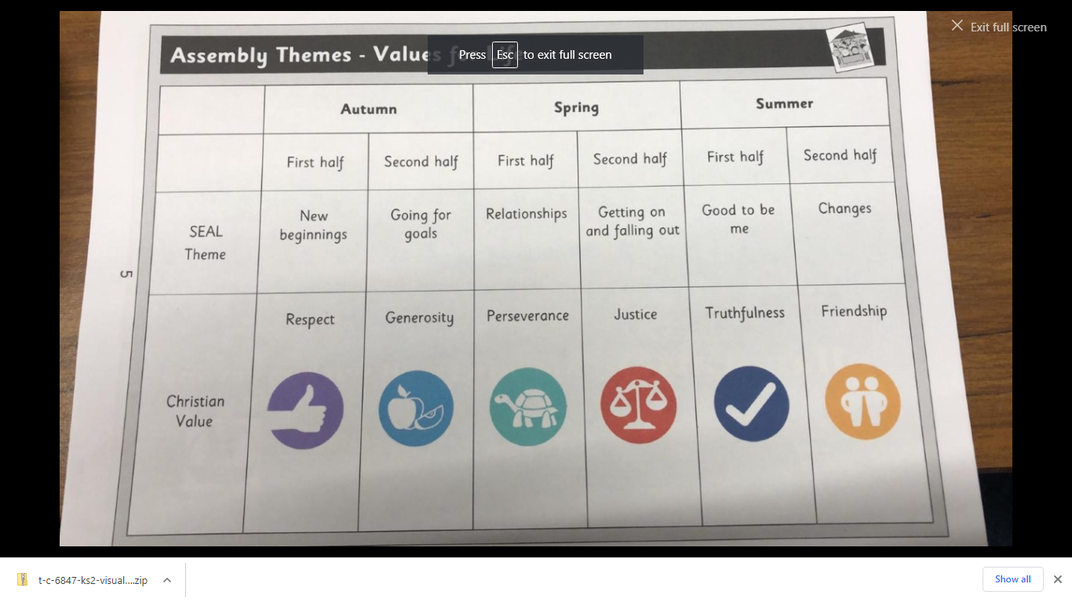
PSHE  (Jigsaw) | *Taking Care | Being Me in my World | Celebrating Difference | Dreams and Goals | Healthy Me | Relationships
Our attributes or Learning Dispositions
Perseverance Reflectiveness Resourcefulness Reciprocity
We are looking for these at all times in all lessons.
“I have come that they may have life, and have it to the full” John 10:10

