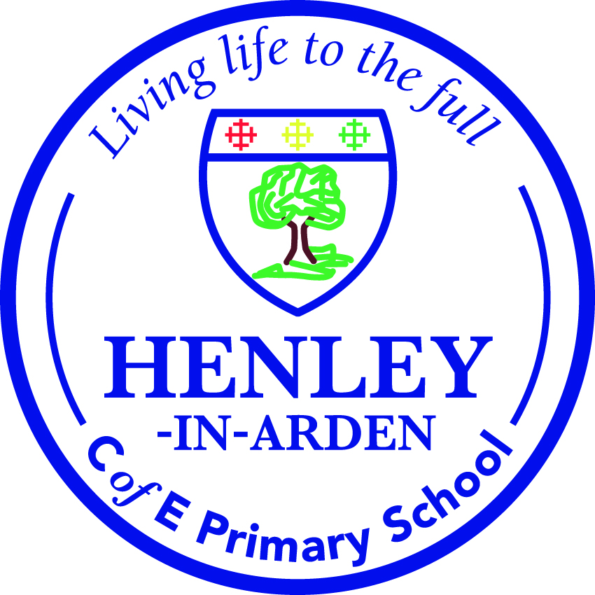
Geography Curriculum
Topics
Autumn | Who Am I and Who Am I Becoming? | To gain a better understanding of who they are as a person, develop an understanding of where they come from and their history. Build on strategies to develop confidence, develop a growth mindset, develop emotional resilience.
Autumn | Celebrating Difference | Celebrating our differences can enable us to open our minds to new ideas and experiences. By being interested and open to the differences between us we can discover new ideas and ways of thinking as well as making new friends and experiencing different opportunities. It can also help us challenge stereotypes.
Autumn | The wonders of Christmas | RE Christmas focus
Spring | Heritage and Culture | This theme is history focused so pupils have the time and opportunity to delve into a significant period of history that had a political, social, religious, or economic impact on life as humans knew it at the time.
Spring | Dreams and Goals - Building a Sustainable and Inclusive World | It is about celebrating significant figure, inventions and organisations through the lens of the Global Goals. All year groups explore the influence people or events have had over major developments. Children will study Moments and Movements that have changed the World. Linked with the British Values, each year group will study a particular moment or movement that is significant to our current time in the world.
Spring | The Easter Story | RE Easter Focus
Summer | Citizenship and the World | Allows children to develop knowledge of how our world has advanced geographically, through physical and human geography but also how different cultures through history has shaped our lives; giving children the opportunity to develop a better understanding of our world today.
Summer | Lights Camera Action | As performance is the focus of this theme, lessons explore either the legacy of Shakespeare or one of the most prestigious titles in the peerages of the United Kingdom. Children will focus on how to build a community through performances. Depending on the cycle, Each year pupils will learn about a different aspect of Tudor life and deepen their understanding of how this narrative was influenced by major changes that occurred around the world at the time.

Geography Curriculum Aims

At Henley in Arden CofE Primary School we believe that Geography motivates and inspires our children to find out about the amazing world that surrounds them. Geography enables children to become global and sustainable citizens who are aware of the world we live in and can take an active part into contributing and protecting the world as they grow up. It also teaches children locational knowledge, place knowledge, human and physical geography and geographical and fieldwork skills starting them and their immediate locality before branching out and examining other parts of the world. This helps to develop children’s curiosity in both their immediate surroundings and places and environments in the wider world whilst also developing the skills necessary to interpret what they see and seek answers to further their knowledge and understanding. We will deliver a curriculum that:

• Inspires curiosity and fascination about the world and its people.
• Equips children with an understanding of diverse places, people, resources and environments.
• Allows children to build on prior learning about physical and human processes and the formation and use of landscapes and environments.
• Develops an understanding that the Earth’s physical features are interconnected and change over time.
• Encourages exploration of their own environment and supports children to make connections between their local surroundings and that of contrasting settlements.
• Systematically develops the disciplinary knowledge of: asking enquiry questions, collecting, analysing and interpreting data through fieldwork; interpreting maps, diagrams, globes and aerial photographs; communicating geographical information in a variety of ways, evaluating and debating ideas and the impact of processes, phenomena and humans on the world.

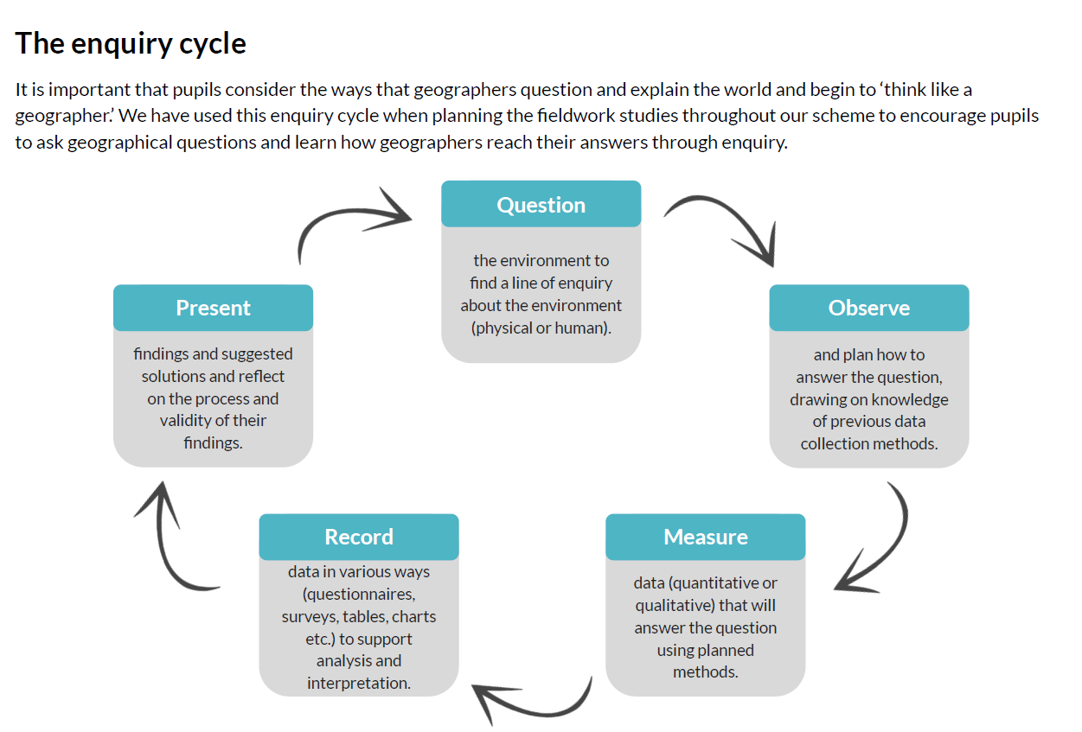
Teaching and Learning
There are five key elements to the implementation of the geography curriculum:

- Plan: each lesson is judiciously planned to identify the different types of knowledge that the lesson focusses on.
- Revisit: At Henley each topic we revisit areas of learning previously taught to support new learning of the next topic. It builds on pupils’ prior learning, drawing upon previously planned lessons. This is done through a range of retrieval activities saved in the folder.
- Teach: We use the enquiry cycle to support learning.
- Assess: pupils are given enquiry-based composite tasks that enable pupils to demonstrate their understanding of the component knowledge.
- Intervene and re-teach: composite tasks identify knowledge components that are not secure. These are re-taught before moving on to avoid future gaps from emerging.

What does teaching and learning look like in this subject?
- Bring the Geography to life in the classroom using all senses through physical artefacts, visual stimuli, sights and sounds and smells of the period.
- Check prior learning has been retained through the retrieval activities.
- Introduce the learning outcome of the lesson, making links to both the wider learning journey and the real world. Ensure that the lesson is understand within a wider appreciation of chronology, drawing upon prior learning and timelines as required.
- Maximise engagement, learning and progress through regular use of high quality teaching and learning techniques such as Cold Call, Turn and Talk, Everybody Writes and Show Call.
- Build in regular checks for understanding during lessons, including through assertive monitoring and targeted questioning, addressing misconceptions quickly and re-modelling where necessary.
- Check priority knowledge has been retained to the working memory at the end of every lesson, EG: use of Exit Tickets.
- Develop knowledge and understanding of the key features and characteristics of the periods studied.
- Ensure that substantive knowledge is developed alongside disciplinary knowledge within meaningful geographical enquiry, so they develop as independent learners and as critical and reflective thinkers.
- Ensure pupils take pride in their written work, continually focus on their handwriting and quality of diagrams, and provide clear evidence in their books of responding to written and verbal teacher feedback.
- Analyse data throughout topics to support researching facts about periods of history.
- Offer opportunities to use ICT, such as film making, researching etc.
- Provide opportunities for subject-specific enrichment both inside and outside of school.
- Use the I do, we do, you do model

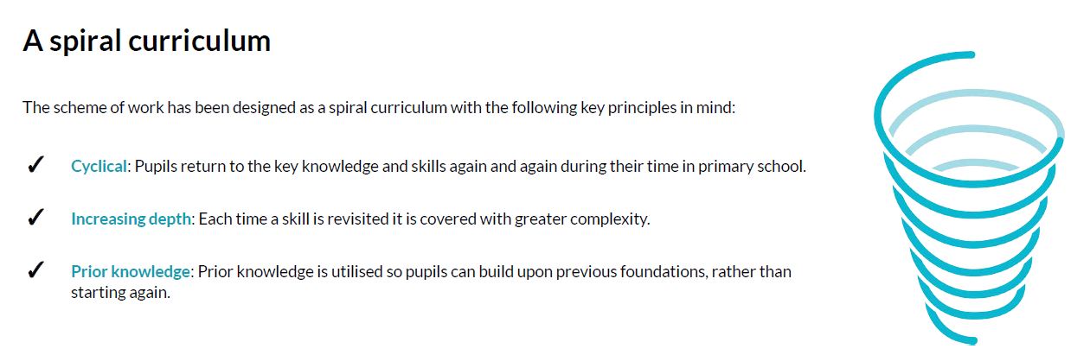

Adapting the curriculum for pupils with SEND in geography
• Adaptive teaching takes place.
• For sensory or physically impaired pupils, geography learning may necessitate enlarging texts, using clear fonts, using visual overlays, or audio description of images.
• Dyslexic pupils may benefit from well-spaced print.
• Teachers identify and break down the components of the subject curriculum into manageable chunks for pupils who find learning more difficult, particularly those with cognition and learning needs. These may be smaller ‘steps’ than those taken by other pupils to avoid overloading the working memory.
• A variety of additional scaffolds may be used in lessons, such vocabulary banks, additional visual stimuli or adult support.

What does it mean to teach Geography in greater depth?
Develop contextual knowledge of the location of globally significant places – both terrestrial and marine – including their defining physical and human characteristics and how these provide a geographical context for understanding the actions of processes. At Greater Depth children should:
1. Ask and answer a good range of pertinent geographical questions.
2. Be able to recognise the type of place it is based on its characteristics.
3. Have a fluent knowledge of the countries within the UK and the world’s continents and oceans
4. (At KS2) They should know a range of European countries.
5. Their use and application of direction is accurate and precisely used based on the compass rose.
Human and Physical Geography
At Greater Depth children may:
1. Use key language for human and physical features consistently and accurately within their written and verbal work.
2. Compare places using the careful and correct terminology to offer reason and explanation, when looking at similarities and differences.
3. Patterns of human and/or physical features are investigated and described in detail.
Geographical skills and Fieldwork
At Greater Depth children may:
1. Be confident to lead their own fieldwork activity that they choose to investigate.
2. Investigate their local area/grounds to answer a pertinent question and record their findings in a geographical way that is an appropriate medium.
3. Complete maps, drawings and grid references with detail for a wide amount of purposes. Choices for the symbols/key are reasoned.
4. Pull together a range of mapping images to be able to investigate and answer pertinent questions.

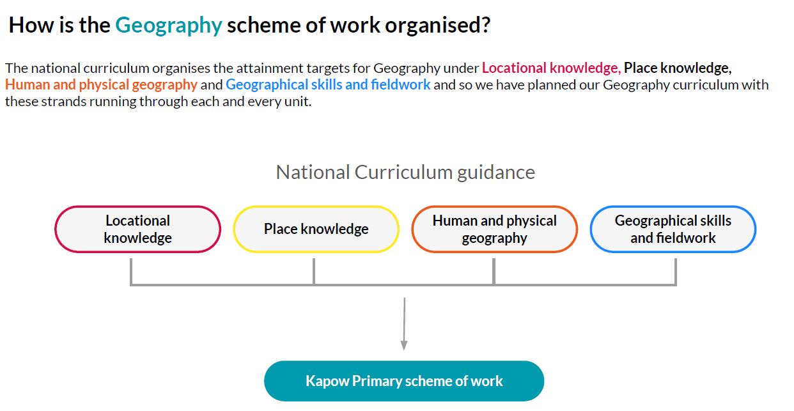
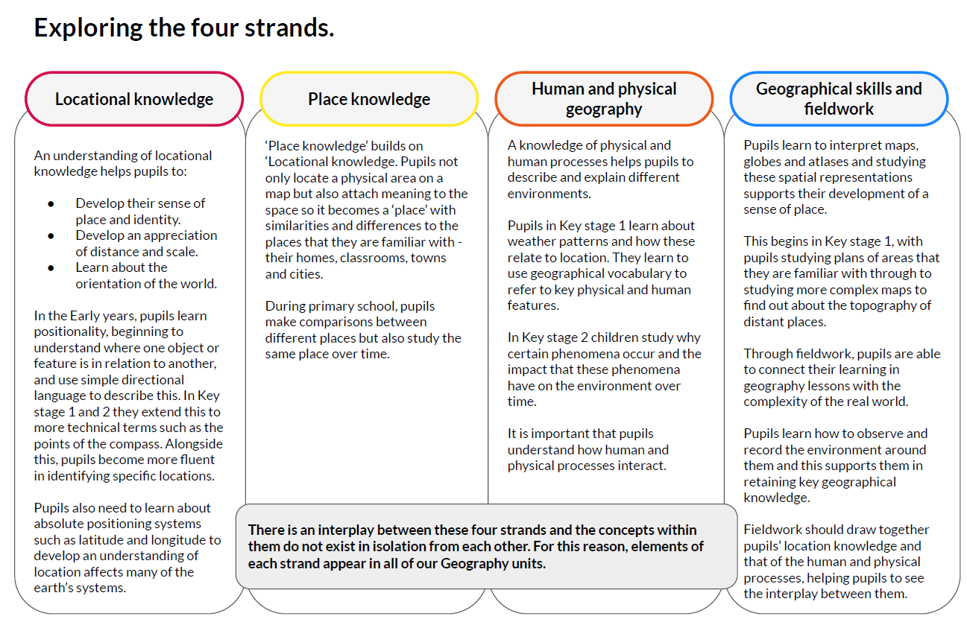
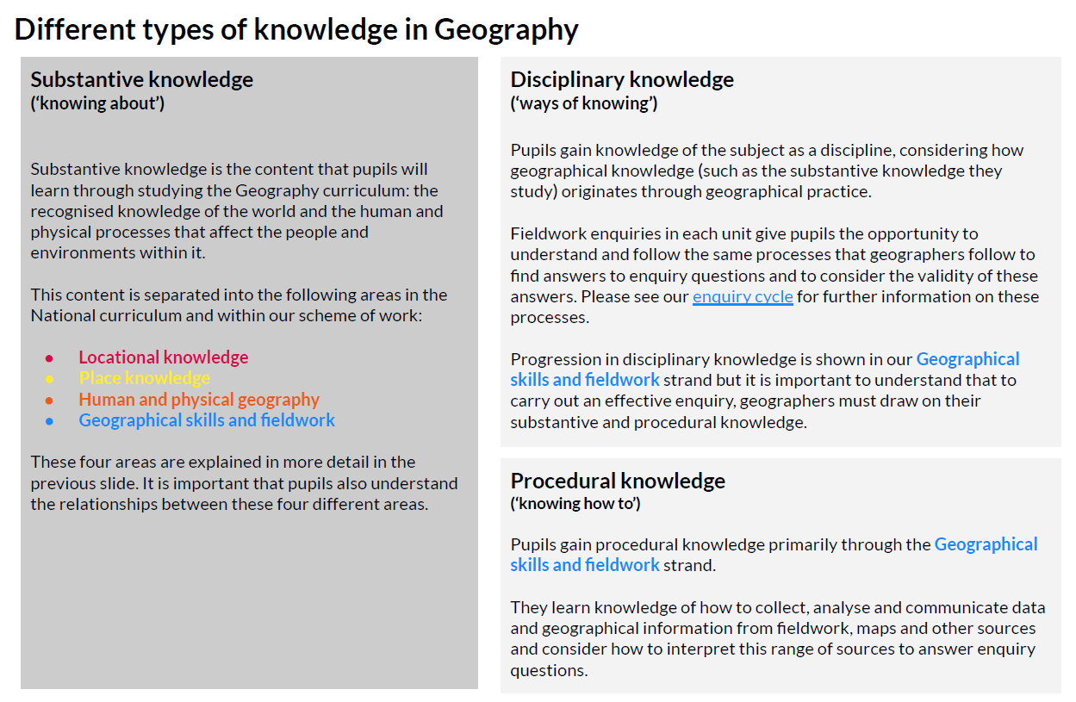

Substantive knowledge
Content of knowledge from the national curriculum
Declarative knowledge (knowing of what – EG: the facts of geography)

Disciplinary knowledge (Skills)
How we know and revise what we know

Ask and investigate geographical questions.

Critically evaluate and debate the impact of geographical processes.

Declarative knowledge (knowing of what – EG: the facts of geography)
- Locational knowledge
- Place knowledge
- Human and physical geography

Procedural knowledge (knowing how to do geography)
- Geographical skills and fieldwork

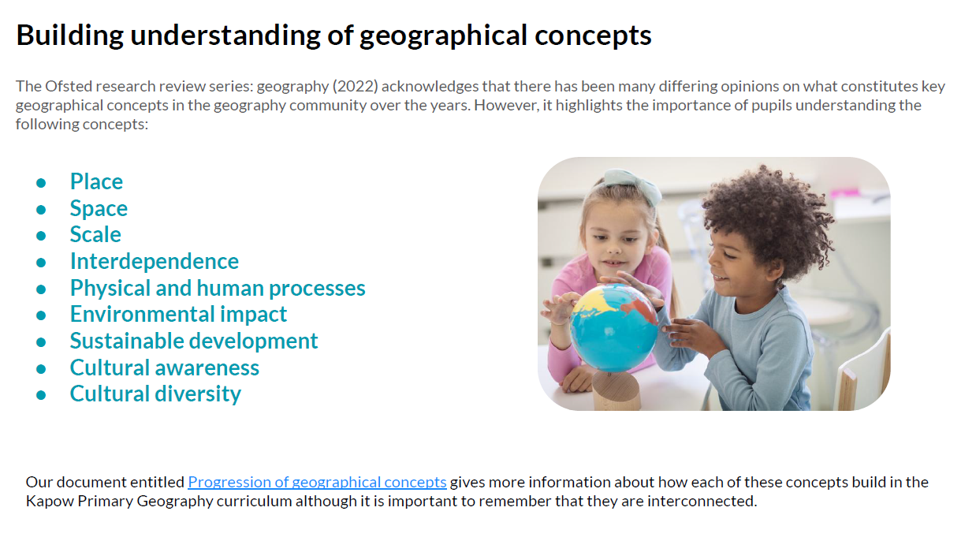

The spiritual development of pupils is shown by their: | The moral development of pupils is shown by their:
- ability to be reflective about their own beliefs, religious or otherwise, that inform their perspective on life and their interest in and respect for different people’s faiths, feelings and values.  - Use of imagination and creativity in their learning  - Willingness to reflect on their experiences.  - Compassion to think about the feelings of a child in a squatter settlement or the victims of a natural hazard  - Exploring your own feelings about the people, places and environment you are learning about.  - Appreciate the awe and wonder of the natural and manmade environments | - ability to recognise the difference between right and wrong and to readily apply this understanding in their own lives, recognise legal boundaries and, in so doing, respect the civil and criminal law of England.  - Understanding of the consequences of their behaviour and actions.  - Interest in investigating and offering reasoned views about moral and ethical issues and ability to understand and appreciate the viewpoints of others on these issues.
The social development of pupils is shown by their: | The cultural development of pupils is shown by their:
- use of a range of social skills in different contexts, for example working and socialising with other pupils, including those from different religious, ethnic and socio-economic backgrounds.  - Willingness to participate in a variety of communities and social settings, including by volunteering, cooperating well with others and being able to resolve conflicts effectively.  - Acceptance and engagement with the fundamental British values of democracy, the rule of law, individual liberty and mutual respect and tolerance of those with different faiths and beliefs; they develop and demonstrate skills and attitudes that will allow them to participate fully in and contribute positively to life in modern Britain. | - understanding and appreciation of the wide range of cultural influences that have shaped their own heritage and those of others.  - Understanding and appreciation of the range of different cultures within school and further afield as an essential element of their preparation for life in modern Britain.  - Knowledge of Britain’s democratic parliamentary system and its central role in shaping our history and values, and in continuing to develop Britain.  - Willingness to participate in and respond positively to artistic, musical, sporting and cultural opportunities.  - Interest in exploring, improving understanding of and showing respect for different faiths and cultural diversity and the extent to which they understand, accept, respect and celebrate diversity, as shown by their tolerance and attitudes towards different religious, ethnic and socio-economic groups in the local, national and global communities.
Which values underpin the curriculum content?
British Values in Geography
British values, including those of democracy, the rule of law, individual liberty and mutual respect and tolerance of those with different faiths and beliefs are embedded in the History curriculum.
Students explore issues such as democracy in their historical context and relate them to the modern day through studying periods such as Ancient Greece. This enables the students to understand how, overtime, changes happened and to evaluate their impact.
By looking at the achievements of famous British people (KS1), students develop an awareness of how they have influenced and shaped the country in which we live. This includes an appreciation of their work.
Teaching students to respect and value diversity is encouraged in the day to day teaching and learning through showing respect for different viewpoints and ideas as well as in the ability to work effectively together both individually and in groups.
National Curriculum Programmes of Study and EYFS Framework
Year R | Year 1 | Year 2 | Year 3 | Year 4 | Year 5 | Year 6
Understanding of the World - Past and Present  Know some similarities and differences between things in the past and now, drawing on their experiences and what has been read in class.  Describe their immediate environment using knowledge from observation, discussion, stories, non-fiction texts and maps.  Explain some similarities and differences between life in this country and life in other countries, drawing on knowledge from stories, non-fiction texts and –  when appropriate – maps. | Pupils should develop knowledge about the world, the United Kingdom and their locality. They should understand basic subject-specific vocabulary relating to human and physical geography and begin to use geographical skills, including first-hand observation,  to enhance their locational awareness. |  | Pupils should extend their knowledge and understanding beyond the local area to include the United Kingdom and Europe, North and South America. This will include the location and characteristics of a range of the world’s most significant human and physical features. They should develop their use of geographical knowledge, understanding and skills to enhance their locational and place knowledge.
 | Locational knowledge  - name and locate the world’s seven continents and  five oceans  - name, locate and identify characteristics of the four countries and capital cities of the United Kingdom and its surrounding seas |  | Locational knowledge  - locate the world’s countries, using maps to focus on Europe (including the location of Russia) and North and South America,  concentrating on their environmental regions, key physical and human characteristics, countries, and major cities  - name and locate counties and cities of the United Kingdom, geographical regions and their identifying human and physical characteristics, key topographical features (including hills, mountains, coasts and rivers), and land-use patterns; and understand how some of these aspects have changed over time  - identify the position and significance of latitude, longitude, Equator, Northern Hemisphere, Southern Hemisphere, the Tropics of Cancer and Capricorn, Arctic and Antarctic Circle, the Prime/Greenwich Meridian and time zones (including day and night)
 | Place knowledge  - understand geographical similarities and differences through studying the human and physical geography of a small area of the United Kingdom, and of a small area in a contrasting non- European country |  | Place knowledge  - understand geographical similarities and differences through the study of human and physical geography of a region of the United Kingdom, a region in a European country, and a region within North or South America
 | Human and physical geography  - identify seasonal and daily weather patterns in the United Kingdom and the location of hot and cold areas of the world in relation to the Equator and the North and South Poles  - use basic geographical vocabulary to refer to:  o key physical features, including: beach, cliff, coast, forest, hill, mountain, sea, ocean, river, soil, valley, vegetation, season and weather  o key human features, including: city, town, village, factory, farm, house, office, port, harbour and  shop |  | Human and physical geography  - describe and understand key aspects of physical geography, including: climate zones, biomes and vegetation belts, rivers, mountains, volcanoes and earthquakes, and the water cycle  - describe and understand key aspects of human geography, including: types of settlement and land use, economic activity including trade links, and the distribution of natural resources including energy, food, minerals and water
 | Geographical skills and fieldwork  - use world maps, atlases and globes to identify the United Kingdom and its countries, as well as the countries, continents and oceans studied at this key stage  - use simple compass directions (North, South, East and West) and locational and directional language [for example, near and far; left and right], to describe the location of features and routes on a map  - use aerial photographs and plan perspectives to recognise landmarks and basic human and physical features; devise a simple map; and use and construct basic symbols in a key  - use simple fieldwork and observational skills to study the geography of their school and its  grounds and the key human and physical features of its surrounding environment |  | Geographical skills and fieldwork  - use maps, atlases, globes and digital/computer mapping to locate countries and describe features studied  - use the eight points of a compass, four and six-figure grid references, symbols and key (including the use of Ordnance Survey maps) to build their knowledge of the United Kingdom and the wider world  - use fieldwork to observe, measure, record and present the human and physical features in the local area using a range of methods, including sketch maps, plans and graphs, and digital technologies
Geography - Blue is Key geography topics | KS1 A | KS1 b | ¾ A | ¾ B | 5/6 A | 5/6 B
Who Am I and Who Am I Becoming? |  | Local: Where am I? |  | Local: What are rivers and how are they used?
Celebrating difference | Local: What was it like to live here? |  | Why do people live near volcanoes? |  | What is life like in the Alps? | Would you like to live in the desert?
Wonders of Christmas
Heritage and Culture | What was the weather Like? | Would you prefer to live in a hot or cold place? | Where does our food come from? | Who lives in Antarctica? | Why does population change? | Why do oceans matter?
Dreams and Goals

Citizenship and the World |  | What is it like to live in Shanghai? | Are all settlements the same? | Why are rainforests important to us?
Lights Camera Action  Local Study -Shakespeare | What can you see at the coast? |  |  |  | Where does our energy come from? | Can I carry out an independent fieldwork enquiry?

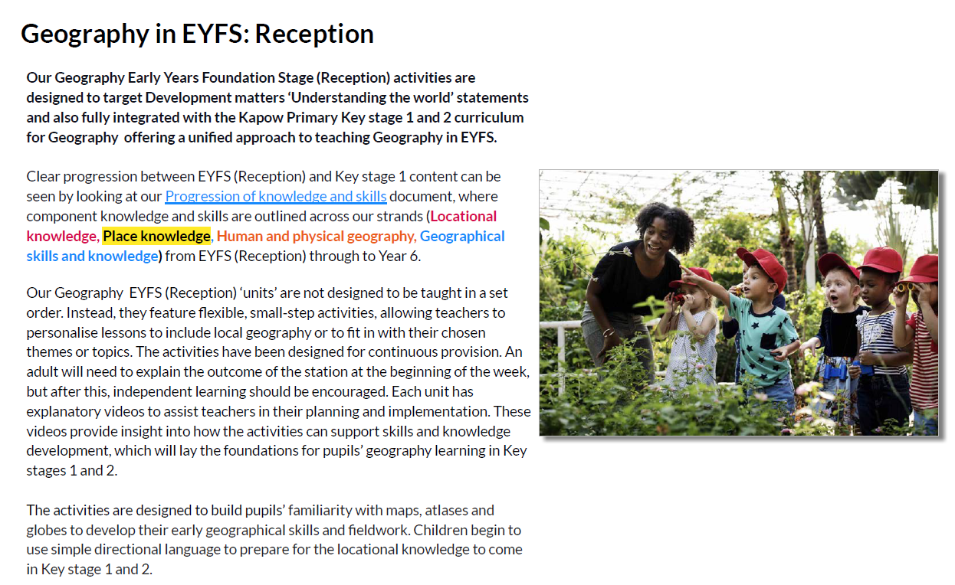
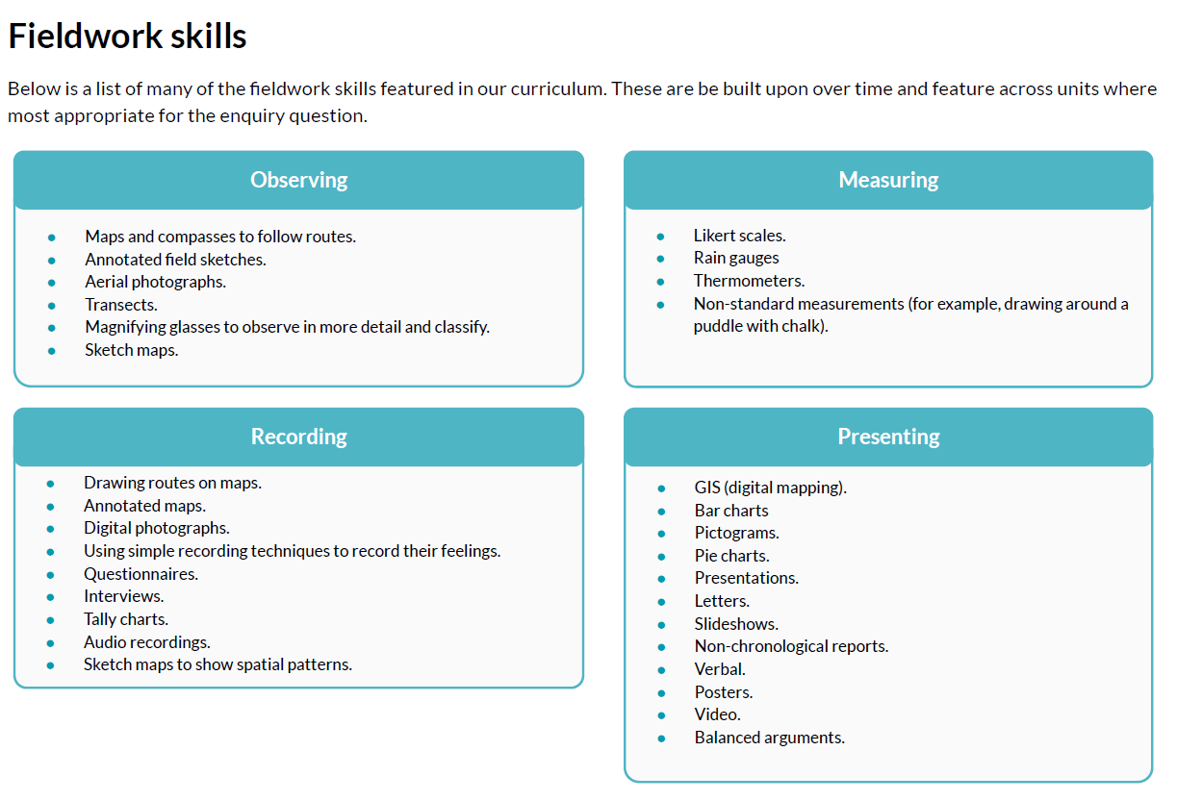
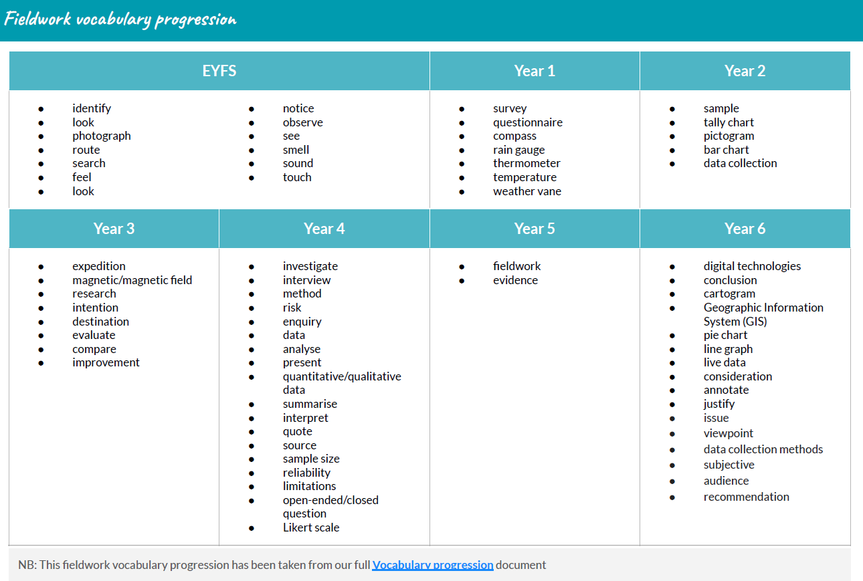
Procedural Knowledge:
This is used alongside Kapow documents to support Teacher planning for progression.

Progression in Geography – Mapwork – Using Maps to Navigate
In order to develop contextual knowledge of the location of globally significant places – both terrestrial and marine – including their defining physical and human characteristics and how these provide a geographical context for understanding the actions of processes, pupils must be adept at using maps to navigate.

 | Knowledge | Skill
EYFS | - Know that words can describe how to move | - Follow directions related to movement. E.g. stand up, sit down, come forwards, move backwards
Year 1 | - Understand that a map can tell you where to go | - Use a simple picture map to move around the school  - Use directional language such as  near and far, up and down, left and right, forwards and backwards  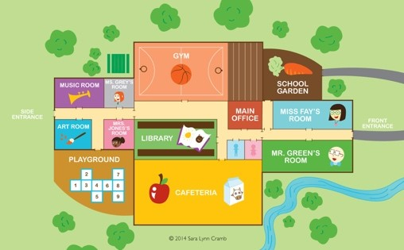
Year 2 | - Understand that a map is a 2D representation of the real, 3D world  - Know that a picture on a map represents a place or feature in the real world | - Follow a route on a map  - Use simple compass directions (North, South, East, West)  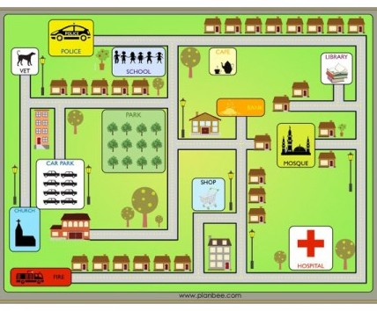
Year 3 | - Know that a symbol on a map, just like a picture, represents a place or feature in the real world  - Know that when reading co- ordinates, you read across the x-axis and up/down the y-axis  - Know that when reading co-  ordinates the point at which the | - Follow a route on a map with symbols  - Describe and follow a journey  between two places/features using 4 figure compasses (NSEW). E.g. Move north two steps, then west three steps.
 | lines or row/columns intersect is the locationof the place/feature | - Describe and follow a journey between two places/features using letter/number co-ordinates as the Henleyt and finish.  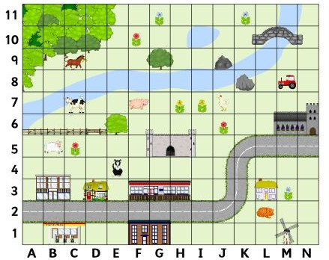
Year 4 | - Know that a large scale map is one that shows lots of detail, normally over a smaller area  - Know that when reading four-figure grid references the first two numbers represent the x-axis and the second two numbers represent the y-axis  - Know that four-figure grid references take you to a box within the grid, not just a specific point like a co-ordinate | - Follow a route on a large scale map  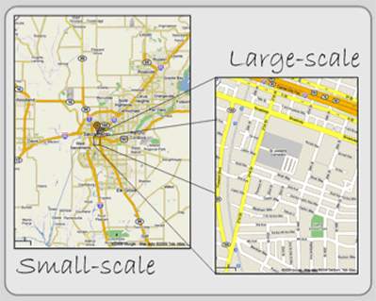  - Begin to use 8 figure compass directions to describe a route. E.g. the  transatlantic slave trade was the movement of slaves from the Gulf of Africa, north-west to Central America.  - Use four-figure grid references to describe a location on a map, including the use of a key  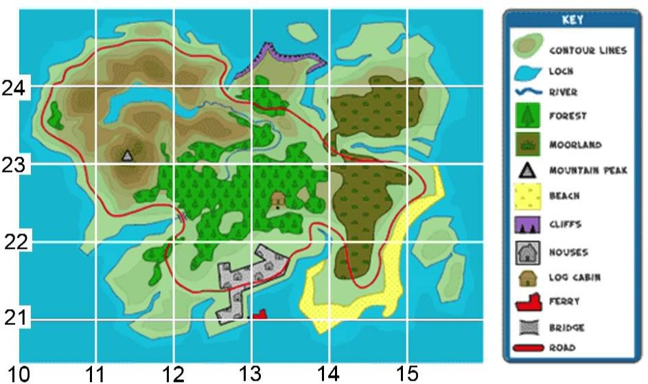
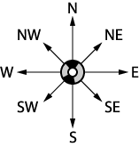
Year 5 | - Know that six-figure grid references are split into two groups of three digits  - Know that the first two digits of the first group represent the numbers on the x-axis  - Know that the first two digits of the second group represent the numbers on the y-axis  - Know that the last digit of each group of three represents going across/up the box as if it were split  equally into ten columns and rows | - Use six-figure grid references to describe a location on a map, including the use of a key  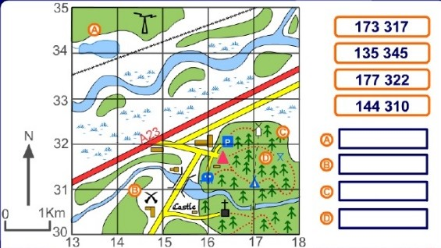  •
Year 6 | - Know that an Ordnance Survey map is a detailed map produced by the British government map-making organization | - Follow a short route on an OS map, using symbols and a key  - Follow a short route on a variety of  scaled maps

Procedural Knowledge:

Progression in Geography – Mapwork – Using Maps to Describe Landscapes
In order to equip pupils with knowledge about diverse places, resources and natural and human environments, they must be adept at describing landscapes in order to make judgements and comparisons. As pupils progress, their growing knowledge about the world, ascertained from the skill of describing landscapes, should help them to deepen their understanding of the interaction between physical and human processes, and of the formation and use of landscapes and environments.

 | Knowledge | Skill
EYFS | - Know that we can describe  something by comparing it to something else | - Use relative vocabulary such as bigger, smaller, like, dislike
Year 1 | - Know that we can describe the place of something. This is called its location. | - Use directional language such as near and far, up and down, left and right, forwards and backwards
Year 2 | - Know that a compass can describe the location of something relative to the centre point  - Know the names of key human features, including: city, town, village, factory, farm, house, office, port, harbour and shop  - Know the names of key physical features, including: beach, cliff, coast, forest, hill, mountain, sea, ocean, river, soil, valley, vegetation, season and weather | - Use simple compass directions (North, South, East, West)  - Use aerial photographs and plan perspectives to recognise landmarks and basic human and physical features  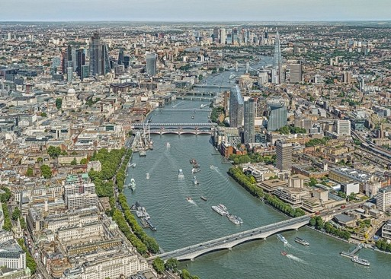
Year 3 | - Know that the boundary of a country can be marked by a physical feature such as a mountain range  - Know that the boundary of a country can be invisible but marked by a line on a map  - Know that a map can show a small area of land or a large area of land  - Know that when reading co-  ordinates, you read across the x-axis and up/down the y-axis  - Know that when reading co-  ordinates the point at which the | - Match boundaries (e.g. find same boundary of a country on different scale maps)  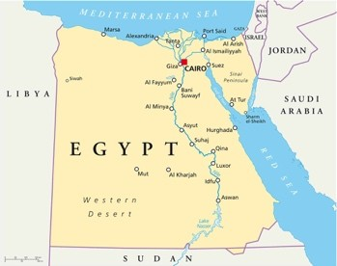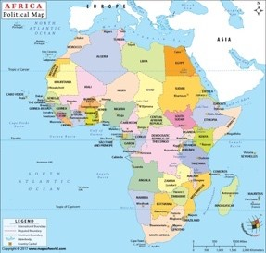
 | lines or row/columns intersect is the location of the place/feature | - Identify features using 4 figure compasses (NSEW). E.g. The Nile runs from south to north in Egypt.  - Identify features using letter/number co-ordinates  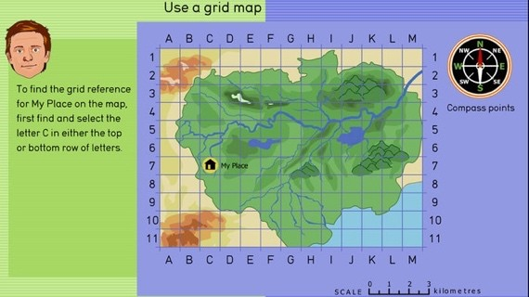
Year 4 | - Know that a large scale map is one that shows lots of detail, normally over a smaller area  - Know that a small scale map is one that shows less detail, normally over a larger area  - Know that an aerial photograph is a photograph taken from above  - Know that when reading four-figure  grid references the first two numbers represent the x-axis and the second two numbers represent the y-axis  - Know that four-figure grid references take you to a box within the grid, not just a specific point like a co-ordinate  - Know that latitude and longitude are a system of lines used to describe the location of any place on Earth.  - Know that lines of latitude run in an east-west direction across Earth.  - Know that lines of longitude run in a north-south direction. Although these are only imaginary lines, they appear on maps and globes as if they actually existed. | - Locate places and features on a range of maps (variety of scales)  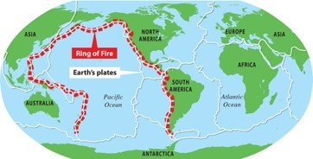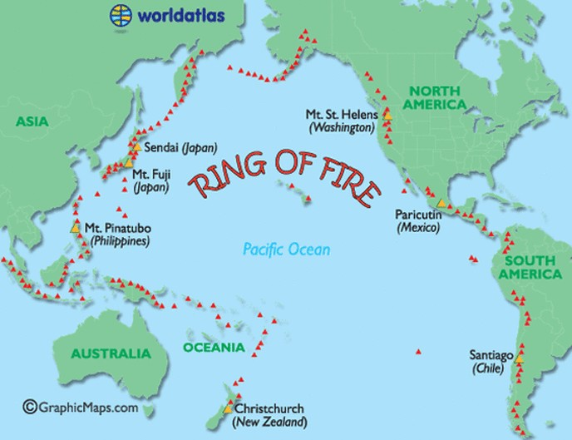  - Identify features on an aerial photograph, digital or computer map  - Begin to use 8 figure compass  directions when describing landscapes. E.g. Mount Vesuvius is located north-west of Pompeii  - Use four figure grid references to  identify features on a map, including the use of a key  - Use lines of longitude and latitude on a map to locate a feature
 |  | 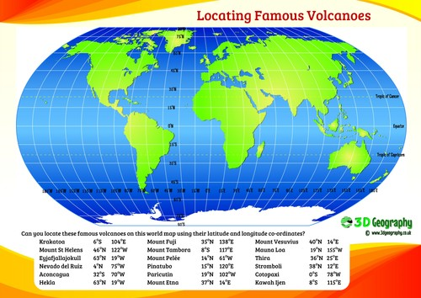
Year 5 | - Know that an aerial photograph is a photograph taken from above  - Know that when giving an 8 figure compass direction, north or south come first, then east or west. E.g. NE, NW, SE, SW  - Know that six-figure grid references are split into two groups of three digits  - Know that the first two digits of the first group represent the numbers on the x-axis  - Know that the first two digits of the second group represent the numbers on the y-axis  - Know that the last digit of each group of three represents going across/up the box as if it were split equally into ten columns and rows  - Know that an Ordnance Survey map  is a detailed map produced by the British government map-making organisation  - Know that a symbol represents a real life human or physical feature | - Compare two landscapes using maps and aerial photographs  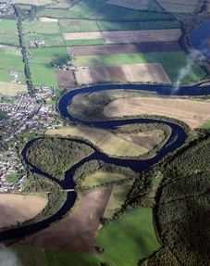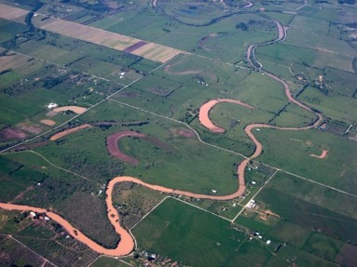  - Find and recognise places on maps of different scales.  - Use 8 figure compasses directions when describing and comparing places and landscapes. E.g. the Isle of Dogs is north-west of Greenwich park.  - Begin to use 6 figure grid references  by finding the location of a place or feature  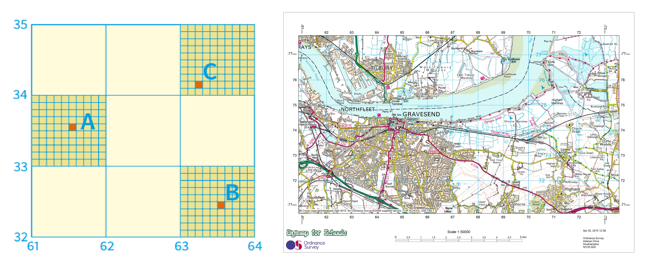  - Describe the features shown on an OS map by using the key and symbols.  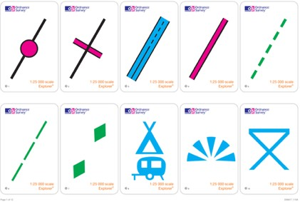

Year 6 | - Know that geographical artefacts such as maps and aerial photographs can tell us about human behaviour, such as settlement choices  - Know that when giving an 8 figure compass direction, north or south come first, then east or west. E.g. NE, NW, SE, SW  - Know that six-figure grid references  are split into two groups of three digits  - Know that the first two digits of the  first group represent the numbers on the x-axis  - Know that the first two digits of the second group represent the numbers on the y-axis  - Know that the last digit of each group of three represents going across/up the box as if it were split  equally into ten columns and rows | - Make geographical conclusions based on analysis of a landscape using maps and aerial photographs. E.g. Many mines can be found in the north-east of South Africa which shows that this region is richer in resource. This land could be under conflict if many people want the resource.  - Use 8 figure compass directions  when describing and comparing places and landscapes on a variety of scales.  - Use 6 figure grid references  accurately by giving and finding the location of a place or feature

Procedural Knowledge:

Progression in Geography – Mapwork – Making Maps
Students must be able to communicate geographical information in a variety of ways, including through maps. As such, students must understand the purpose of maps and what makes a map increasingly accurate and informative.

 | Knowledge | Skill
EYFS | - Know that a drawing can represent something real | - Draw 2D representations of familiar objects  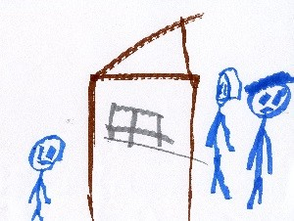
Year 1 | - Know that we can copy pictures from photographs and maps to create our own map | - Draw basic maps, including appropriate pictures to represent places or features  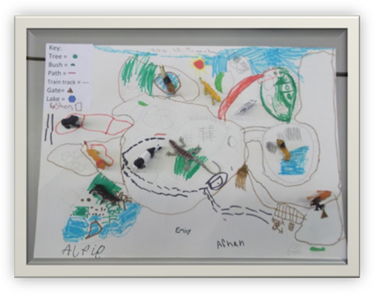  - Use photographs and maps to identify features
Year 2 | - Know that a symbol is a pictorial representation of a real-world object  - Know that a key provides the names  of a symbol to avoid having to label each symbol on a map | - Draw or make a map of real or imaginary places  - Use and construct basic symbols in a  key
 |  | 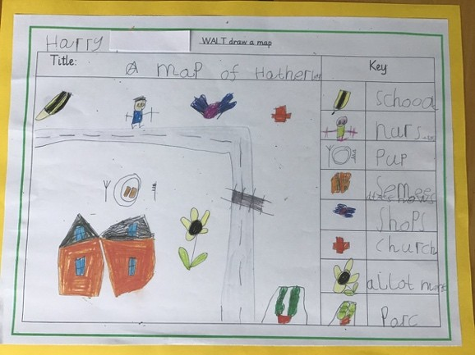
Year 3 | - Know that a symbol is a simpler version of a pictorial representation of a real-world object  - Know that standard symbols are used across lots of different maps to make them easier for people to understand and become familiar with  - Know that a key provides the names of a symbol to avoid having to label each symbol on a map | - Draw or make a map of a real location that includes human and physical features  - Henley to use standard symbols  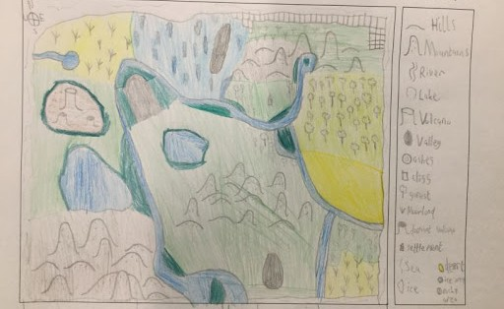
Year 4 | - Know that a sketch is a drawing of an area from a given viewpoint  - Understand that a map is an aerial perspective of an area with 2D symbols representing the world  - Know that the positioning of symbols on a map is important and must be accurate in relation to one another  as maps are used for navigating | - Draw a map based on a fieldwork sketch with positioning of key features located accurately in relation to one another
Year 5 | - Know that an Ordnance Survey map is a detailed map produced by the British government map-making organisation | - Draw a map with positioning of key features located accurately in relation to one another and use OS symbols
Year 6 | - Know that map scale is the relationship between distance on the map and distance in real life. | - Draw a map that shows appropriate distance between places or features based on a given scale
 |  | 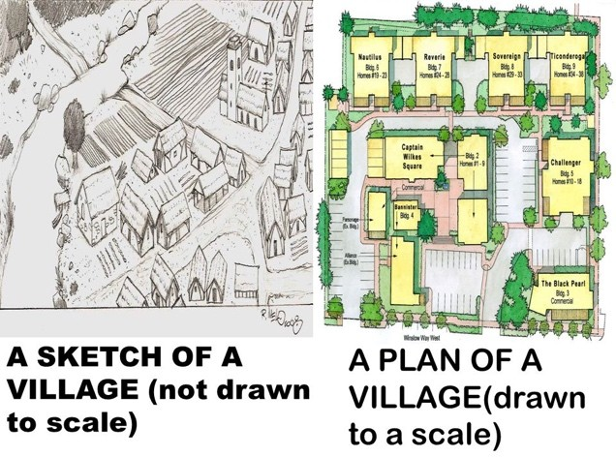
Procedural Knowledge:

Progression in Geography – Fieldwork – Sketching
In order for students to understand the processes that give rise to key physical and human geographical features of the world, how these are interdependent and how they bring about spatial variation and change over time, they need to engage in fieldwork activities and capture their surroundings through sketching. As students progress through their time at Ark Kings Academy, they become more proficient sketchers and are able to communicate their findings in an informative way.

 | Knowledge | Skill
EYFS | - Know that a drawing can represent something real  - Know that objects can be described based on their size and colour | - Draw their familiar environment, accurate with colour and key features  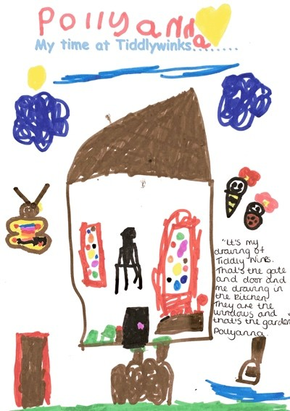
Year 1 | - Know that we can capture what we see by drawing  - Know that words can be used to label  drawings, maps and photographs so they are clearer | - Create plans and draw simple features in their familiar environment, mainly made up of outlines of features  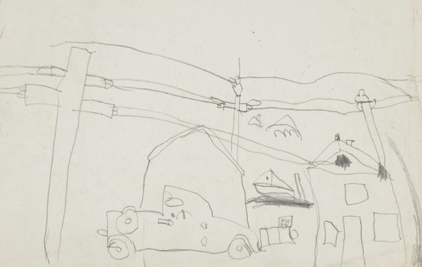  - Add labels onto a sketch map, map or photograph of features
Year 2 | - Know that we can capture what we see by drawing and the more detail we add, the more accurate they will be  - Know that words and phrases can be used to label drawings, maps and photographs so they are clearer and describe the features  - Know that adjectives describe objects  and places | - Create plans and draw simple features in their familiar environment  - Add labels onto a sketch map, map or photograph of features
Year 3 | - Know that sentences can be used to label drawings, maps and photographs so they are clearer and describe the features  - Know that adjectives describe objects and places  - Know the four points of a compass (NSEW) as well as positional language such as above, below, beneath, next to, between, opposite | - Draw an annotated sketch from an observation including descriptive labels and indicating direction and position  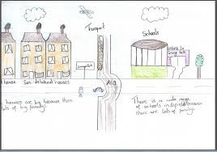
Year 4 | - Know that sentences can be used to label drawings, maps and photographs so they are clearer and describe the features  - Know that adjectives describe objects and places  - Know that causal conjunctions are  used to Henleyt an explanation, such as because, since, so, as  - Know the four points of a compass  (NSEW) as well as positional language such as above, below,  beneath, next to, between, opposite | - Draw an annotated sketch from observation including descriptive and explanatory labels and indicating direction and position
Year 5 | - Understand that a geographical investigation is where you use inquiry skills such as sketching to generate and answer questions about an area  - Understand that a geographical  process is a sequence of actions that shape or change our environment | - Use sketches as evidence in an investigation  - Annotate sketches to describe and  explain geographical processes and patterns
 | - Understand that a geographical pattern is similarities in observations that can be used to describe an environment | 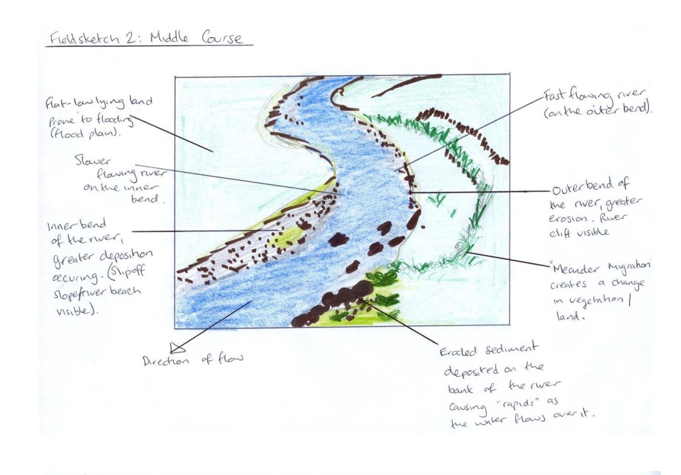
Year 6 | - Understand that a geographical investigation is where you use inquiry skills such as sketching to generate and answer questions about an area  - Know that there are limitations of  fieldwork sketches, such as accuracy because they are drawn by humans  - Know that photographs are accurate snapshots of an area but go out of date  - Know that capturing movement is not possible in a sketch or photograph, so video can be used or data collection which can be  presented in a graph over time | - Use sketches as evidence in an investigation.  - Select field sketching from a variety  of techniques  - Annotate sketches to describe and explain geographical processes and patterns.  - Evaluate their sketch against set criteria and improve it

