
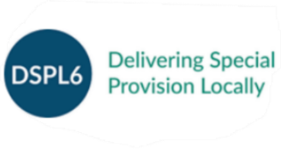

SEND Parent Information & Support Network
In partnership with the DSPL6 we offer several support services for parents of children with SEND. We run a Parent Support Network in Potters Bar once a month and an online SEND surgery every half term.

The Parent Support Network is a drop in session running at Elm Court. We are a supportive group of parents and professionals who all want the best for our children. We offer a supportive environment where people can share a wealth of tried and tested ideas to support you and your family. You are welcome to attend each month or as your diary allows. Each session runs from 9.15am until 10.45.
The dates for the Autumn term
Friday 19th September 2025
Friday 17th October 2025
Friday 21st November 2025
Friday 12th December 2025

Every half term we run an online appointment SEND surgery which is open to families with children that attend a Hertsmere school. These run throughout the day, which is split into free bookable 30 minute slots where you can discuss your childs’ SEND needs. An Eventbrite link will be shared via our mailing list a week before each surgery. The dates of the SEND surgeries for this academic year are:
Thursday 9th October 2025
Tuesday 25th November 2025
Thursday 22nd January 2026
Thursday 5th March 2026
Tuesday 28th April 2026
Thursday 18th June 2026

