Heyhouses Endowed C.E. Primary School
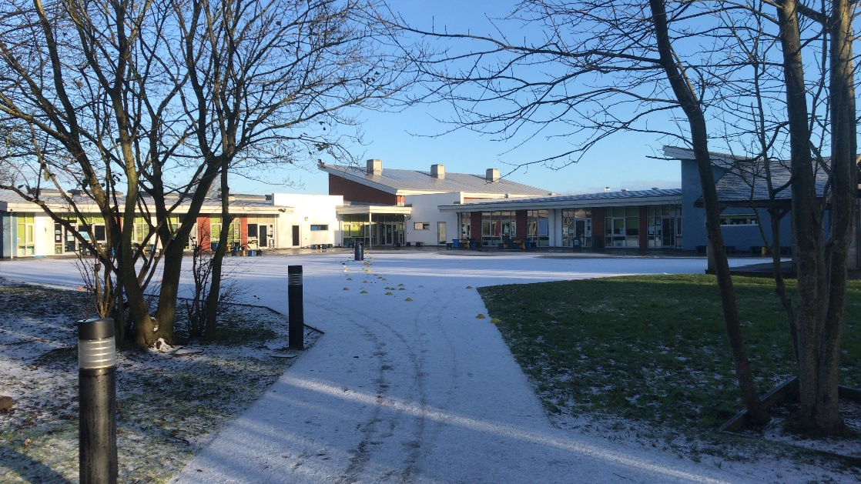
Remote Learning Framework Action Plan
This was taken from the DFE Remote Learning Guidance and Template.
We have made it into an Action Plan to ensure we are delivering what our children deserve.

Remote education plan:  There is a plan in place for remote education and the headteacher has the overarching responsibility for the quality and delivery of remote education, including that provision meets expectations for remote education.  The plan is underpinned by high expectations to provide the quality delivery of a planned curriculum for all (including vulnerable children and children with SEND), which is aligned as close as possible to the in-school curriculum. | All year groups will upload their weekly timetable on to the website using the same format. Work packs will be available for those children that cannot access the internet or do not have any devices at home.  All children in school will be taught the same curriculum as the children at home.  SEND pupils to be given differentiated work if they can not access the work the rest of the year group are doing.  Many PP pupils are in school and those that are not will access the remote learning. | To help develop your remote education plan:  My Maths  Education City  Testbase  On Target Maths  Bug Club  Oak Academy  White Rose Maths  Purple Mash  Timetable Rockstars  IDL English and Maths has been issued to those children who are struggling to access even differentiated work.
Communication  Governors, staff, parents and carers are aware of the school’s approach and arrangements for remote education. | All governors, staff, parents and carers are aware of our approach and arrangements for remote learning. | Regular communication and updates are provided with any changes to the provision.  Regular phone calls by the TA’s to all parents.  Pastoral Support worker calling vulnerable children  Communication sheet to be filled out by class teachers and returned to HT to analyse.  Newsletters and staff briefings sent regularly
Monitoring and evaluating  The school has systems in place to monitor the impact of remote education. This includes:  - understanding the impact on staff workload and how to mitigate against it  - staffing changes  - having access to appropriate management information (such as staff and pupil sickness and absence data) to help the school respond to changing contexts | The school has systems in place to monitor the impact of remote education.  Staff teams, have shared the workload, both in school and in setting and monitoring the remote learning. This reduces workload for staff.  All staff are aware that they can email/call HT. SLT if workload is a problem.  HT/ SLT to be made aware of any staff changes needed. | Rota in place  Regular communication with staff  HT / SLT working on attendance at home

Home environment  The school is aware of the learning environment in the home and works with parents and families to understand and ensure that pupils will be able to access education at home.  The school supports pupils on how to self-regulate during remote education, including:  - understanding their strengths and weaknesses to improve their learning  - how to learn from home  - how to manage their time during periods of isolation | Heyhouses has adapted our remote education provision depending on pupil’s home environment.  Pupils who might lack digital access to support the remote education provision will be supported by school by providing them with a books, paper and where possible laptop and internet access. | Laptops to be supplied to families  Data to be supplied to families  Regular phone calls in order to support children understand their strengths and weaknesses in order to improve learning
Laptops, tablets and internet access  Where digital approaches are used, leaders are aware of any limitations to access to the internet, and suitable devices, for pupils which impact on remote education provision. Leaders are making suitable alternative arrangements to minimise the impact of these limitations, either by providing pupils with devices and/or internet access or ensuring appropriate offline provision where pupils without access are considered vulnerable and are expected to come into school. | School is making suitable alternative arrangements to minimise the impact on remote learning. These will be provided to the pupils that need it by the end of Week 2 | A list has been created for children that need to loan a laptop  A text to be sent to see if any families are needing to loan a laptop.  Weekly phone calls by the TA to see if families have suitable devices.
Supporting children with additional needs  Children and young people with high needs, including disadvantaged pupils, SEND and vulnerable pupils, have the right structures and provision in place to help remote education.  This includes guidance for parents and carers on how to effectively support remote education, and ensuring pupils have access to the right hardware and software to support their needs. | Children with IEP’s in mainstream will be receiving differentiated work if they are unable to access the work that has been set for the rest of the class. | Oak National Academy provides resources for teachers to support children with additional needs.  TA’s to speak to all parents each week
Monitoring engagement  The school has systems for checking whether pupils are engaging with their work, and informs parents and carers immediately where engagement is a concern. | School checks weekly whether pupils are engaging with their work and will inform parents and carers immediately where engagement is a concern  Each year group provides feedback to the children either via email or through phone calls. | TA’s to make weekly phone calls to check any concerns around work.  Parents are aware they can contact staff in school at any time if need be.
Minimum provision  School sets work that is of equivalent length to the core teaching pupils would receive in school in an appropriate range of subjects, and as a minimum:  - Key stage 1: 3 hours a day, on average, across the school cohort, with less for younger children  - Key stage 2: 4 hours a day | All pupils in school and at home will receive their appropriate length of lessons and a range of subjects | Staff are aware of remote education expectations from the government
Curriculum planning  The school has a clear, well-sequenced curriculum that supports pupils both in class and remotely.  This could include a remote curriculum that is identical to the one taught in class, one that is similar but adapted or one that is completely different. | School has a clear, well sequenced curriculum for pupils in class and those working remotely.  The remote curriculum is very similar to the one taught in class | Oak Academy  White Rose Maths  My Maths  Bug Club  Phonics Play  Purple Mash  Timetable Rockstars
Curriculum delivery  The school has a system in place to support remote education, using curriculum-aligned, resources.  Where remote education is taking place, it should include recorded or live, direct teaching time from the school or other educational providers (such Oak National Academy), and time given for pupils to complete tasks and assignments independently.  The school is setting up the use of a digital platform to support effective communication and accessibility for all pupils, including those with SEND.  School website is used to provide online learning for parents. | The school has a good system in place to support our remote learning.  Our remote learning includes recorded lessons, direct teaching time from other educational providers and time for children to complete the tasks.  School is using their own systems to support effective communication and accessibility for all pupils. | Oak National Academy provides resources and guidance on how to map resources to a school’s existing curriculum.  Recorded lessons  White Rose Maths video’s  Story time by our teachers  Recorded lessons by teachers
Assessment and feedback  The school has a plan in place to gauge how well all pupils are progressing through the curriculum using questions and other suitable tasks.  The school provides feedback, at least weekly, using digitally-facilitated or whole-class feedback where appropriate. | The school has a good plan in place to gauge how well all pupils are progressing. The school provides feedback, at least weekly using -----or written feedback on pupils’ work.  Pupils are also assessed on their understanding by their engagement and responses during remote, taught lessons. | Weekly phone calls – feedback to parents  Written feedback to children through marking their work packs/jotters  Response to questioning on remote calls.

Effective practice  Senior leaders are aware of all the guidance and ensure wider teaching/school staff are aware of (and how to access) resources available to support remote teaching. | Teaching staff are aware of resources available to support remote learning | GOV.UK provides a good practice guide to support schools in their delivery of remote education.
Staff capability  Staff have access to the digital resources and tools (for example, textbooks, workbooks, platforms, devices and internet) they need to teach and support pupils remotely.  Where used, staff have the appropriate training and support to use digital tools and resources, including how to ensure they are accessible for pupils with SEND.  Where possible, the training provided is sustained and iterative to ensure staff continue to support effective teaching practice remotely. | Staff have access to the digital resources and tools that we need to teach and support pupils remotely.  Staff have had some training in order to support the use of digital tools and resources.  Staff who feel confident are able to use digital resources
Strategic partnerships
The school is sharing best practice and making best use of capacity across schools to address any known gaps.
Realistic expectations of pupils, parents and carers  Parents and carers have clear guidance on how to support pupils at home, and how this is aligned to the remote education information required to be published on the school’s website.  Pupils understand the expectations on how many hours they should be learning and how to participate in remote education (for example, how to submit assignments). | Parents and carers have clear guidance on how to support pupils at home. Those that struggle are able to contact school at any time or tell the TA/ or teachers when they call.  Information regarding remote learning can be found on the school website  Children understand how they can participate in remote learning.  HT to inform pupils on the expectations on how many hours they should be learning. | Calls home  School website to be updated regularly.  Office staff to pass on any messages to class teachers.  Website to be updated weekly
School community events  Pupils are given regular opportunities to attend and participate in shared, interactive sessionss and activities to maintain a sense of community and belonging, especially disadvantaged and SEND pupils. | Daily assemblies/ worship time support the children in feeling part of school.  Daily letters from the Headteacher  Initiatives to keep the children and their families involved in school life | Daily letters  Worship daily recorded and sent out via YouTube  Heyhouses Island Songs initiative  PTA treasure hunts
Ensuring safety  There are clear safeguarding protocols in place to ensure pupils are safe during remote education. It is essential to have and communicate clear reporting routes so that children, teachers, parents and carers can raise any safeguarding concerns in relation to remote education. | Parents and carers are able to raise any safeguarding concerns at any time.  School has clear safeguarding protocols in place to ensure pupils are safe.  School has clear reporting routes so that children, teachers, parents and carers can raise any safeguarding concerns. | Weekly phone calls  Calls to the office  Good communication with staff in school
Online safety  If the school chooses to provide remote education using live streaming and pre-recorded videos, teachers understand how to keep children safe whilst they are online. | Online safety has been taught in school  PSHE lessons whilst in remote learning have covered safety online.
Wellbeing  Leaders, teachers and pupils are aware of how to spot potential wellbeing or mental health issues and how to respond.  There are regular catch ups with pupils, one to one particularly for those that are most vulnerable. | Staff are aware of potential wellbeing problems. They are aware to let the class teacher or HT know if there are any problems around wellbeing or mental health.  Weekly phone calls home to the parents and child. Any child that has not been contacted within two weeks will | Phone calls home  Good communication  Pastoral care lead to call the most vulnerable once a week as well as the TA
Data management
The school has appropriate data management systems in place which comply with the General Data Protection Regulation (GDPR).

Behaviour and attitude  There are clear rules for behaviour during remote lessons and activities. Pupils know them and teachers monitor and enforce them. | Same rules apply as when we teach the children in school. Staff to make parents aware about any inappropriate behaviour.

