History Policy for Heyhouses CE Primary School

A high-quality history education will help pupils gain a coherent knowledge and understanding of Britain’s past and that of the wider world. It should inspire pupils’ curiosity to know more about the past. Teaching should equip pupils to ask perceptive questions, think critically, weigh evidence, sift arguments, and develop perspective and judgement. History helps pupils to understand the complexity of people’s lives, the process of change, the diversity of societies and relationships between different groups, as well as their own identity and the challenges of their time.

Aims

• To stimulate a curiosity and interest in the past.

• To introduce children to sources and how to examine them.

• To understand that our present has been shaped by the past.

• To develop an understanding of the concept of time.

• To gain and use terms associated with time.

• To encourage questioning and develop investigational skills.

• To provide natural links with other subjects.

• To develop a sense of worth of their own heritage.

• To develop closer links with the community.

• To increase children’s knowledge and understanding of other countries and cultures.

• To help pupils develop a sense of identity through learning about the development of Local, British, European and World History.

* To take into account the effect of Covid and Lockdown on the development of History skills and ensure that skills are revisited as necessary, allowing continued progression throughout the school.

Knowledge, Skills and Understanding

All pupils will be given opportunities to develop;

1. Chronological understanding
2. Knowledge and understanding of events, people and changes in the past
3. Historical interpretation & enquiry
4. Communication.

Please see the attached Skill Guidance Grid.

Assessment

Children in the Foundation Stage have their attainment on entry assessed by observations and their progress is tracked and monitored through the use of the age related expectations in The Foundation Stage profile will indicate if children are reaching expected levels by the end of Reception and will be used in transition into Key Stage 1.

Assessment without Levels descriptors can be found in the attached grid with the end of year expectations’ for each year group 1 - 6. Teachers can use the statements to assess progress, whilst also reflecting upon the skills demonstrated in previous year groups. Children will be assessed according to work produced, observations and discussions.

Please see attached LPDS – End of Year Expectations Grid.

Equal Opportunities and Inclusion

• All children are given access to a broad and balanced History curriculum regardless of gender, ability, race or religion.

• Provision will be made for individual needs in IEP’s.

• Equal opportunities are provided for boys and girls, also for children with special needs, those who are talented or gifted and children from different cultural backgrounds.

• A feeling of self-worth will be engendered throughout the teaching activities.

Enrichment/Extension activities for More Able Children

***Aims***

• To recognise those children showing particular talent in History.

• To develop their motivation and self-esteem.

• To have classroom activities that set challenging targets and provide opportunities for them to develop and apply their capabilities.

• To evaluate progress and adapt targets accordingly by using the skill grid.

• To encourage self-review.

*Increase depth and breadth of knowledge through;*

• developing appropriate and specific questioning skills

• extending knowledge by using a range of source materials including ICT

• encouraging greater understanding of the reasons why people behaved as they did, why events happened and the consequences

• beginning to select, use, analyse and evaluate sources to answer questions about the past.

Health and Safety

• All aspects of this policy and practice are carried out with regard to our health and safety procedures.

• All relevant risk assessments should be read in conjunction with this policy.

LONG TERM PLANS – Coverage

|  |  |  |  |  |  |  |
| --- | --- | --- | --- | --- | --- | --- |
| **History** | **Autumn Term 1** | **Autumn Term 2** | **Spring Term 1** | **Spring Term 2** | **Summer Term 1** | **Summer Term 2** |
| **EYFS** | **Early Learning Goals – Past and Present**   * Talk about the lives of people around them and their roles in society * Know some similarities and differences between things in the past and now, drawing on their experiences and what has been read in class. * Understand the past through setting, characters and events encountered in books read in class and storytelling. | | | | | |
| **Year 1** |  | **Toys from the past** |  |  | **Homes from the past** | **Seaside Holidays from the past** |
| **Year 2** |  | **WWI and Wartime Heroes** | **Great Fire of London** |  | **Castles, Kings and Queens** |  |
| **Year 3** | **Romans** |  | **Anglo- Saxons** |  | **Vikings** |  |
| **Year 4** | **Tudors** |  | **Stone Age to Iron Age** |  | **Ancient Greece** |  |
| **Year 5** | **Victorians –**  ***Local study of***  ***St Annes and Heyhouses (Remembrance Day)*** |  | **WWII** |  | **Early civilisations**  ***In-depth study of Egyptians.*** |  |
| **Year 6** | **Crime and Punishment** |  | **Mayans** | **History of Condover Hall -**  **Local History** |  |  |

Skills Guidance Grid

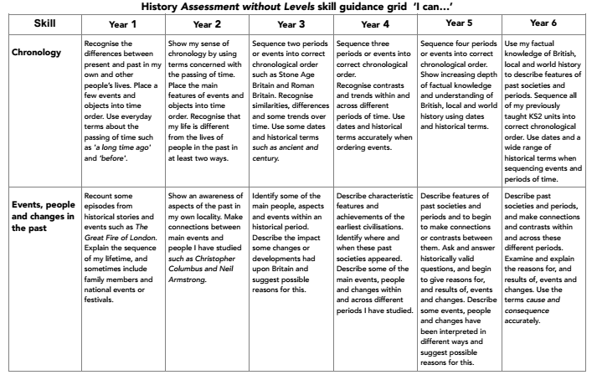

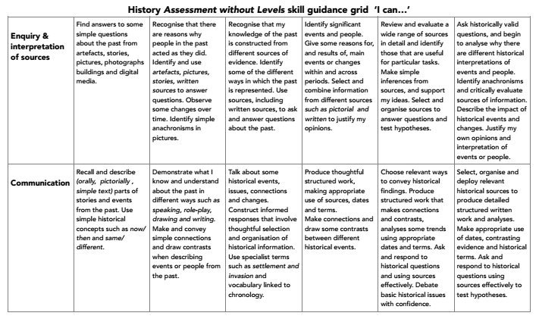

End of Year Expectations Grid

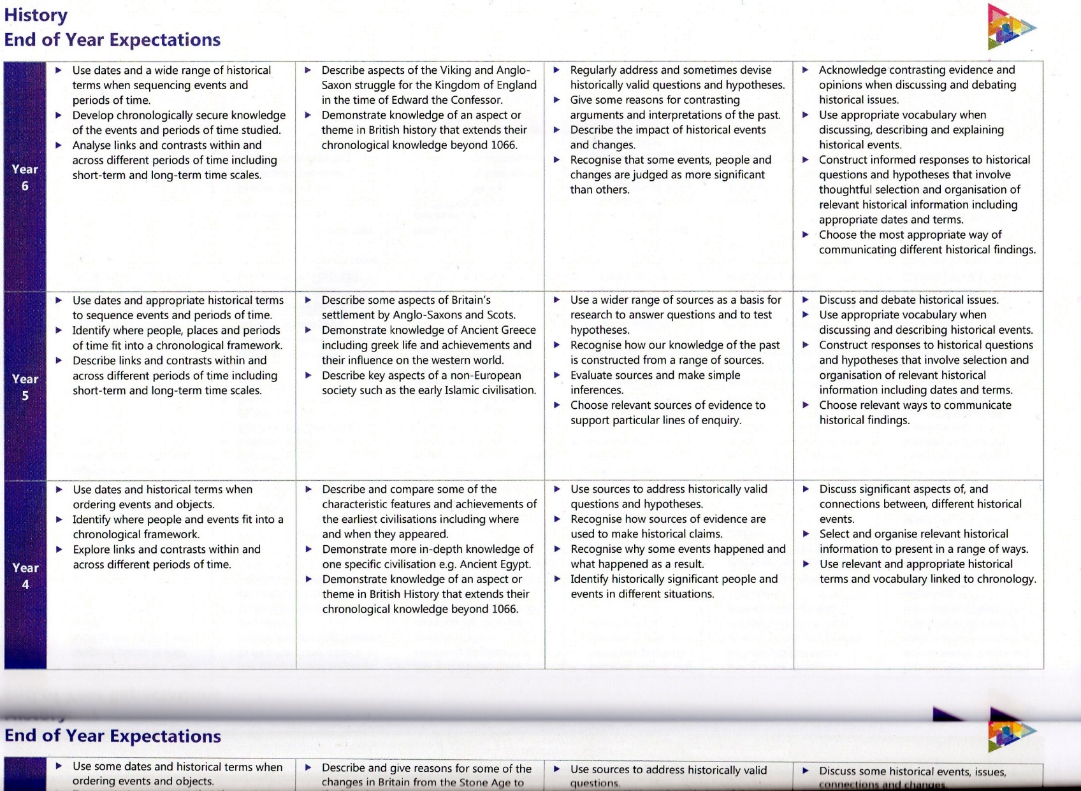

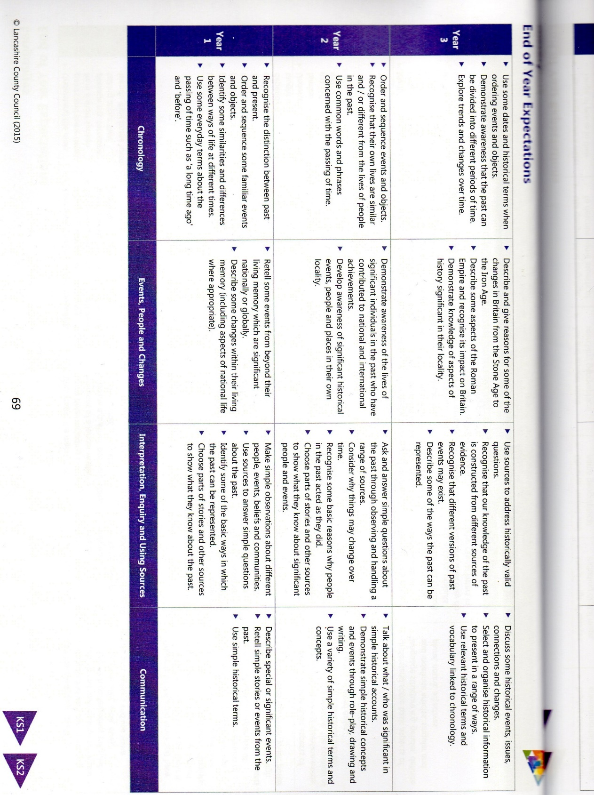

History in the new Early Years Foundation Stage Framework

EYFS Development Matters Statements - Children in Reception

Specific area - *Understanding the World*

Children to be given opportunities to;

* Comment on images of familiar situations in the past
* Compare and contrast characters from stories, including figures from the past.

**New Early Learning Goals – Past and Present**

* Talk about the lives of people around them and their roles in society
* Know some similarities and differences between things in the past and now, drawing on their experiences and what has been read in class.
* Understand the past through setting, characters and events encountered in books read in class and storytelling.

Checked and up dated in September 2021.